How to Install a 5.0 Coyote Into a Fox Mustang - Breeding Easy

Sean Hyland Motorsport drops a Coyote powerplant into a Fox
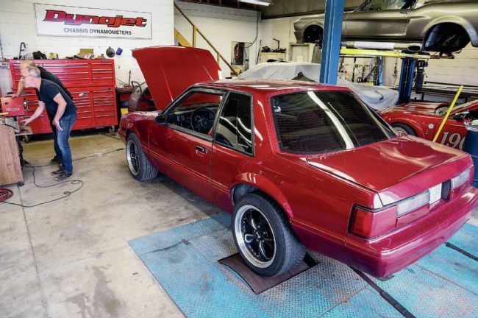
Dale Amy
December 30, 2014
Since its inception, Sean Hyland Motorsport (SHM) has built just about its entire business plan around Ford’s Modular engine family, starting with modification of the earliest SOHC and DOHC 4.6L’s back in the ’90s when everyone else seemed afraid to mess with the newfangled cammers. Not surprisingly then, much of SHM’s focus is now on the 5.0L Coyote.
Compare The Jaguar XJ®. Find A Retailer
In both Mustang GT and F-150 truck applications, the Coyote has proven itself to be a rare combination of muscle, fuel efficiency and reliability, landing it at or near the top of everyone’s potential engine swap list (SHM even has an ongoing program for swapping Coyotes into Land Rover Defenders!) The ready availability of this DOHC 5.0L in Ford Racing crate motor form, and now even on the used or wrecking-yard markets, just makes the Coyote swap temptation that much harder to resist; perhaps, especially to those with high-mileage Foxes in need of a new mill. By now, the idea of mating a Coyote with a Fox is really nothing new—the most common approach involves buying a swap-specific tubular K-member and long-tube headers. This approach certainly works but can add as much as a couple grand to conversion costs, so SHM has been working on ways of making the Coyote transplant easier and even a bit more budget friendly.
What we’re documenting here is SHM’s method of retaining your original Fox K-member as well as utilizing (through modification) the Coyote’s factory short-tube headers (as shipped with the FRPP crate motor.) We’ll also show some specific hardware and components that SHM has developed to make Coyote-into-Fox swaps more convenient.
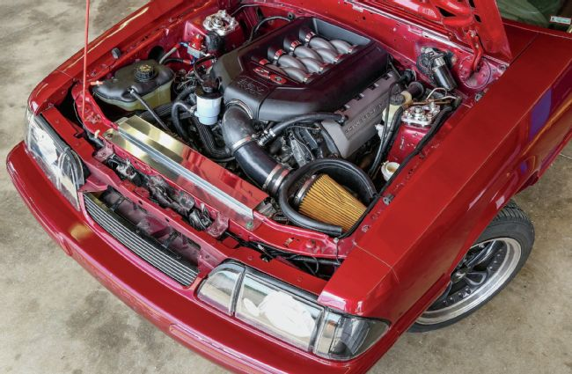
Sean Hyland Motorsport has some potentially cost- saving parts and tricks for implanting the 5.0L Coyote into a Fox.
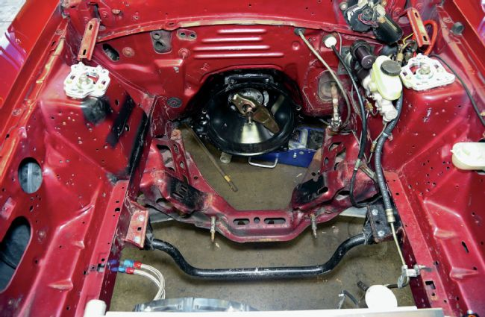
Our transplant beneficiary is a well-used but basically solid LX coupe. Owned by SHM technician Mike van Hees, it was originally a four-cylinder car before Van Hees substituted a Windsor small-block, which in turn had already been removed by the time of our arrival at SHM’s Woodstock, Ontario, shop.
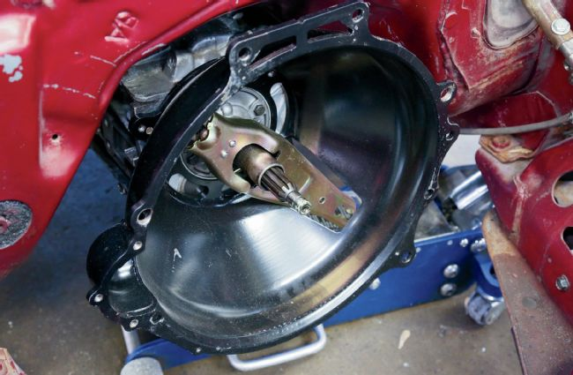
01. The coupe’s upgraded World Class T-5 remained in place during the swap but is now fronted by a QuickTime SFI-approved bellhousing for the Coyote conversion. The Modular bellhousing diameter requires a longer clutch fork (’96-’04 SN95) to receive the clutch cable. Note: SHM will offer all of the conversion hardware used in this article, either individually or as part of a complete swap kit for your particular application.
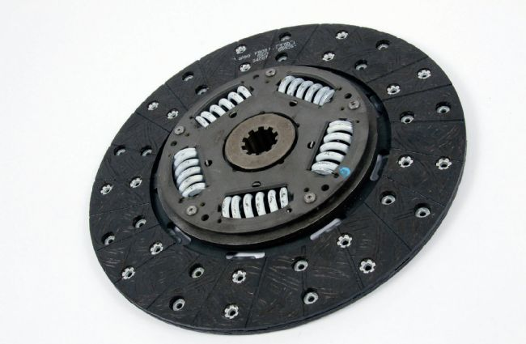
02. An 11-inch, 10-spline clutch (similar to a Terminator’s) was used. SHM stocks these for the Coyote-into-Fox swap.
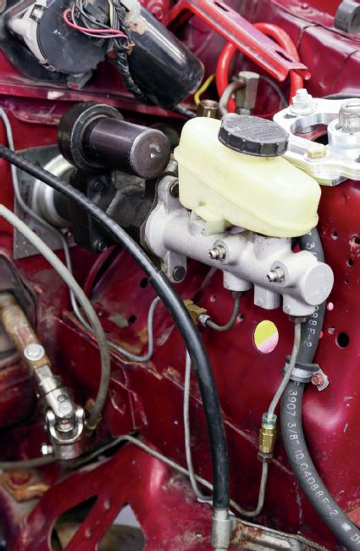
03. The impressive width of the Coyote means your Fox vacuum brake booster will have to go. Van Hees installed a used Hydroboost setup that he sourced online (for $150.) These are readily available, inexpensive, and an easy swap. Or, for those wanting to increase leg muscle mass, manual brakes are an option. This shot also shows the top portion of a Flaming River steering shaft setup that was necessary to clear the swap’s new engine mount (the factory steering rag joint is just too big.)
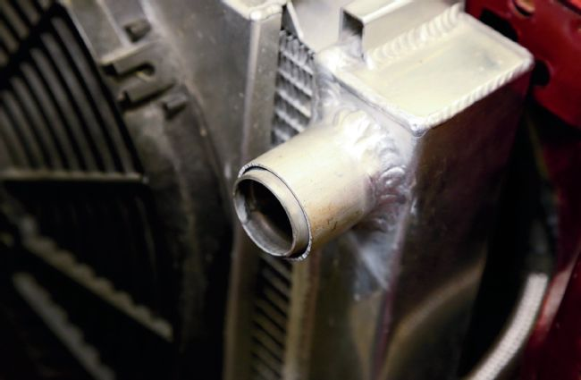
04. Inlet/outlet locations on Fox radiators will work fine with stock Coyote hoses, but the Fox inlet has a quarter-inch smaller diameter. Van Hees’ answer was to weld on a sleeve to bring the inlet up to 11/2 inches to match the Coyote hose.
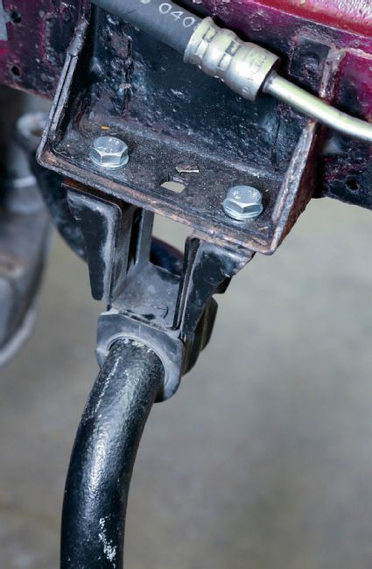
05. Stock Fox sway bar positioning has been known to cause clearance issues with a Coyote’s alternator and oil filter. A simple solution is to substitute an SN95 sway bar chassis mounting brackets like this so that the bar is positioned lower.
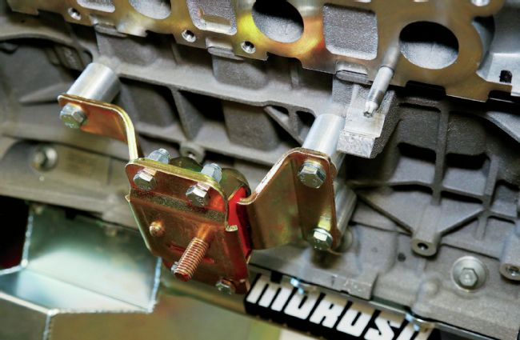
06. SHM has come up with a specific engine mount and spacer combo to position the Coyote into the factory Fox K-member. This is the setup for the passenger side of the block.
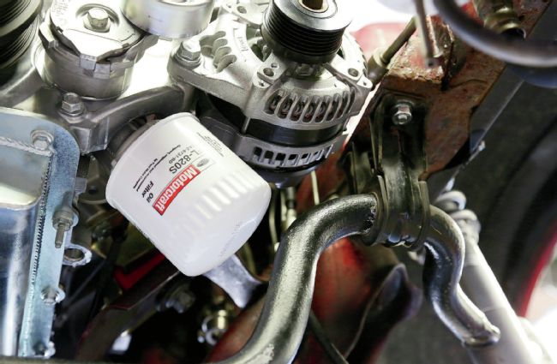
07. With the engine temporarily set in place, you can see how these longer SN95 sway bar brackets provide plenty of space for both filter access and the alternator. Motorcraft’s shorter FL-820S filter provides additional clearance.
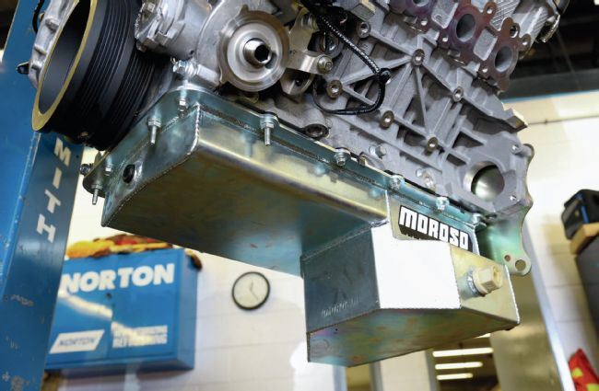
08. The factory Coyote oil pan cannot be used, but Moroso makes an 8-quart replacement specifically for the swap (PN 20571). It reuses the Coyote windage tray, dipstick tube, and pickup and even has a 20mm fitting on the side for the factory oil level sensor.
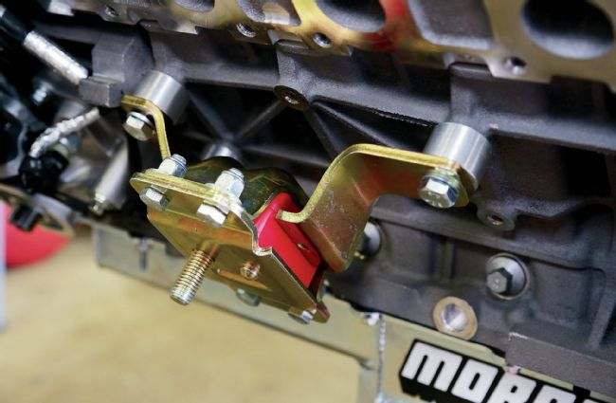
09. Note the shorter spacers on this driver-side mount. Like most components in this story, the complete mount kit, with spacers and hardware, will be available through SHM.
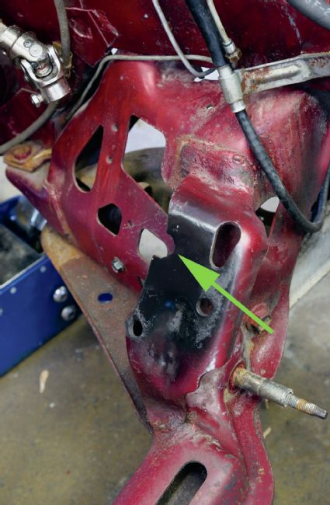
10. As far as receiving those new mounts go, they utilize an existing hole on the passenger side of the factory K-member, but the swapper is required to make a new cutout (arrow) on the driver’s side of the K.
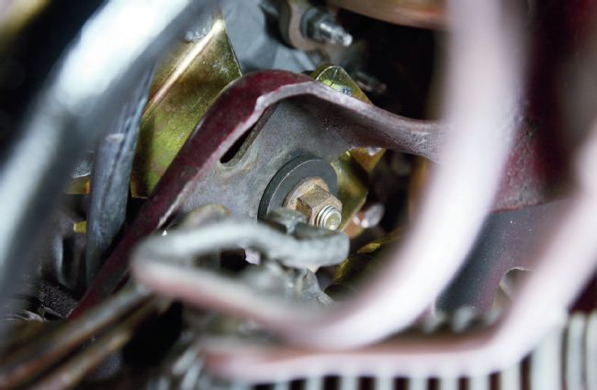
11. Once the Coyote is in place, the driver-side mount is secured using this extralarge washer.
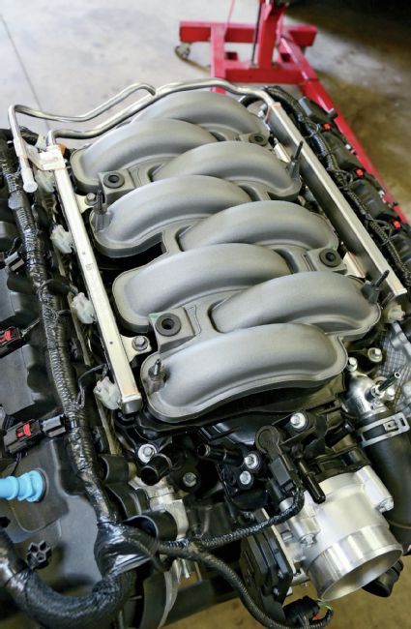
12. Factory Coyote Mustangs feed their fuel rails from the driver’s side, while the opposite is true on Fox cars; the solution is to reverse the fuel rail orientation.
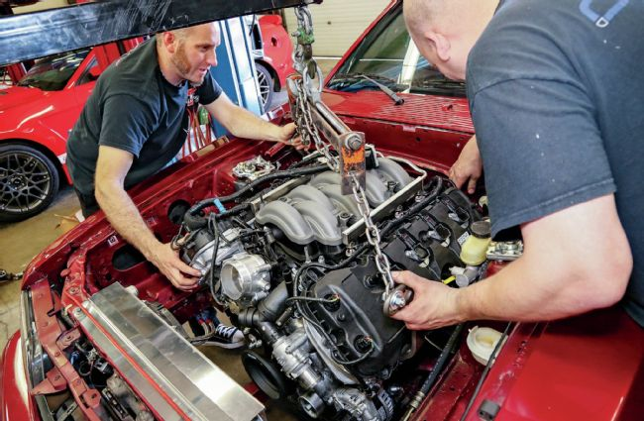
13. Van Hees and fellow SHM technician Brent Allender got pretty efficient at sliding the fat-headed Coyote in and out of the Fox engine bay as they investigated what was necessary to utilize a factory stamped K-member and the Coyote’s short-tube headers.
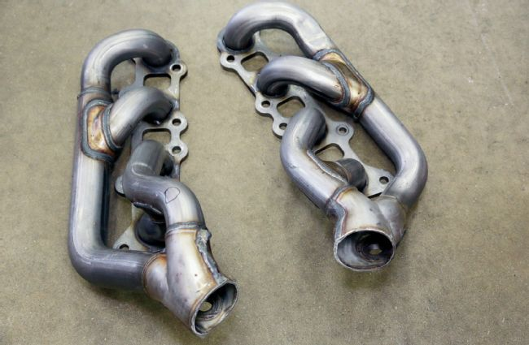
14. Instead of expensive, swap-specific long-tube headers, SHM has found a way to use the crate motor’s included (factory Mustang) stainless tubular headers—albeit with some modification. In order to avoid interference with the firewall, these must have their large, flat flanges sawn off.
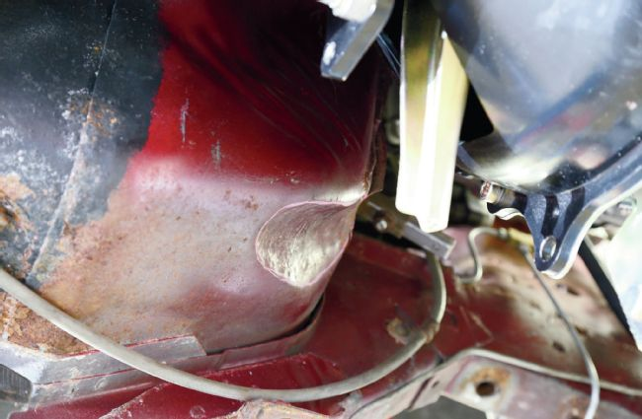
15. The driver-side floorpan required some reshaping with a body hammer to provide clearance for the header (clearance on the passenger-side floorpan is not a problem.)
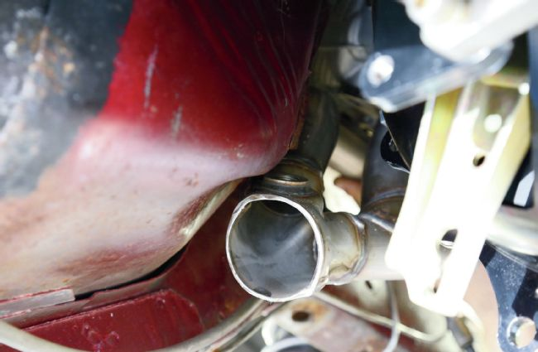
16. The driver-side header now clears nicely, but there’s no room to fit the oxygen sensor, so its bung will be plugged and that sensor will be relocated a short distance downstream. No repositioning is required for the passenger-side header’s sensor.
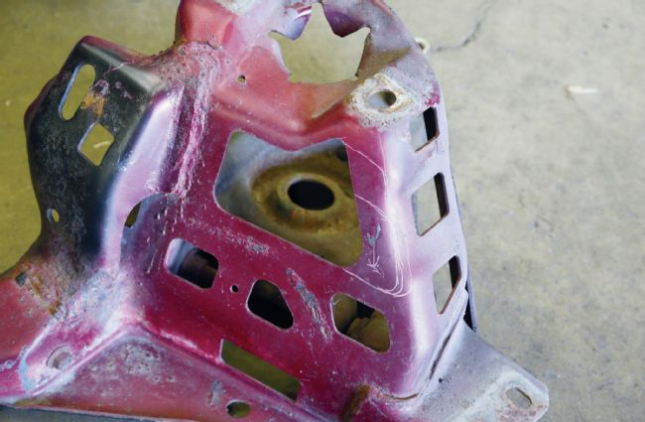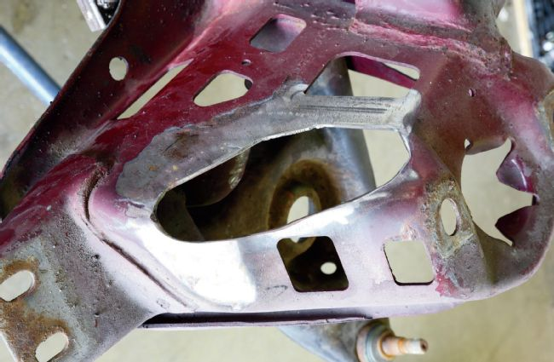
17. However, creating room for that right-side header did require taking material from the K-member, shown in stock form on the left and after surgery on the right.
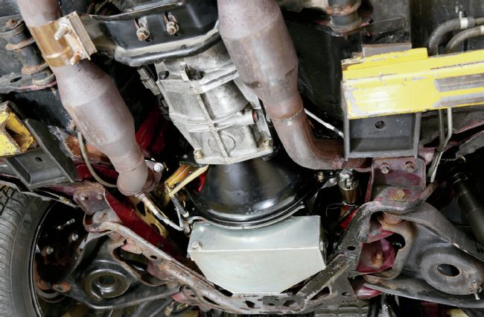
18. To connect the Coyote headers to his exhaust system, Van Hees welded on Fox-style ball-and-socket flanges (clocked to clear any floorpan interference) and then bent up short sections of pipe, welding them to the front of the cats on his existing system. No need for a new H- or X-pipe. Any competent exhaust shop should be able to make such a connection in short order.
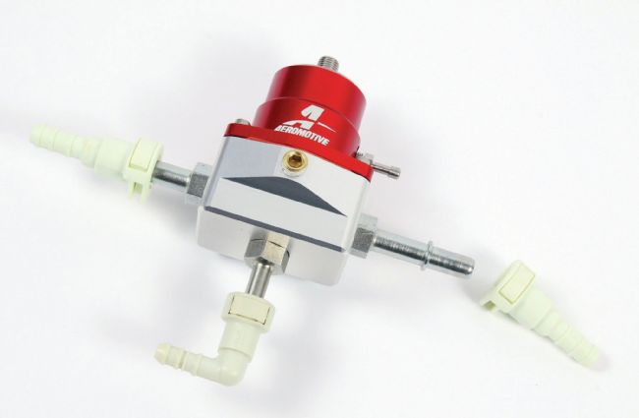
19. SHM sells a number of components to facilitate the Coyote swap, including a fuel pressure regulator complete with factory-style quick-connect fittings (to negate the need for AN fittings.)
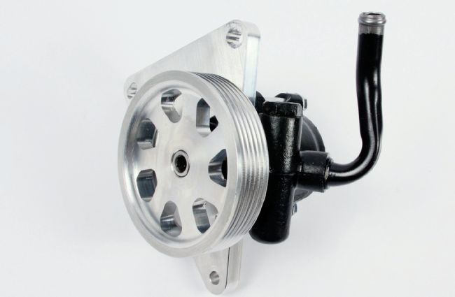
20. Another SHM proprietary part is this power steering pump assembly made specifically for Coyote crate engine swaps.
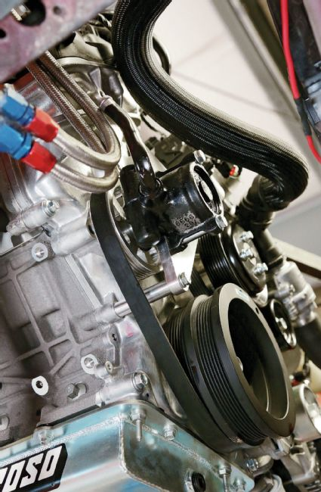
21. SHM’s power steering pump kit also supplies all necessary mounting hardware, including spacers and a drive belt. Hyland also sells the line necessary to plumb the pump to Hydroboost.
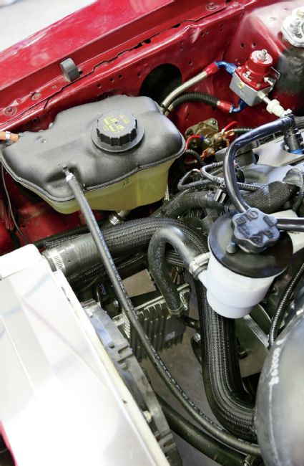
22. Van Hees used a coolant expansion tank from a factory Coyote GT, and the power steering reservoir is from a pre-electric-steering GT500 (this relatively large reservoir is necessary to feed the Hydroboost.) This shot also shows the FRPP Controls Pack processor mounted low in about the same location as an S197’s factory PCM. And yes, the battery now resides in the trunk.
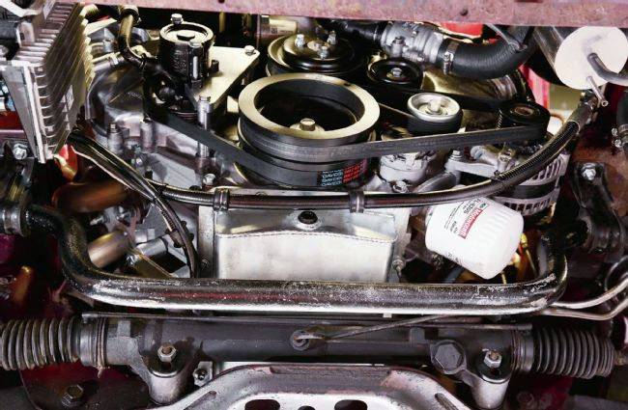
23. Another view from beneath. The steering rack is mounted with offset bushings to clear the oil pan. SHM stocks these bushings as well as the line seen running across the front of the pan, connecting the power steering pump to the Hydroboost.
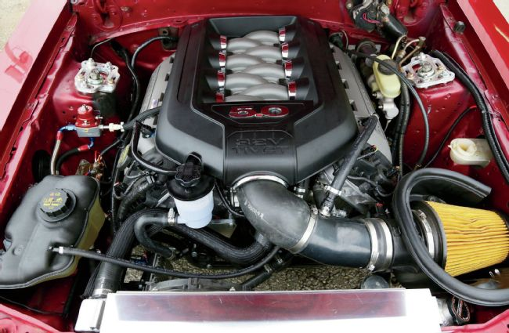
24. An overall look at Van Hees’ finished engine bay certainly gives off an installed-at-the-factory vibe and proves that, for determined swappers, and with SHM’s help, a Fox will accept a Coyote without resorting to a tubular K-member or long-tube headers.

On the Dyno and the Street
Of course, all this transplant work would be meaningless if the results didn’t reward the considerable effort. Seat and dyno time quickly set any fears to rest. We expected the transplanted Coyote to bring along its well-documented good manners and civility, but we were absolutely amazed by how fiercely it performs in the lightweight Fox coupe body. During our test drive we rolled it over truck scales where, with two onboard, the notchback weighed in at 3,280 pounds (1,800 on the front axle, 1,480 out back). Subtracting roughly 400 pounds for driver and passenger puts the car itself at around 2,900 pounds, wet—roughly 700 pounds less than an S197 GT. No surprise then that, as the Brits might say, it goes like the clappers. But that’s only a subjective description as reported by the seat of my Wranglers.
Consider A Jaguar XF®. Find A Retailer Now
After returning to SHM, we rolled the coupe right onto the shop’s Dynojet for a more objective analysis. The accuracy of our jeans was confirmed when we observed that the bone-stock crate Coyote was sending 397 hp and 386 lb-ft to the tires, with a broad, torque curve staying above 300 lb-ft all the way from 2,400 to 6,800 rpm. Next stop for Mike van Hees will be a dragstrip—but only once he hunts down some stickier rubber.
As a bonus, Van Hees also reports that fuel mileage is way up from his coupe’s previous breathed-on Windsor small-block. That frugality may not last, however, as his next addition will be Sean Hyland Motorsport’s proprietary, TVS-based, Coyote-specific supercharger. But that’s a story for another day.

