Everything You Ever Wanted to Know About the Coyote Powerplant: Return of the 5.0

Coyote, Road Runner, and VooDoo carry the Mustang torch
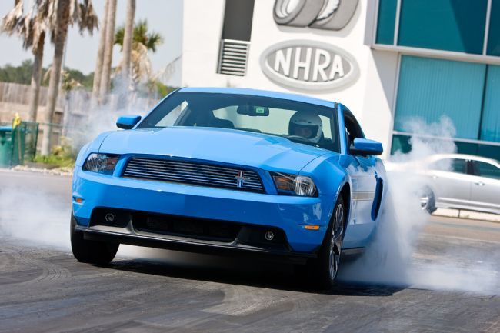

Evan J. Smith Freelancer
June 11, 2015
Photos By: Courtesy of Ford
Under pressure to produce engines with lower emissions, better economy, more power, and less vibration and harshness, Ford recognized that the classic small-block was at the end of its engineering rope. A new engine was needed to power the iconic pony car. Ford wasted little time developing the modular line of engines. It took a few years for enthusiasts to warm up to the overhead-cam technology, but with time came horsepower. The Mustang GT evolved from 225 hp to 260, 300, and then 412—after the introduction of the Coyote 5.0L engine. The Coyote has also evolved, into the Boss 302 and the new VooDoo 5.2L version in the Shelby GT350. These engines have given the Ford Mustang an edge in performance, even when the competition has many more cubic inches.
Jaguar® Leasing Deals. Find A Retailer.
The 5.0L Ford engine debuted in 1968, when it was simply called a 302. With a four-barrel carb, it produced 250 hp (SAE gross) and gave buyers who didn’t want a big-block a nice-performing V-8 option. There have been many great version of the 302ci powerplant, including the venerable Boss 302s of 1969 and 1970, the 225 hp 5.0 H.O. (used from 1987-1993), and the Cobra 302 fitted to 1993-1995 SVT Cobra Mustangs.
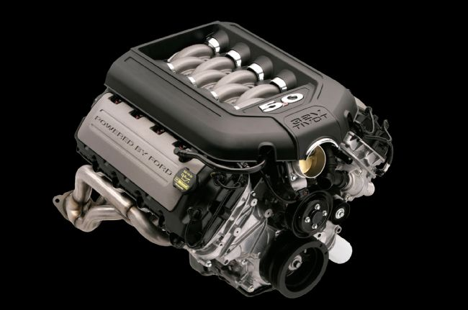
The 5.0 engine moniker was popular with the Fox-body crowd, so much so that many V-8 Mustang owners often referred to their Mustang as simply a “five point oh.” Recognizing the significance of the term 5.0, Ford capitalized on the opportunity to bring back the moniker when the 2011 GT engine was developed. The world welcomed a modern 5.0 in late 2010. The decision proved popular with enthusiasts.
Along with the displacement, enthusiasts fell in love with the 400-plus horsepower (412 to be exact) that came with the 2011 GT. Starting with a clean slate, Ford engineered the 5.0L with power, efficiency, and economy in mind. Ford combined the very best attributes from the modular line of overhead-cam engines to develop the “Coyote” utilizing a strong aluminum block with deep-skirting, high-flow aluminum heads, variable cam timing, a composite intake, and tuned exhaust headers. Other features of the base 5.0 include 11:1 compression, 0.472/0.433-inch lift, and duration of 260/263 degrees. The engine includes a windage tray and an 8-quart oil pan, with a 1-5-4-8-6-3-7-2 firing order.
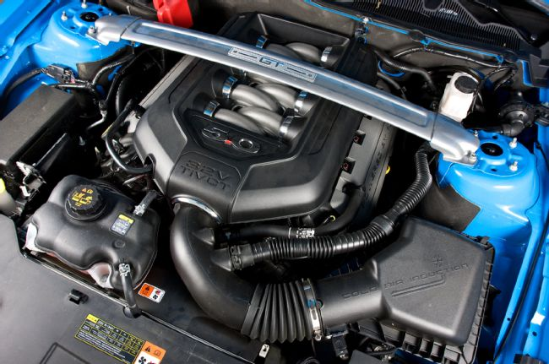
Introduced in 2011, the 5.0 Coyote engine made 412 hp at 6,500 rpm and 390 lb-ft of torque at 4,250 rpm.

Cylinder heads
The Coyote project began in the spring of 2007 when Ford’s director of large gas and diesel engines, Bob Fascetti, selected Mike Harrison to build a new engine for the Mustang. Harrison initially reported that his team could design and build an engine to make 370-380 hp, and Fascetti told them 400 was the number.
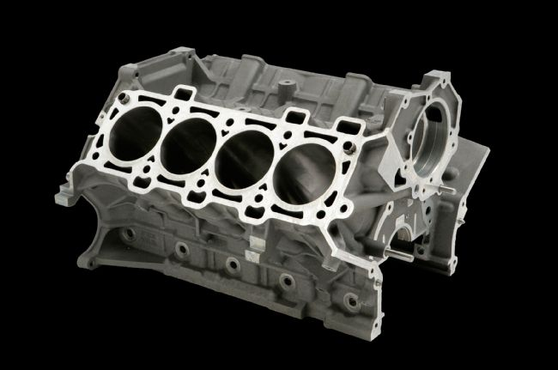
The all-aluminum block features 100mm bore spacing, along with external ribbing and deep skirts to add strength around the crankshaft main caps.
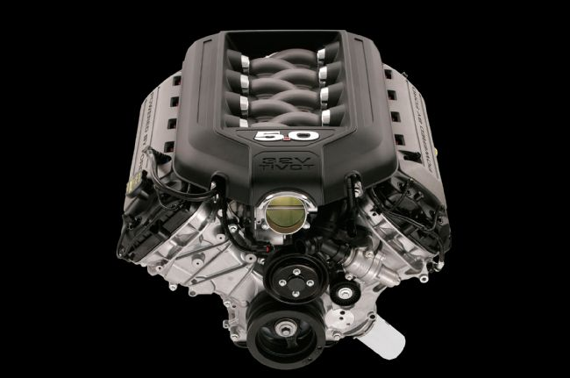
First to be designed was the cylinder heads. That task fell on engineers Todd Brewer and John Reigger. They created heads that outflowed the GT500 Four-Valve heads by almost 5 percent, and Kevin Shinners developed the quartet of cams to match the flow characteristics. “For the first time ever, we only ground one set of cams,” said intake, combustion, and exhaust engineer Adam Christian. The heads feature two 37mm intake valves and two 31mm exhaust valves activated by roller fingers (rockers) and big 193cc intake ports.
All-new aluminum four-valve-per-cylinder heads feature compact roller-finger followers, and this creates additional room for bigger, higher-flowing ports. Furthermore, the cylinder head design was built to withstand higher cylinder head pressures. They also feature crossflow cooling for sustained high-rpm use. Head bolt size was increased from 11 mm to 12 to contain the higher combustion pressures.
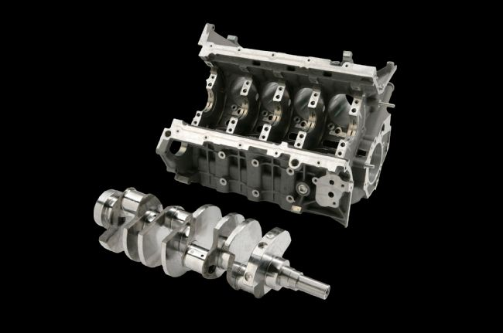
The Coyote is fitted with a forged steel crank able to sustain 7,000 rpm operation. Notice the thickness in the pan rails.
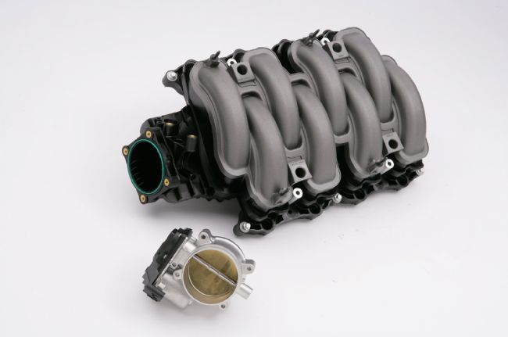
Long-runner composite intake houses the 83mm center-mount throttle-body.

Building block
Ford retained the 100mm bore spacing found in the modular design, but that’s about all that remained. The Coyote uses cast-iron four-bolt main bearing caps, with side bolts, and a forged steel crankshaft. The design has been a proven winner, even well past 7,000 rpm and with over 1,000 hp. The Coyote features a 92mm (3.63-inch) bore and a 92.2mm (3.65-inch) stroke.
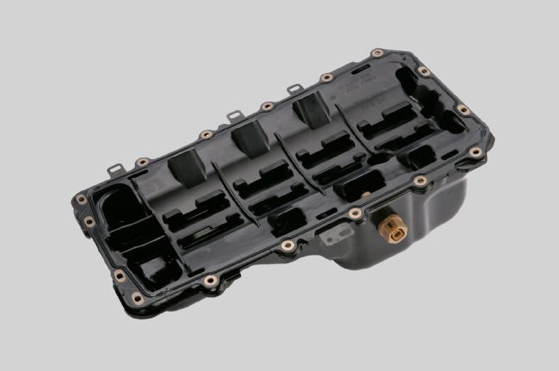
The steel oil pan holds 8 quarts. The pan gasket uses an integrated windage tray to scavenge oil from the crank. This reduces parasitic loss and adds horsepower.
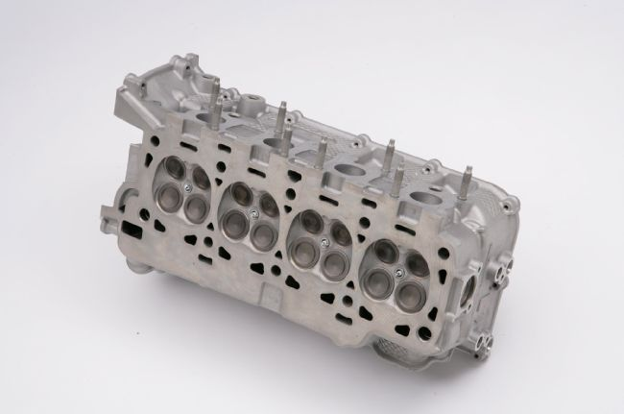
Ford says, “The aluminum block was developed for optimized windage and oil drain back under lateral conditions and high-rpm use, such as a track-day outing. Increased main bearing bulkhead widths and nodular iron cross-bolted main bearing caps with upsized bolts were also employed to accommodate the significant performance increase. An additional element is the increased capacity and baffling of the deep-sump stamped steel oil pan to enable sustained high-rpm use and offer the convenience of 10,000-mile oil change intervals. Piston-cooling jets also were incorporated for performance-minded customers and for faster oil warm-up on cold start.”
Coolant crossover passages were moved from the intake to the block; it also uses forged powder metal rods, with a floating wrist pin and hypereutectic pistons. As you know, the team selected a composite intake manifold. This design is lighter than aluminum, has smooth passages, and keeps the incoming air cooler. The intake utilizes a 83mm inlet and a 80mm throttle-body.
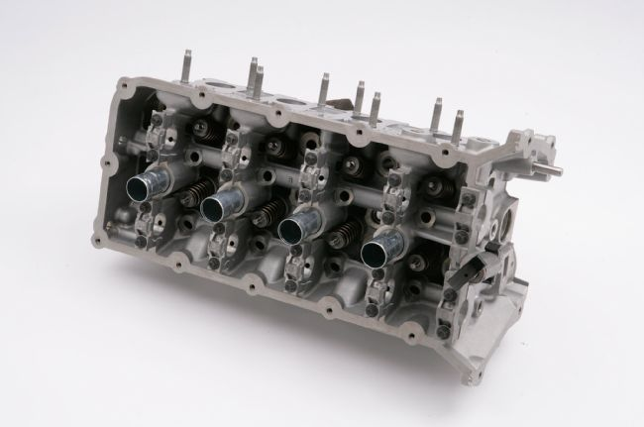
Horsepower comes from airflow, so engineers designed an awesome set of heads. The base Coyote heads have a sizeable performance advantage over the GT500 heads. In fact, ported versions can support well over 1,000 hp.
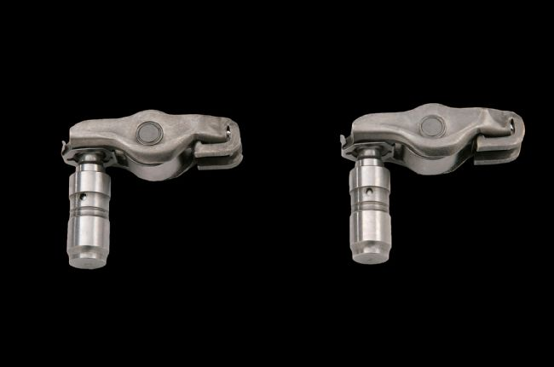
Like all modular engines, the Coyote uses hydraulic lifters with finger followers.

Exhaust
The new firing order required a new header design to maximize scavenging and flow, so specially designed tubular exhaust headers were developed. After loads of computer modeling, a twin-T design was chosen in the 11th hour, right before the team was about to go with cast manifolds. The first set of headers was actually made by engineer Adam Christian over a weekend in his home garage.
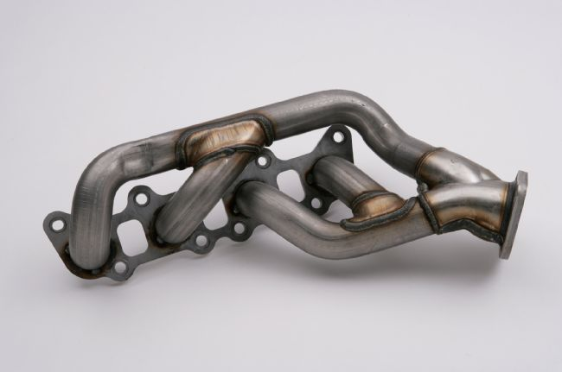
Specially designed headers were needed to work with the new firing order.

Timing is everything
Ford learned a thing or two on variable cam timing on the Three-Valve engine. “Ti-VCT provides extremely precise variable—yet independent—control of timing for intake and exhaust valves,” says Ford. So you get an abundance of torque in the midrange, excellent fuel economy, and great high-rpm power.
Compare The Jaguar XJ®. Find A Retailer
“Ti-VCT is a win-win-win technology,” says Barb Samardzich, vice president of global powertrain development. “It helps our new range of engines to deliver high performance with unsurpassed highway fuel economy and reduced emissions.”
Traditionally the camshaft has only been able to open the valves at a fixed point. Now the camshaft positioning, which alters the timing of the valve events in relation to the pistons, can be advanced or retarded during operation.
The system is actuated by camshaft torque and pressurized oil. Mike Harrison says, “Using camshaft torque energy provides even faster throttle response and maximizes use of existing energy to aid fuel economy. Working like a ratchet, the one-way valves allow precise timing of camshaft events, continually optimizing timing to provide maximum torque or maximum fuel economy, based on driver input.”
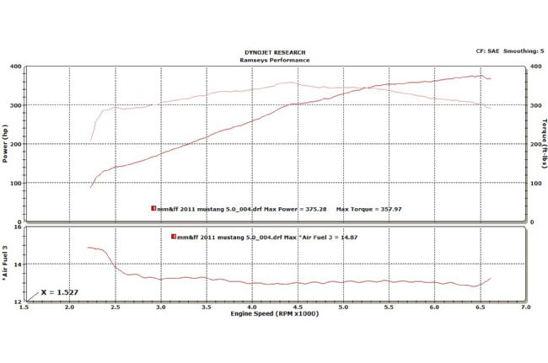
Here’s a dyno chart for a typical stock 2011 5.0 Coyote.

Boss 302
In order to call a Mustang a Boss, it takes a special engine—one with attitude. Ford used select engineers within the 5.0L V-8 team to create the Boss. Using new technology and some old-fashioned hot rod tricks, they coaxed 444 hp and 380 lb-ft of torque from the 5.0L that spins nicely to 7,500 rpm.

Photo Gallery
View Photo Gallery

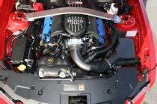

In 2012 Ford released the Boss 302 and the Boss 302 Laguna Seca. Amazingly, Ford extracted 444 hp from the hopped up “Road Runner” version of the Coyote.

“The core group of engineers on the Boss 302 engine understands and respects the heritage of the name and the history behind the original engine,” explains Mike Harrison, Ford V-8 engine program manager. “The first Boss 302 was a specially built, free-breathing, high-revving small V-8 that gave it certain desirable characteristics on a race course— and we capture that essence in the new engine. In keeping with the spirit of the original, the new Boss 302 engine achieves its maximum power output at speeds at or above 7,500 rpm. Unlike the original engine, however, low-speed torque and drivability are uncompromised thanks to twin independent variable camshaft timing (Ti-VCT) technology and computer-aided engineering design tools.”
The engineers turned to Ford’s Daytona Prototype engines for a new intake design. They saw that the DP engines used a short-runners-in-the-box design, which virtually eliminates lag when the throttle is snapped open.
“The effect of the new intake design is dramatic,” says Harrison. “When I took the prototype car to Mustang Chief Engineer David Pericak, he took a short drive, tossed me the keys, and said ‘Book it. It’s in the program.’ He knew what we were onto, and that’s really the point where the Boss 302 was born.”
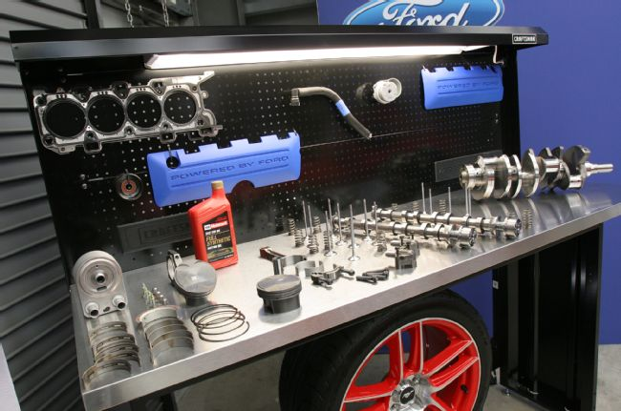
To match the intake, the team went with CNC porting on the heads the full length of the intake and exhaust ports. Even the combustion chambers received some massaging. According to Ford, the process takes 2 1/2 hours per head. “This also required a lightweight, high-speed valvetrain and bulletproof reciprocating assembly that would not only hold together for 150,000-plus miles but also produce power at peak rpm,” states Harrison.
“What most people don’t realize is that engine stresses increase exponentially as engine speeds rise,” he explains. “So moving up from GT’s 7,000-rpm red line required significant reengineering of many different parts. Sacrificing reliability and usability over the GT engine was never an option.”
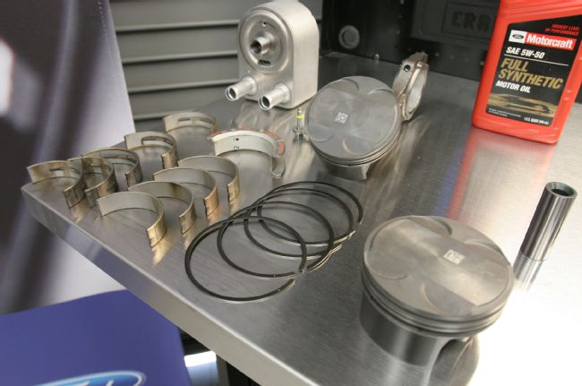
The Boss 302 featured some trick engine components.
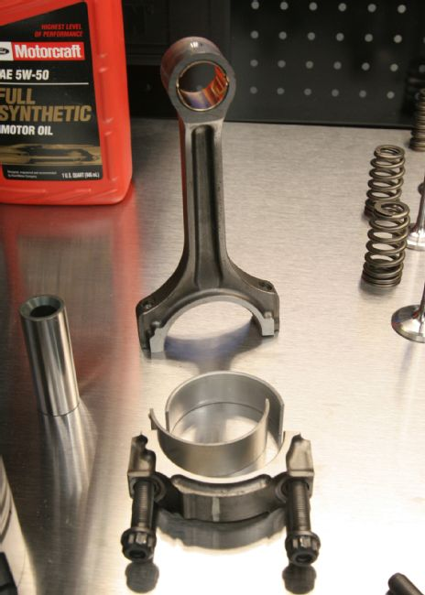
The Boss uses upgraded sinter-forged connecting rods for improved strength, which is needed for the higher combustion pressures and engine speeds.
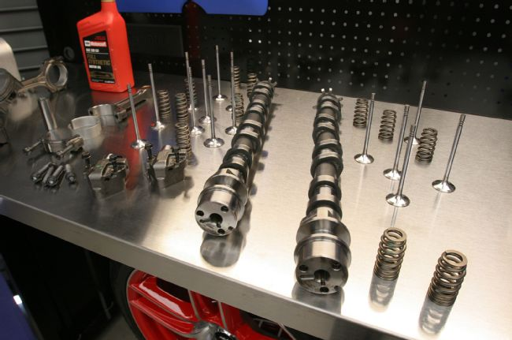
Forged aluminum pistons designed for high rpm are also used in the Boss 302.

Boss-specific goodness
• Revised composite intake system with shorter runners, inspired by Daytona Prototype racing engines, for high-rpm breathing.
• Forged aluminum pistons and upgraded sinter-forged connecting rods for improved strength, needed for the higher combustion pressures and engine speeds.
• New high-strength aluminum-alloy cylinder heads with fully CNC-machined ports and chambers for exceptional high-rpm airflow without sacrificing low-speed torque.
• Lightened valvetrain components to provide excellent dynamic performance up to speeds well above the engine redline.
• Sodium-filled exhaust valves for improved heat dissipation.
• Race-specification crankshaft main and rod bearings for higher load capability and improved high-speed durability.
• 5W50 full synthetic oil with engine oil cooler for improved oil pressure and longer-lasting lubrication during extreme racing conditions.
• Revised oil pan baffling for improved oil control under racing conditions and during cornering loads greater than 1.0 g.

Photo Gallery
View Photo Gallery
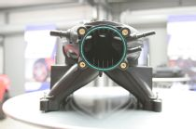
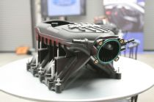
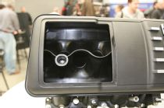
One of the coolest pieces on the Boss is the tall composite intake. This “tunnel-ram” style features a large plenum with tall, straight runners designed for higher-rpm operation. The cutaway shot reveals the smoothness of the runners.
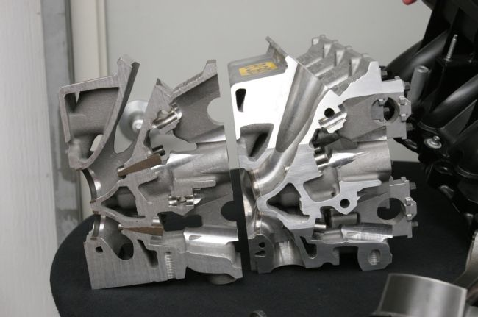
CNC-ported heads improved flow over the stock Coyote heads. A version of the Boss heads was used by Ford Racing on the 2013 and 2014 Cobra Jet Mustangs.
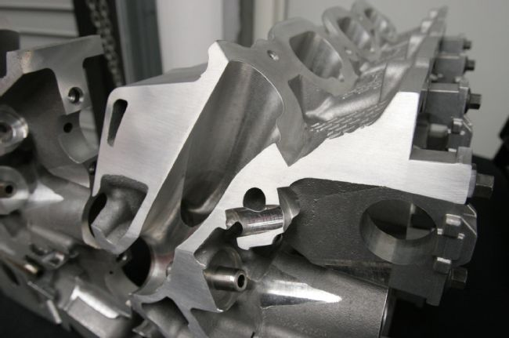
Here’s a view of CNC port work.
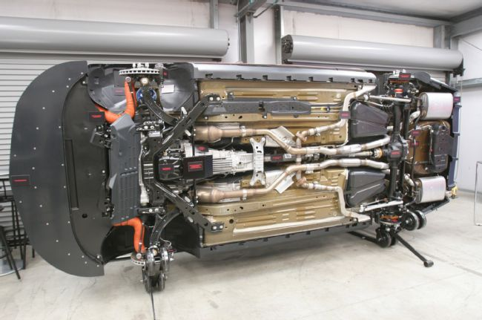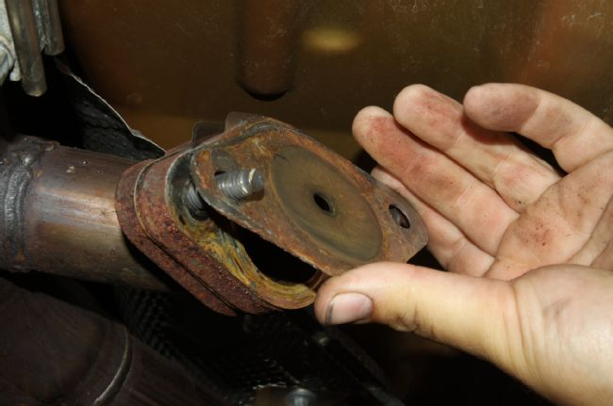
The Boss also featured a special exhaust with side pipes and removable baffles to increase sound.

Production engine durability testing
Before any engine can make its way to production, it must endure serious testing. Harrison explains, “Despite its racing heritage—and the rigors of track-day testing—the Boss 302 V-8 is still a production Ford engine, built alongside the 5.0L GT engine at the Essex Engine Plant in Ontario, Canada. That means it has to meet or exceed all the standard durability testing every Ford engine is required to complete.”
He adds, “Ford had no engine test cells built to run at that kind of sustained speed. Ford Racing had one, but it wasn’t instrumented to do production durability testing. So we had to reengineer the dyno cell with new balancers and jackshafts so the dyno wouldn’t fly apart running at red line hour after hour.”
Ultimately the Boss engine was tested at full output for hundreds of hours, where it outperformed the specifications. Ford stated that the test was equivalent to running the Daytona 250 race flat-out more than 175 times—in a row.
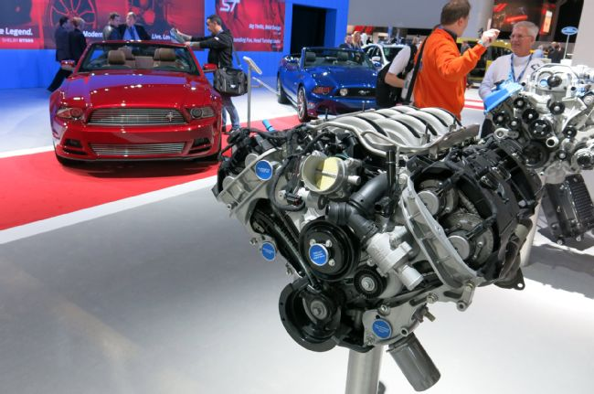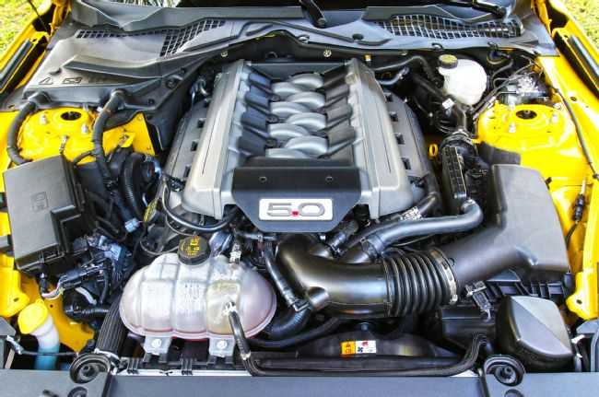
For 2015, Ford made subtle changes and horsepower increased to 435 hp on the base GT.

VooDoo
The 2015 Shelby GT350 and R variants will represent the pinnacle of naturally aspirated performance from Ford. The Coyote-based 5.2L “VooDoo” engine in the Shelby is expected to produce over 520 hp and rev past 8,000 rpm. This is an immense level of power from a modern production engine of only 5.2L.
“The Shelby GT350R Mustang is a no-compromise car in the pursuit of maximum track capability,” says Raj Nair, Ford group vice president of global product development. “It is a thoroughbred street car making use of technology and ingenuity to deliver performance few enthusiasts have ever experienced.”
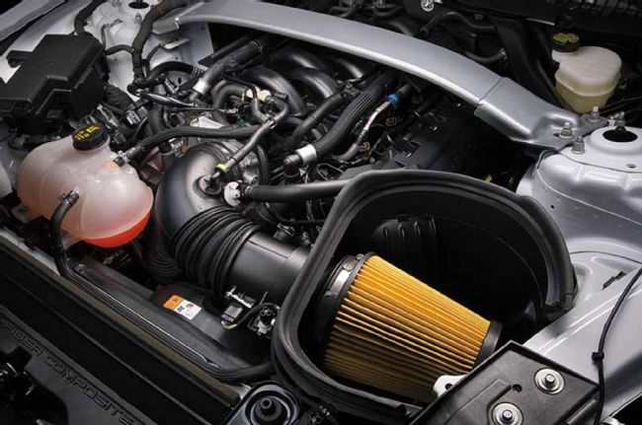
The ultimate warrior is the new 5.2L engine dubbed VooDoo that will power the Shelby GT350. Ford states it will make over 500 hp, but we’re thinking it’ll end up somewhere over 520.

To achieve the displacement, Ford enlarged the bore size, and it also moved from a traditional crankshaft to a flat-plane crankshaft. Flat-plane cranks don’t require counterbalance weights, so they are lighter and allow the engine to rev faster than cross-plane cranks, which have larger counterweights to “balance” the rotating assembly. Traditional V-8s have the connecting rods attached to the crankshaft at 90-degree intervals; the flat-plane design spaces all crank pins evenly at 180-degree intervals. You can also expect very light pistons, and we hear compression is up there, as high as 12.5:1.
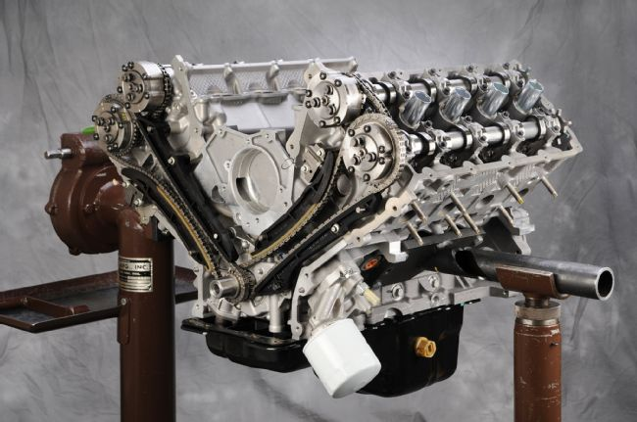
Here’s an assembled Coyote long-block showing off the cam drive system.
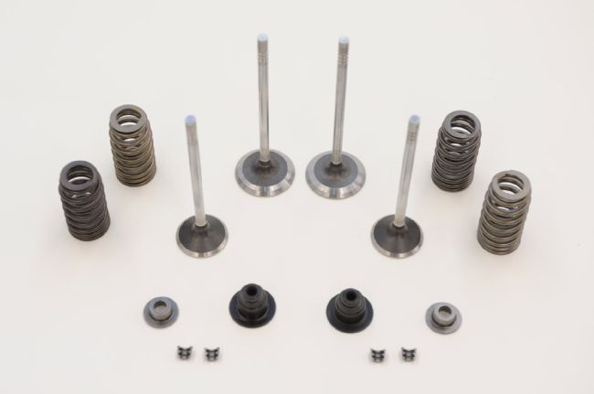
Typical valvetrain components from a Coyote engine; they are lightweight and designed to live in the upper rpm range.

All-new heads get enlarged ports, bigger valves, and higher-lift cams. A new intake is used with taller ports, a larger plenum, and a 90mm throttle-body. As you can imagine, the headers have also been redesigned to work with the additional flow and the new firing order. We anticipate this engine will have big fan appeal, and we expect enthusiasts will look for ways to use the VooDoo heads and intake on standard Coyote engines.
Mustang enthusiasts will be expecting a lot of performance from the Shelby GT350, as it replaces the popular GT500. Ford indeed is making a bold move moving from a supercharger beast to a high-revving all-motor package, especially when the competition is really stepping up. One thing is certain: Ford’s got its finger on the pulse, and the Shelby GT350 is the next step in the Mustangs evolution.
