First step to engine assembly: Cleanup and prep

By Wayne Scraba, automedia.com

Difficulty: Moderate

Estimated time: 180 minutes
Share
Email
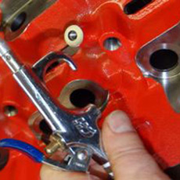
For the beginner, assembling an engine at home is most certainly an intimidating prospect. There are plenty of parts that have to fit precisely and there are plenty of dimensions that must be checked and double-checked (and some triple-checked). There are all sorts of seemingly “foreign” pieces that somehow have to work in perfect harmony. For the beginner, it seems like an impossible task to put it all together. We’re here to tell you it isn’t.
Engine assembly is like any other major project. There are various parts and subassemblies that are completed first, and then each “builds” upon the last. Building an engine at home is a skill just about anyone can learn. Sure you’ll need a good collection of specialized tools (we’ll help you with tool selection throughout the entire series), but the reality is that anyone can assemble an engine. If you take your time and are meticulous with your work, pretty soon you’ll be rewarded with a complete ready-to-run engine.
What follows is a look at how to assemble an engine properly in your own home garage using tools and equipment anyone can purchase (or in some cases, rent). Once you complete the process for the first time, you might be surprised at how satisfying it really is. You’ll probably want to follow up with another engine build! Check it out!
A clean working environment
While it’s possible to build an engine almost anywhere, a clean environment is a must. In our garage, we stop any car maintenance activities that create dust and grit. For example, if another project requires grinding then we either move the operation to another spot or figure out another time to get it done.
You’ll also need a workbench. We have one in our garage, and we’d be the first to tell you it’s too small and regularly cluttered. If your workbench is cluttered, clean it off. If you don’t have a good workbench, a sturdy folding table will do. Once the clutter is reduced, cover the bench surface with paper. Some folks use newspaper. Others prefer butcher paper. We use white poster board because it’s easy to spot little parts, and it’s a bit more immune to oil spills than newsprint.
When it comes to using tools, we always clean them after use. We’ve found a quick shot of brake cleaner (aerosol) and a wipe down with a clean paper towel goes a long way toward keeping the project clean. It also makes it more enjoyable to work with the tools.
Cleaning the pieces
When it comes to assembling an engine, one of the biggest mistakes a novice can make is to contaminate the components. Any piece of grit that turns up during the assembly process can (and regularly will) scratch internal surfaces such as the cylinder walls or reciprocating components. We’re convinced contamination is one of the leading causes of premature engine failure. Because of this, once the parts return from the machine shop (obviously something you can’t do in your own garage), they must be thoroughly cleaned and kept clean during the entire assembly job.
So how do you clean the pieces? It’s actually rather simple. Scrub everything with hot water and liquid dish soap or car wash detergent. The catch here is that you have to access all of the oil gallery holes, which means the block gallery plugs should all be removed (as is regularly the case with blocks that have been through a machining process). The folks from B&B Performance have a special nine-piece brush kit designed to work in all engine oil galleries (see the tools and source list below). They even include two extra-long brushes for scrubbing oil galleries adjacent to the cylinder block lifter bores.
Our backcountry garage isn’t blessed with a paved driveway or even a cement apron in front of the overhead doors. It’s simply gravel. To circumvent grit accumulation during the wash cycle, we always place the block and components being cleaned on a rubber mat. An old pickup truck tailgate mat or bed floor mat works perfectly. Before going any further, make a mental note: Once you start cleaning something like a cylinder block with soap and water, you can’t stop until the job is done. The old saying about “rust never sleeps” truly applies here. You need time to complete both the wash and dry cycles.
Cylinder block preparation
First things first: Hot water and soap is mixed into a bucket and the pressure washer is hooked to a hot water tap. We use a conventional car wash scrub brush for the initial cleaning. Once that’s done, remove the cylinder block main caps and go through all of the oil galleries with the B&B Performance brush kit. Once you think everything is clean, start all over again and rescrub the entire works.
We’re fortunate to own a big 220-volt, 5.5-horsepower compound air compressor. It produces copious quantities of air. No matter what type of compressor you own (or rent), be sure the regulator is set to provide something in the range of 100+ psi. Snap a blowgun attachment into the air hose and let the compressor rip. What you really need to do is blow as much water off the engine as possible, and the quicker the better. Use the air force to blow all of the water out of the oil galleries, and don’t be timid. There will be plenty of water moving around, particularly from the exit points of smaller oil passages.
After drying
Once the block is blown dry, you must oil all of the machined surfaces. There are a couple of ways to accomplish this: A clean rag soaked in clean light oil (for example, 10W-30) or automatic transmission fluid works. So does a light mist of spray lubricant, followed by a wipe down with a clean shop towel. Spray lubricants will naturally displace water so it works in your favor. We always clean the machined surfaces until the shop towels show absolutely no trace of dirt. The preferred towel here is actually a roll or two of paper towels. We prefer the mechanic-style blue jobs since they don’t tear or shed as easily as kitchen towels.
We treat all of the internal engine components to the same cleaning process. Once clean, we place the various bits into fresh plastic bags and zip them shut until we need the respective parts. When cleaning items such as a crankshaft, you’ll note that the small brushes from B&B Performance go a long way toward getting into the various oil passages. Be careful not to nick any machined surfaces.
Once the block is spic and span, it should be wrapped up. While jumbo garbage bags work, they’re usually flimsy. We prefer to use an engine storage bag. B&B Performance offers 4-mil plastic bags designed to protect racing engines against dirt and moisture. They’re large enough to accommodate an assembled big-block, even one with headers in place. These sturdy covers are ideal for storing and transporting race motors, too. And that means they’re perfect for protecting your block while you’re not working on it. We always wrap the block or engine immediately after work on it has ended. Remember, the main idea is to keep contamination to a minimum.
Plugging the holes
All engine blocks are equipped with a series of pipe plugs. They’ve most likely been removed during the machining and hot tanking process, and obviously should not be present during your cleanup. You’ll need to replace them during engine block preparation. Your local auto parts store, car dealer or machine shop can help you with the respective plugs you’ll need. For a cleaner look, we prefer AN (aluminum) plugs with internal hexes, but brass plugs will work, too. For some applications, a rear cam plug will have to be installed as well. Most of these are of the drive-in (with a hammer) variety. It’s best to leave the cam plug out until later (after the camshaft has been installed). In addition, some engine stand configurations don’t allow access to the back of the block, so you won’t be able to install the plug until the engine is off the stand.
Typically, the rest of the plugs are equipped with pipe threads. That means the plug is tapered. To seal a pipe thread you can either use Teflon® tape (a pain) or pipe thread sealant. We prefer the latter. Cover the threads with sealant and install the plugs. It’s that simple.
The last thing you need to install is the oil filter bypass valve along with the oil filter adapter. There are plenty of different formats out there, but in our sample engine, the bypass valve simply drops into the block. It’s driven home and set with a hammer and a small socket. The oil filter adapter is a double-threaded affair. The block side should have the threads lightly covered in blue medium-strength thread-locking fluid (don’t use red, as it will require considerable heat if the adapter requires removal). Torque to specs and you are done.
In the next segment, we’ll show how to install the crankshaft and measure the main journal, rod journal and crankshaft thrust dimensions. While these steps are absolutely critical in the engine assembly process, it’s not as intimidating as it sounds. In the meantime, check out these photos.
Tools used:
- Engine-cleaning brush kit
- Engine storage bag
- Thread sealant
- Medium-strength thread-locking fluid
- 3/16-inch, 1/4-inch, 5/16-inch and 3/8-inch hex drives
- 3/8-inch drive ratchet
- Air compressor
- Blow gun (air)
- Pressure washer

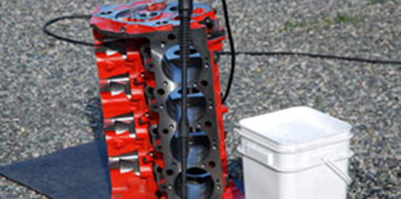
Before a freshly machined engine can be assembled, it has to be cleaned. And really cleaned! You’ll need a bucket or two of hot soapy water, a pressure washer and a set of good quality engine brushes.

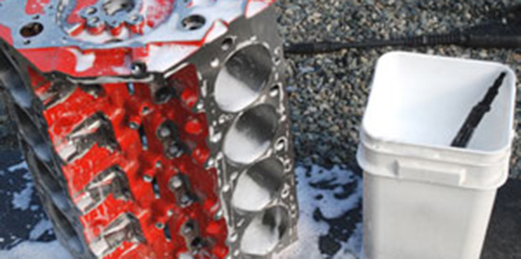
Scrub all of the accessible surfaces with soap and water. Liquid dish detergent works perfectly. So does automotive car wash soap. You’ll have to go through a lot of soap and water. The pieces need to be clean. Once clean, remove the main bearing caps and clean them separately (they’re not removed in this photo). Removing the caps allows you to access the main bearing oil galleries.

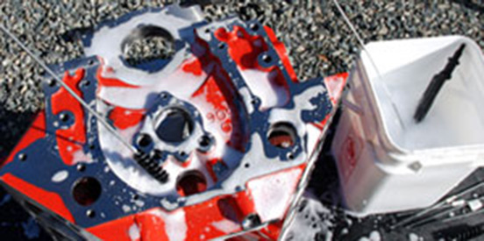
Once the outside is initially cleaned, you can scrub the internal oil passages. The extra-long brushes from B&B Performance are designed so that you scrub the entire length of the lifter oil galleries and, in the case of this engine, the main oil gallery.

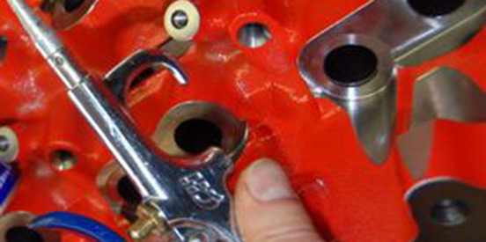
Once rinsed a number of times with hot water, you can dry the works off. Compressed air and lots of it is your friend when it comes to drying engine hardware. We typically wipe dry multiple times.

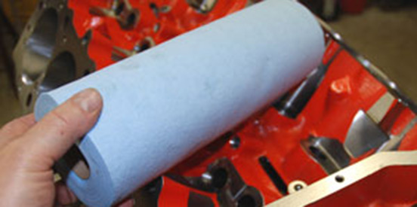
Continue to wipe the block down until the shop towels no longer show any traces of dirt. Paper towels are better than cloth for this task, and we prefer these blue mechanic towels.

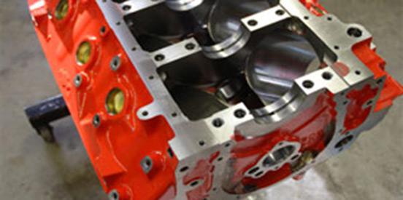
Your finished cylinder block should look like this when you’re done. In this example, the water jack core (soft) plugs were installed when the block was CNC machined. Remember, spotless is the operative word – you really can’t get these pieces clean enough.

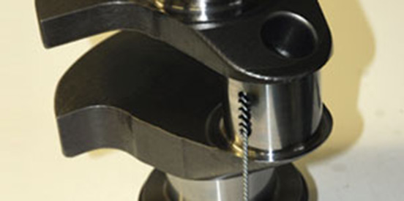
Other components such as the main caps, crankshaft, connecting rods, pistons and wrist pins also need cleaning (using the same process as the bare block). The crank has oil passages machined into it. We’re using the B&B Performance brushes to reach inside the passages.

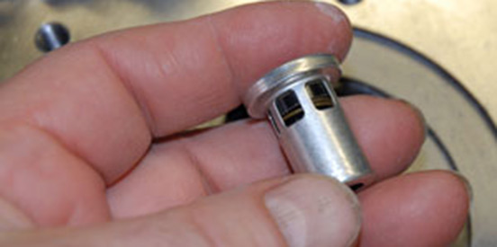
Most engines mandate some form of oil filter bypass valve. Our example uses a valve like this.

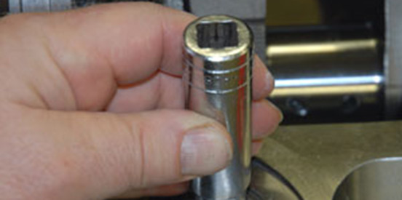
The valve slips into the machined passage on the oil filter pad as shown in the first photo. Using an old socket that fits the OD of the valve, seat it with a small hammer. A light tap should get the job done. It has to fit flush with the machined oil filter boss.

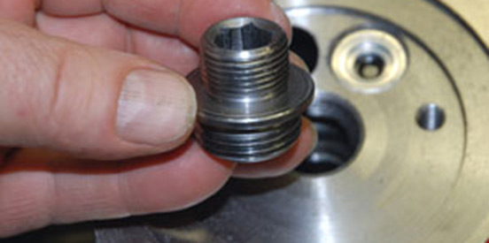
Here’s a look at the oil filter adapter used in our build (most are similar). The side with the internal wrench hex faces outward.

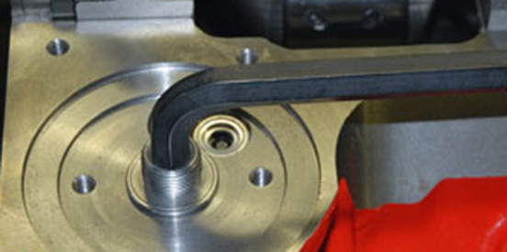
The oil filter adapter must be locked in place. In this case, Permatex medium-strength thread-locking compound is used. The adapter is tightened with a large hex Allen key.

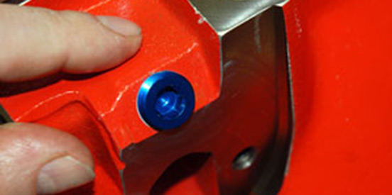
Most cylinder blocks have a variety of pipe thread plugs. It’s common practice to use brass or aluminum or even steel plugs (we use Aeroquip aluminum internal hex jobs). No matter what type of plug you use, you’ll need some form of sealant, simply because pipe threads leak without it. You can use pipe sealant tape, but a good thread sealant is easier to use. Coat the thread and tighten the plug. Once the plug is installed, wipe off the excess.

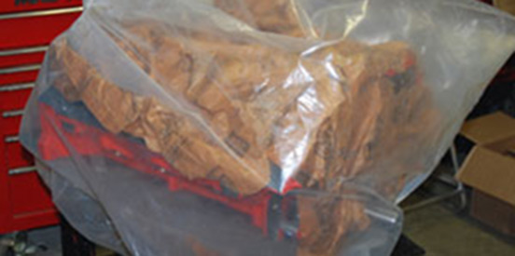
When you’re not working on the various engine pieces, wrap them tightly with plastic. We generally try to keep a clean oil-soaked craft paper on the outer machined surfaces (inside the bag). Our example is a paper called “Armor Wrap,” but any clean paper will work.

Engine assembly: The bottom end

By Wayne Scraba, automedia.com

Difficulty: Moderate

Estimated time: 240 minutes
Share
Email
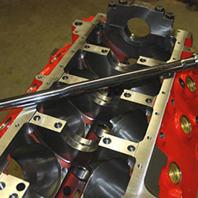
In our previous segment on engine assembly, we showed how to (fastidiously) clean various engine components, and how to prep the cylinder block for assembly. Here, we’ll get into the actual meat and potatoes of engine assembly: measuring main bearing clearances, measuring rod bearing clearances and checking crankshaft thrust dimensions. In the process, the crankshaft will be installed, the main bearing caps will be torqued and the bottom end will be readied for reciprocating component (rod, wrist pin and piston) installation.
Sounds complex, but the truth is there’s nothing fancy here except persnickety measurements, attention to cleanliness and plenty of patience. Bottom line: If you can muster up the persistence for detail, you can handle the job. It’s that simple. Here’s how it’s done.
Measuring the mains
The first step is to measure the crankshaft main bearing journal diameters. This is best accomplished on your workbench. We use a micrometer to check the dimensions in an “around the clock” pattern on each journal. What that means is that we check each of the main journals in multiple locations.
To properly use a micrometer, slowly tighten the spin wheel until the mic contact points meet the crank journal. Spin the bottom thumbwheel (ratchet stop) until you feel three clicks on the micrometer as it contacts the journal (keeping in mind you don’t want to scratch the journal surface either). Double-check to ensure that the mic contact points are touching the journal evenly (not cocked to one side). Lock the micrometer and check the reading. Record each reading as you go around the journal. In essence, you’re accomplishing two things: You’re checking for crankshaft main journal out of round (if the readings from different points differ) and you’re also checking the outside diameter of the crankshaft journal.
Follow the same steps around each main bearing journal and record each set of figures for each journal. On a typical modern V8, you’ll have five bearing journals to measure on the crankshaft.
There are two different times you can measure rod journal dimensions: right after you’ve finished checking the mains or later, once the crank is installed in the engine. If you’re confident the crank was properly machined, you can save those steps for later (which is what we’re doing here). If you’re not so confident regarding the crank accuracy, it’s best to measure it now. That way, if the dimensions are off you don’t have to go any further on the engine assembly job.
Finally, when using a micrometer, keep in mind that heat has an effect on readings. Never carry a mic around in your pocket and don’t hold it for excessive amounts of time. Additionally, when storing the micrometer, be sure the measuring contact points are left open so that temperature variations do not stress the instrument.
Next up, each main bearing has to be installed, and the assembled diameter has to be checked. The bearings should be cleaned and dry. We start at the front and work our way backward, beginning with main bearing number one (bearing caps are usually numbered and marked with an arrow facing forward). The idea here is to install the bearing, torque the bearing cap and measure the inside diameter of the bearing bore with the bearing installed. More detail below.
Install the main bearings
To install the main bearing, you’ll note there are tangs on the bearing insert (in the old days, they were sometimes called bearing “shells”). Most engines also have an oil hole in the block that coincides with the upper bearing insert. This oil hole links the main bearing to the main bearing supply machined within the cylinder block. Only one-half of the bearing set (inserts) per main journal cap will be equipped with an oil hole. It’s essential you get them right (hole in the bearing coinciding with the hole in the cylinder block-machined bearing web).
Begin the installation with the tang side of the bearing insert. Install in the block and then push the opposite edge into the main bearing bore. Repeat the process in the accompanying main bearing cap. Be sure the bearing is fully seated. You’ll note there is a small amount of bearing insert extending past the main cap as well as past the cylinder block bearing bore. This is the bearing “crush.” When the main bearing cap bolts are torqued in place, the bearing “crushes” into the outside of the bore. This ensures the bearing does not spin or turn during engine operation. At this time, you only need to install bearings on the number one main.
In most engines, the main bearing caps are numbered (the exception is usually the thrust bearing cap since it’s far different than any of the other bearing caps). Additionally, many main caps have an arrow that points forward: It goes toward the front of the engine. This arrangement places all of the bearing tangs on one side.
Oil the threads for the main cap bolts. We generally use good old-fashioned SAE 30 conventional (non-synthetic) for this purpose. Install the front cap (with bearing inserts in place). Thread the bolts in by hand and then using a soft face hammer (dead blow plastic or brass), seat the cap against the block. Torque the cap bolts to the factory-recommended specification. Generally, we use three equal steps (for example, 25, 50 and 75 foot-pounds), alternating between the bolts in each of the steps. On four bolt main caps, we start on the inner caps first then work outward. This tends to tighten the bearing cap evenly.
Check the clearances
Using an inside micrometer or dial bore gauge, measure the bearing inside diameter. Much like the crankshaft, we tend to measure the bearings (within the bore) in several different locations. Subtract the crankshaft outside diameter (measured previously) for journal number one from the bearing bore diameter. That resulting figure is the bearing clearance. Check the figure against manufacturer specifications. If the bearings are out of spec, you’ll have to juggle bearing halves (you can buy slightly under- and oversize bearings for popular engines) to come up with the appropriate clearance figures.
Repeat the entire process for all of the main bearings and caps. Once complete, remove all of the caps. Keep each cap and bearing intact. Leave the lower bearings in the cylinder block.
Installing the crankshaft
Depending upon the engine you have, it can be equipped with either a one-piece or two-piece rear main seal. No matter what format, it must be installed next. In either case, install the seal so that the lip faces inward (toward the engine). Clean the seal groove with a shot of brake cleaner and a fresh shop towel. The groove must be clean and oil free for the sealant to work properly. Apply a small amount of RTV silicone sealer on the seal groove in both the cylinder block and the main cap. Wipe up any excess (a wet finger works perfectly). Install the bottom half of the seal, or in the case of a one-piece seal, gently tap into place over the crankshaft (you can use a seal driver, but most seals easily tap on).
Apply motor oil (the same SAE 30 oil works) to the main bearings. Alternatively, you can use engine assembly lube (shown in the photo). It sticks with more tenacity than oil, providing more protection during the initial startup. Apply a small amount of engine oil or assembly lube to the main seal lip. Lower the crankshaft into place.
Reinstall the number one cap and the thrust bearing cap only. Seat the caps (using a soft face hammer). Install the bolts by hand, but don’t tighten.
Checking thrust clearance
Using a soft face hammer (plastic dead blow or brass), tap the crank nose (moving the crankshaft rearward). Install a dial indicator to read on the crank flange or nose of the engine. Using a large (clean) screwdriver or pry bar, move the crankshaft backward. Zero the gauge on the dial indicator. Pry the crankshaft forward and check the reading. Record the measurement. Next, torque the caps to specs and repeat the process. Compare the measurements. If the second reading is less than the first, there’s a chance the rear main cap shifted and the thrust surfaces are misaligned. Shift the cap and recheck. By the way, this doesn’t regularly occur, but if it does, you might have to check and shift the rear main cap a couple of times to get it right. Compare your final thrust clearance figure to the manufacturer specifications. Finally, install the balance of the caps (and bearings) and torque to specifications.
Checking the rod clearances
Beginning at the front of the engine, use your micrometer to check the overall diameter of each of the connecting rod journals on the crankshaft. The process is exactly the same as we used to check the main bearing clearances. Check each journal in multiple locations and record those figures.
You can now check the rod bearing clearances. Use the same process we used for the main bearing caps: Install the bearings with the tabs aligned. You can match the numbers on the rods or check to ensure the chamfers are all on the same side and install the caps. The bearings (and caps) are aligned tang to tang (not offset). Using engine oil as the lubricant, torque the cap bolts to the recommended figure and measure the bearing ID with a bore gauge.
Subtract the journal diameter from each of those figures to determine the clearance. Repeat the process for all of the connecting rods. Like the case with the main bearings, if the clearances are out of spec, you can often correct the dimensions by juggling bearing inserts.
Once all of the rod clearances have been checked, you can loosen the rod bearing cap hardware, but don’t completely disassemble. You need to keep the rods and their respective bearings in order. Wrap the engine in the plastic storage bag. You’re done with this segment.
In the next part of our series, we’ll show you how to file-fit piston rings to each cylinder, how to assemble rods onto pistons, and, ultimately, how to install all of the pistons and rods in the engine short block.
Tools used for this part of the assembly:
- Dial bore gauge
- Dial indicator and magnetic base
- Two-third-inch micrometer
- Half-inch drive torque wrench
- Three-quarter-inch and half-inch drive sockets
- Seven-sixteenths-inch 12-point half-inch driver socket
- Large pry bar
- Deadblow hammer
¥ Deadblow hammer
Using “Plastigage”
If you don’t have access to a dial bore gauge (or inside micrometer set) or an appropriate outside micrometer, you can still check bearing clearances with “Plastigage.” Plastigage is a special extruded plastic thread (think of an advanced version of kid’s plastic modeling clay or Silly Putty). The difference though is the stuff is engineered so that it includes controlled crush properties. It’s available at most auto parts stores, in various different crush dimensions to coincide with the clearance figures for your engine.
To use it, loosen the bolts of bearing cap number one. Remove the bolts along with the cap (and bearing). Wipe all traces of oil from the crankshaft and bearing surfaces (we use a paper towel).
Next, tear off a short piece of Plastigage (it’s sold in a long, thin paper envelope). Place a section of Plastigage on the center of the crankshaft journal, oriented front to back or diagonally.
Install the bearing cap and bolts. Torque to specifications, then loosen the bolts once more and remove the cap. You’ll find the Plastigage has crushed on the crankshaft journal.
Using the envelope the Plastigage was packaged in, you’ll find a scale on one end. Compare the scale to the crushed Plastigage on the bearing journal. This is the clearance figure. If the clearances are within specifications, you can move forward: Clean the journal (it wipes off with a towel soaked in brake cleaner) and repeat the process for all bearing journals. You can also use the same format for checking connecting rod bearing clearances.
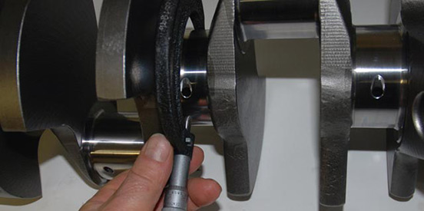
The first step in determining bearing clearances is to measure the crankshaft main journal diameter. Here we’re using an outside micrometer to get the measurement. The article text offers details on how it’s done and tips on using a mic. Check all crankshaft main bearings and record your figures.

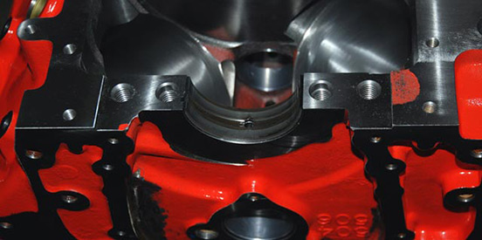
Next, install the main bearing insert for journal number one in the cylinder block. Note the orientation. The oil hole in the bearing half aligns with the oil hole in the main bearing.

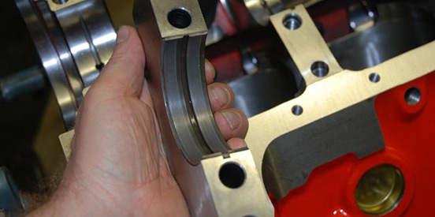
The matching bearing insert for the main cap is installed next. Because of the need for bearing crush, the insert will seem marginally too big, and a minute portion of the insert will protrude past the edge of the cap (the same applies to the insert in the block).

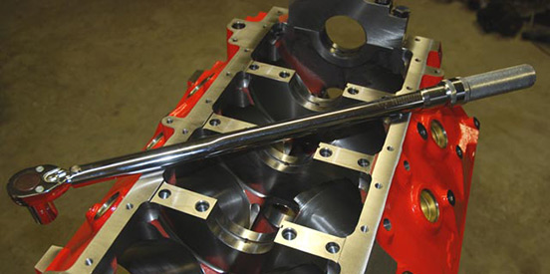
Install the cap and torque the main bearing cap to specs. Typically, we begin with the inside bolts and work outward. In addition, it’s best to use three steps on each of the fasteners in order to “sneak up” on the final torque figure.

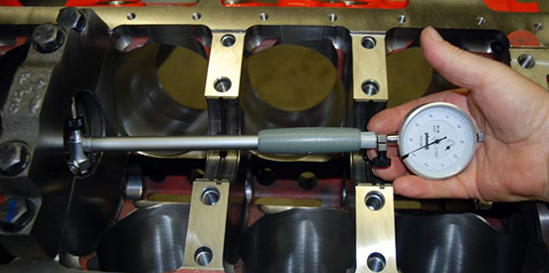
With the bearing installed in the cap and the fasteners torqued to specifications, you can measure the main bearing inside diameter. Here, we’re using a B&B Performance dial bore gauge for the measurement. Subtracting the crankshaft journal figure from this measurement provides the bearing clearance. Record all measurements and repeat this process for all bearings except the rear main.

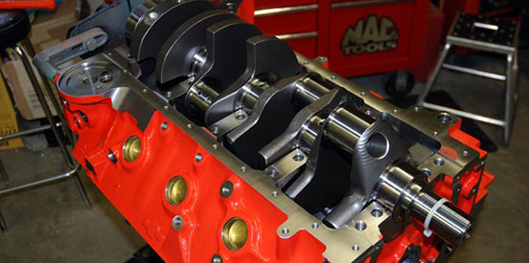
Before measuring the rear main bearing inside diameter, install the oil pump and torque to specifications. The reason is there is always the chance for some distortion of the cap once a heavy oil pump is installed. Here, a huge Titan G-Rotor oil pump is installed and torqued to specs.

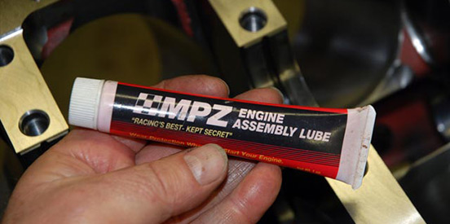
Once you’ve checked all of the main clearances (and they’re all within specification), you can install the crankshaft. You can use conventional engine oil for the installation or assembly lube. Apply a light coating to the lower main bearing halves.

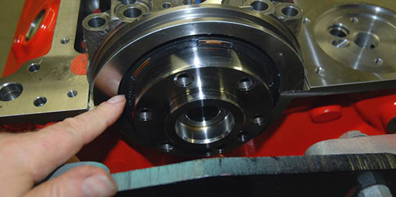
Next, the rear main seal is installed. With a one-piece seal such as this, it must be slipped over the rear of the crank prior to lowering the crankshaft into the block. The article text offers more detailed info, but in this photo you can see the installed seal.

With all of the lower bearing inserts in place, you can gently lower the crank into the main bearing saddles. You can reinstall the rear main bearing and cap along with the first (front) bearing cap.

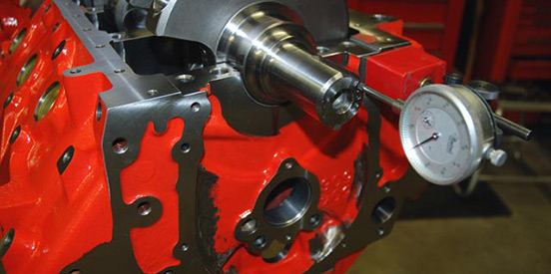
Checking the crankshaft thrust dimension is next. You’ll need a dial indicator setup to read front-to-rear movement on the crankshaft. Depending on how you choose to perform the job, the dial indicator can be set up on the nose of the crank or on the rear flange. For this job, we have access to the flange on the engine stand (it needs to be tapped with a hammer), so we set the dial indicator up on the nose. The text offers details on how this job is accomplished.

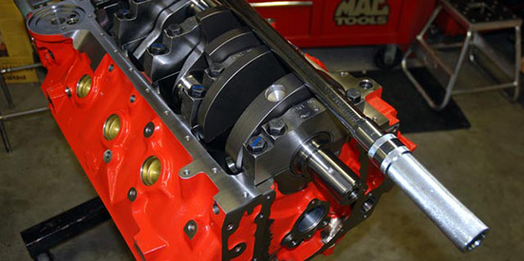
All of the main bearing cap bolts (or studs) can be torqued in place. We use a half-inch drive torque wrench for the job, and while we have three other torque wrenches in our tool collection, this long handle one makes torquing large numbers easy. What’s with the blue line on the outer row of bolts? It’s used to note which caps have been fully torqued. That way you can’t forget if you’re called away. We always double-check them.

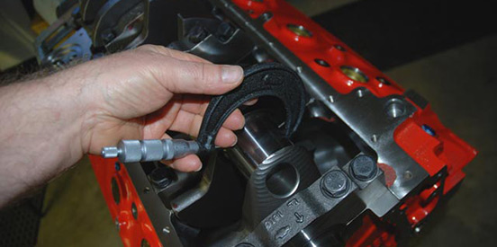
Measuring the rod bearing clearances is next. Here, the number one and two rod journals on the crankshaft are measured using a micrometer. Much like the main journal measurements, it’s a good idea to check in multiple places around the journal. This determines if the journal is in fact round. Repeat the process on all of the bearing journals and record the measurements.

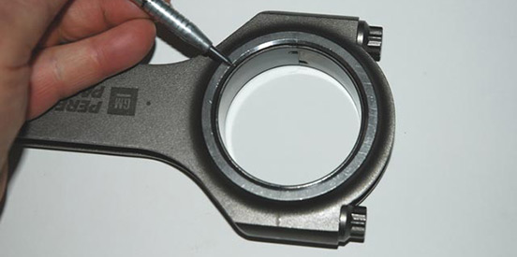
At this point, the connecting rod bearings can be installed. Note the chamfer on the bearing is designed to match the chamfer on the connecting rod. You’ll also note the bearing tangs are next to one another. If the connecting rod (and cap) is unmarked, this orientation ensures the cap is installed correctly. When assembling the engine, the chamfer faces the large fillet radius on the crankshaft.

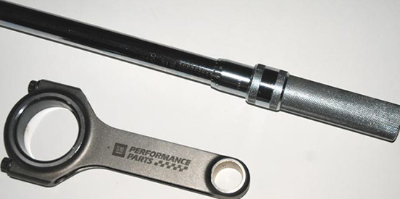
With the bearing installed and the cap correctly oriented, you can torque the connecting rod fasteners to specification. In this case, the GM Performance Parts connecting rods mandated 30W oil as the lubricant during tightening. Sneak up on the final figure just as you did with the main bearing caps.

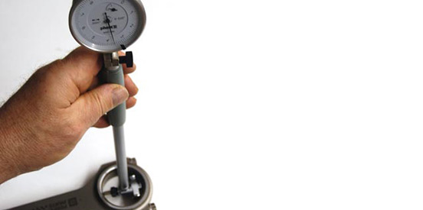
Here, we’re using our B&B Performance dial bore gauge to determine the inside diameter of the rod bearing (installed within the connecting rod). Once this figure is determined for each connecting rod, subtract the crankshaft rod journal dimension to determine the oil clearance. FYI, the best way to measure bores such as this is by way of a dial bore gauge.

Engine assembly: Fitting rods and pistons

By Wayne Scraba, automedia.com

Difficulty: Moderate

Estimated time: 300 minutes
Share
Email
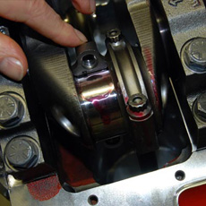
In our previous engine assembly article, we took a detailed look at checking bearing clearances for both the rod and the main bearings, checking the thrust dimension, installing the crankshaft, and torquing the main caps. In this segment, we’ll look at fitting piston rings, installing and locking (in place) floating wrist pins, and installing the piston-ring-pin-rod combination in the block. Essentially with this portion of the build complete, you’ll end up with a relatively complete short block, aside from the camshaft and cam drive.
Tedious but doable
Will you need special skills to reach this point? Absolutely not. Just like the other portions of the build, what you do need is the ability to check, double-check and triple-check your work. Sure, at times it can become tedious, but it’s also fulfilling. And, by the way, if you poll pro engine builders you’ll likely find they also find some of this stuff a bit monotonous, too. Follow along. This is a job you can accomplish.
Measuring and setting the piston ring end gap
Many modern high-performance piston ring sets are designed to be hand fit to each cylinder bore. These “file-fit” rings are manufactured 0.005-inch oversize (larger than the bore size), and it’s up to you to measure and set the end gaps. This only applies to the top and second rings in each ring set. The oil ring package cannot be file fit. Even in file-fit ring packages, the oil ring package is simply installed (more on this later).
The reason a compression ring is file fit in a high-performance engine is because the gap has an effect on performance. Too large a gap and cylinder pressure leaks through the gap, causing the engine to lose power. Too small a gap and the ring ends will butt together as the engine heats and expands. Ring gaps that are butted result in engine damage.
Fitting the gap
You have to run a gap that’s as tight as possible without having the gaps butted. Most engine builders will tell you that 0.004-inch of end gap per inch of bore diameter is a good rule of thumb for the top compression ring. Certain second rings are set a wee bit looser. This is all dependent upon the ring manufacturer and their specification.
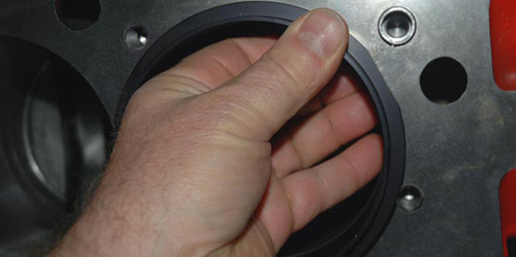
To measure the ring gap, you first have to install the individual ring into a specific cylinder (we typically begin with cylinder #1 in the engine firing order). The ring must be squared in the bore. You can accomplish this with the end of a dial caliper (the depth gauge portion at the back of the scale), but it’s far easier and more convenient to use a commercial ring-squaring tool. Here, the ring is inserted in the bore, followed by the squaring tool. Since the tool is hollow (see the accompanying photo), you just pull the ring back up square to the face of the tool, and you’re done. You can check the gap.

To check the gap, a common feeler gauge is used. Insert the feeler gauge in the gap (if one exists) to determine the dimension. If you’re beginning with rings that are 0.005-inch oversize then there’s likely zero gap (and the rings probably overlap).
To reduce the ring size (increase the gap), you have to file fit the ring. This is done with a ring gap tool. There are some very fancy, sophisticated gapping tools available, but they’re equally expensive (some run deep into the thousands of dollars). A relatively inexpensive and easy-to-find alternative is available from Sealer Power and other companies. It simply has a hand crank that turns a rotary carbide, which in turn trims the ring end gap. You have to go slowly: filing a small amount, checking the gap in the respective bore, filing some more and so on. The idea is to effectively “sneak up” on the gap. If the end gaps are excessive then you’ll have to purchase a new ring (or ring set). Once the gap is set, we gently de-burr the end gap with another small, fine hand file.
In the filing process, it’s a good idea to fit each ring a specific cylinder. As a result, you’ll end up (for example) with a custom-filed top ring and custom-filed second ring for cylinder number one and so on down the list. We simply mark a large white poster board with each cylinder number and set the gapped rings aside for (later) installation on each piston.
Wrist pins and retainers
Keeping the wrist pin in check within the piston is critical. If the pin moves sideways, then the cylinder wall will ultimately be destroyed. There are several means to keep a pin in check, the most common being a pressed pin (in the rod) or a full floating arrangement with some form of lock ring.
Pressed pins are regularly found in passenger car applications. Here, the pin is press fit into the small end of the connecting rod. The pin movement takes place between the wrist pin and the pin bore of the piston. Engines with press-fit pins must be assembled by an engine (machine) shop with special equipment designed for the task at hand. The process involves heating the small end of the rod. Next the piston is set in place over the rod small end and the wrist pin is pressed into place. It’s not a job for a home engine-builder.
Floating pins, on the other hand, are often found in high-performance engines. Here, the pin is allowed to float within the connecting rod small end. Instead of being pressed in place, the wrist pin is held in check with one of three types of locking devices: spiral locs, round wire locks or snap rings (regularly called “Tru Arcs”). Pistons are machined with retainer grooves (some for double retainers per side) that accept the locking device. The most effective device of the bunch is the Spiral Loc (essentially a flat coil of hardened steel), but it’s also the most difficult to install.
The conventional way to install a set of Spiral Locs is to use a pair of small screwdrivers to literally spin the lock wire into place (into the groove machined in each end of the piston pin bore).
Basically, you start at one end (without the wrist pin or rod in place), turning in both Spiral Locs (one after the other). Next, the wrist pin and piston are assembled on the connecting rod. At that point, the remaining two Spiral Locs are worked into place. Most folks will tell you to keep a box of bandages handy with this job. Good advice.
Tru Arcs are essentially heavy-duty snap rings that install by way of snap-ring pliers. Round wire retainers aren’t that common, but there are tools available to install them (more in the photo guide). In any case, never reuse a pin retainer of any sort. Once used, they can become distorted (particularly from the removal process). Tension is lost and you run the risk of the retainer being damaged or destroyed during engine operation.
Installing piston rings
Once the piston-pin-rod combination is assembled, it is time to install the piston rings. Here, it’s a matter of winding the rings onto the pistons. In times past, piston rings were thick, higher tension affairs than we commonly see today. Some folks installed the rings on the piston by way of a special set of pliers. Today, with lighter tension (and regularly thinner cross section) piston rings, it’s easy to assemble them on the piston.
Start with the oil ring expander. It doesn’t matter which direction it faces. Simply wrap it over the piston and insert in the oil ring groove. Next, carefully wind on the oil ring scraper rails. One goes to the bottom of the oil ring groove; another to the top. Each gap on the oil ring (expander and the pair of upper and lower scraper rails) should be positioned 120 degrees away from each other. You have to be careful with the expander since they have a tendency for the ends to overlap. Once installed, the oil ring package (expander and the pair of scraper rails) should be able to easily float from side to side in the groove. Double-check the expander before the piston is “pushed” into the bore (more on this later).
Next, the second ring is installed, followed by the top ring. If you examine the ring package, you’ll find a set of “pip” marks on both the top and the second ring. These pip marks are always installed facing up. Once installed, rotate the gaps so that they don’t coincide. Keep in mind, however, that rings actually spin within the piston groove. Keeping the gaps separated minimizes the amount of oil fouling that can occur during initial engine fire-up.
Installing the pistons and rods
Wipe the cylinder bores with a clean, lint-free towel and apply a small amount of conventional (non-synthetic) oil to the walls. We always apply a liberal amount of oil to the wrist pins and piston rings as well. There’s a caveat here though: You don’t need to drench the piston in oil. You only need sufficient oil to lubricate the rings as they pass through the piston ring compressor.
There are two common types of ring compressors on the market: expander types where the tool is clamped over the piston and you tighten it in place and a tapered job where the rings are progressively tightened as the piston is pushed through it into the bore. In either case, liberally coat the compressor with oil (again, it doesn’t have to be dripping wet).
Rotate the crankshaft so that the rod journal is at Top Dead Center for the piston you’re installing. Place the piston/ring compressor combination over the cylinder bore. You have to be positive the piston is correctly oriented. For example, if the piston is domed, the dome is on the outside of the block or the valve notches are at the top (nearest the lifter valley). Additionally, be sure you’ve assembled the piston-rod combination correctly so that the chamfer on the connecting rod (and rod bearing) faces the fillet radius on the crankshaft. Finally (and as mentioned previously), double-check the oil ring(s) to ensure the expander ring end gaps haven’t overlapped.
If the connecting rod is equipped with studs, cover them with protectors (most auto parts stores sell inexpensive jobs) or use a length of rubber tubing over the studs. The idea here is to prevent the rod studs from damaging the crank during installation. We also coat the connecting rod bearing with assembly lube.
At this point, you should be able to push the piston and rod assembly into the bore, simultaneously guiding the rod so that it falls in place over the crankshaft rod journal. In most cases, you can hand push the piston in. In others, a very light tap with the handle end of a clean plastic hammer handle works. The need for excessive force means the oil ring isn’t installed correctly.
Rotate the engine on the engine stand. Coat the rod bearing (cap end) with assembly lube and install. You can torque to specs at this point, using three steps to sneak up on the final assembled torque. Slide the rod from side to side. It should move easily. Repeat the process for all of the pistons and connecting rods. Double-check the final torque figures (we usually make it a practice to check them three times).
Wrap the engine in the plastic storage bag. You’ve completed this segment of the build.
Tools used:
- Piston ring filing tool
- Piston ring squaring tool
- Tapered piston ring compressor
- Crankshaft socket-half-inch drive
- 1/2-inch drive ratchet
- 1/2-inch drive torque wrench
- Deadblow hammer
- Feeler gauge set

Photo guide

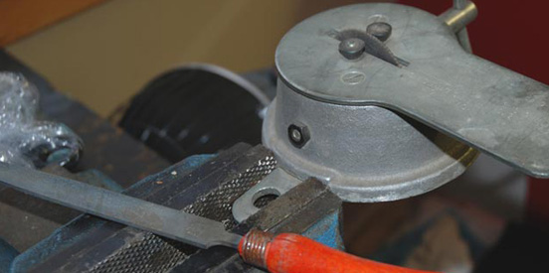
Filing piston rings to fit isn’t new. It’s been a performance item for more than three decades. It’s not a tough job either, but you have to take your time. We use this ring filer from Sealed Power to get the job done. There are much more exotic machines out there, but this one accomplishes the job for little cost. The downside (in comparison to some of the three-digit-cost jobs) is that you must grind small amounts, check, regrind and so on until the correct gap is reached.

In the article, we mentioned the use of a ring-squaring tool. Here’s the B & B Performance model in action. To recap, the piston ring is installed in a given bore. Next, the ring-squaring tool is placed over the bore (and into it – the tool has a machined step on the ID). You simply pull up on the ring, squaring it against the tool.

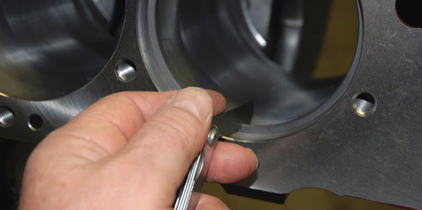
Once the ring is square in the bore, you can check the gap. Here, a common (but high-quality) feeler gauge is used to check the gap.

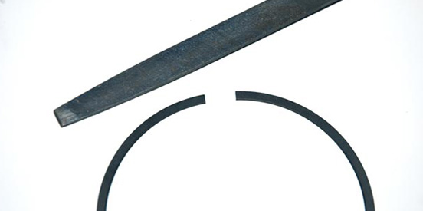
Once the gap is set, it’s a good idea to very lightly de-burr the ring with a small, fine-tooth file. What you want to do is to gently remove the sharp ends the filing process creates.

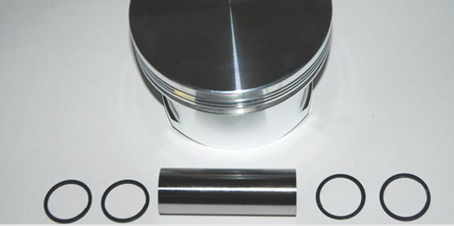
With the rings filed, it’s time to assemble the piston-wristpin-connecting rod package. Key components shown here are the pins, Spiral Loc retainers and, of course, the piston.

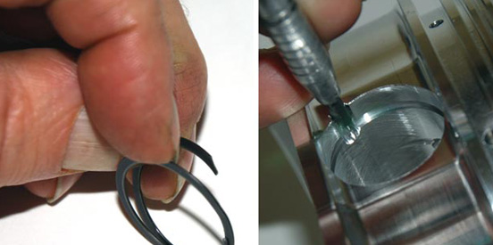
Here’s a closer look at the Spiral Loc pin retainer along with the lock ring groove machined into the CP piston. The idea is to wind the lock into the groove.

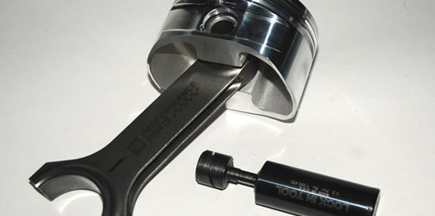
In this photo, you can see the rod, piston, pin and a special tool that’s designed to ease the pain of Spiral Loc or round wire retainer installation.

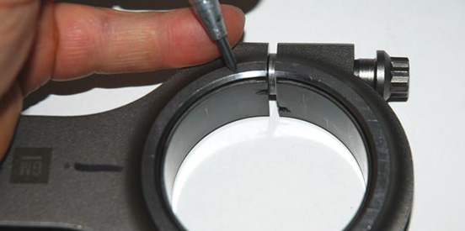
During assembly, you have to ensure the piston and connecting rod is properly oriented. This means the rod big end side (and bearing) with the large chamfer must face the crankshaft fillet radius. The piston notch(es) must also be oriented correctly.

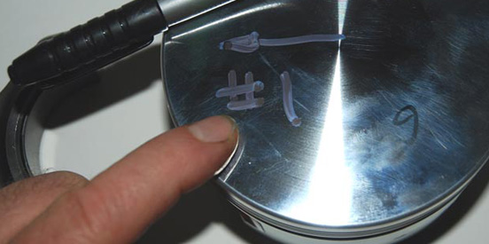
As you can see, marking the piston surface with the bore number and the direction of installation (arrow faces forward) makes for easier assembly.

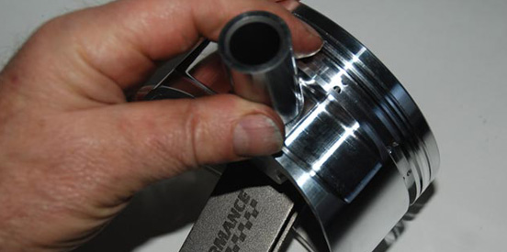
Lubricate the pin and install. Follow up with the appropriate remaining wrist pin retainers and the combination is ready to install.

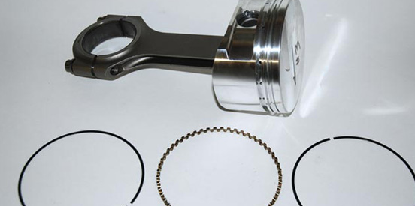
Next is the installation of the ring package. It sounds difficult and there are plenty of old tales regarding it, but it’s not that difficult. Today’s low-tension rings make installation rather simple. The article offers full details on the process.

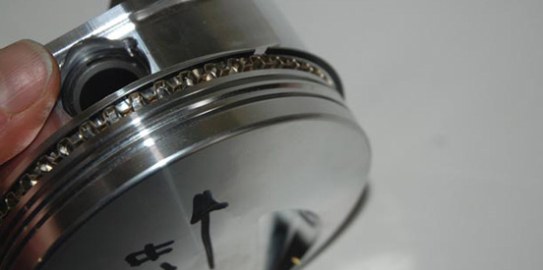
The oil ring expander is installed followed by the oil ring scrapers. The only trick here is to make sure the ends of the expander don’t overlap.

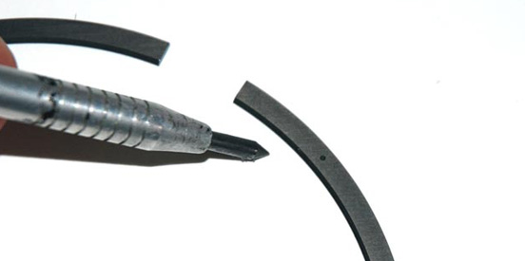
The second and top rings can be installed next (in that order – you install rings from the bottom up). Note the hollow “dot” on the ring? That’s a pip mark. Pip marks are generally installed pointing up. The top and second rings usually have them.

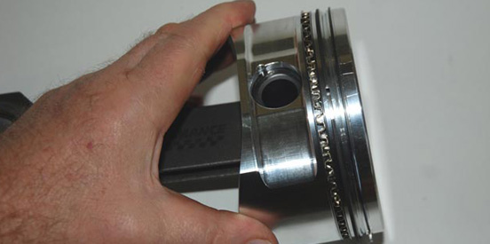
Here’s the assembled piston ring package. Prior to installation, it’s a good idea to separate the respective ring gaps (top, second and oil). Most engine builders concur that a spread of approximately 120 degrees between the gaps is right (a third of the way around the piston).

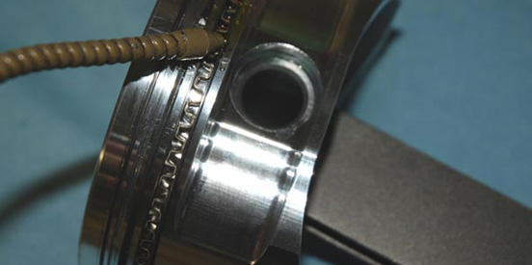
Lube the ring package using conventional (not synthetic) motor oil. We use assembly lube on the bearings. Keep in mind you don’t need to shove the rod into a pail of oil. Sufficient oil to keep the works from binding during installation is all that is necessary.

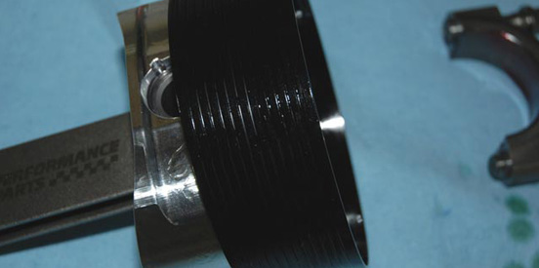
In this photo, the piston package has been inserted into a tapered ring compressor (this is a very nicely machined high-quality piece, as is their ring-squaring tool). What it does is slowly compress the rings on the piston as they go down into the bore. This tends to eliminate ring hang up as the piston is installed. We always double-check the ring orientation (including the oil ring expander) as it goes through the compressor. It’s also a good idea to lube the ID of the tapered compressor with engine oil.

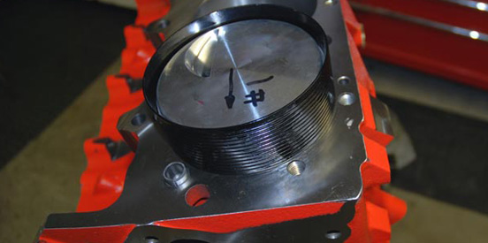
This photo shows the piston skirt and rod inside the cylinder bore with the compressor on the block deck surface.

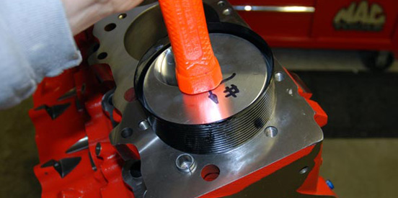
You can often push the piston through the compressor with your fingers, but in some cases, a very light tap with the (clean) end of a hammer handle can be used to get things moving.

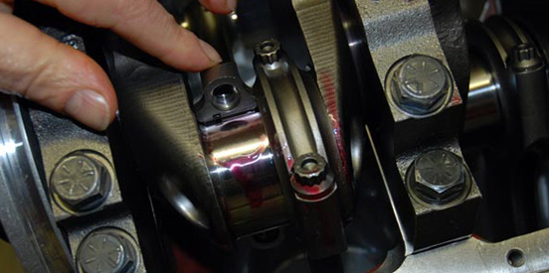
On the bottom side, you have to carefully guide the connecting rod over the crankshaft journal. The red fluid is engine assembly lube. Keep in mind it is quite easy to damage the crank, particularly when using connecting rods with studs. More info is in the main article above.

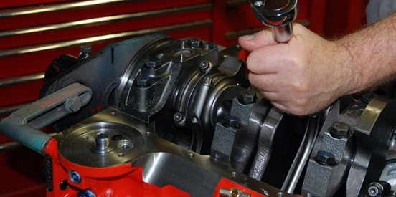
Tighten the rod bolts (or nuts, depending upon the configuration) and then torque to specification. Typically, we use three steps to work our way up to the required torque figures.

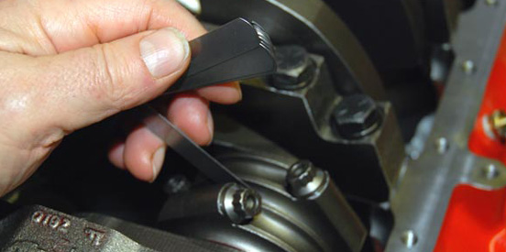
While not covered in the article, it’s a good idea to check the connecting rod side clearance. To do this, a feeler gauge is simply inserted between the respective connecting rod pairs. Factory service manuals regularly spell out a tolerance range for this me

Engine assembly: Installing the cylinder heads

By Wayne Scraba, automedia.com

Difficulty: Moderate

Estimated time: 240 minutes
Share
Email
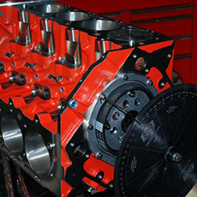In our previous engine assembly article you’ve learned about fitting rods and pistons. In this portion of the engine assembly, we’ll look at cylinder heads and head installation. There are some words of caution here: If the engine has a roller camshaft (that requires considerable valve spring pressure), or has a set of stiffer than normal high-performance valve springs, you should exercise extreme caution if you decide to perform the assembly at home. We don’t recommend it. Springs under tension are extremely dangerous, and we’ll explain it further in another portion of the article. Aside from physically assembling the cylinder heads, installation is very, very straightforward. If you can tighten bolts and know how to operate a torque wrench, then it’s a piece of cake. Check it out.

Head assembly
Virtually all engine machine shops or cylinder head manufacturers will assemble the heads for you (as is the case with the engine build series cylinder heads). There’s good reason for this: They have the tooling and the expertise. But what follows is a look at how the assembly is accomplished.
When the machine shop rebuilds or blueprints your cylinder heads, the process of grinding the valves and grinding the seats will effectively sink the valves deeper into the cylinder head. What this does is change the installed height of the valve spring. Valve spring installed height is the distance from the base of the valve spring pocket on the cylinder head to the outer spring lip on the valve spring retainer.
Measurements to determine the valve spring’s installed height can be made a number of ways, but by far the easiest is with Crane Cams’ height micrometer. What it does is take the place of the valve spring in the cylinder head. The retainers and valve locks are installed, then the tool is tightened until it reaches installed height – basically, as far as it will go. Compare this dimension to the spring manufacturer’s specification.
How to adjust installed height
So how do you adjust installed height? Small adjustments are made by way of shims placed under the valve spring. Note that aluminum heads all require at least one hardened shim in order to prevent the spring from damaging the soft aluminum in the spring pocket. What happens is that the sharp, hard end of the spring erodes the softer aluminum cylinder head material. When you add shims, the installed height is reduced. If the installed height needs to be increased, there are two choices available: Increase the depth of the spring pocket or install valves with longer stems. Of the two, the use of valves with longer stems is much preferred. The reason is that cutting into the head to increase the spring pocket depth can weaken the head or inadvertently cut into a water jacket.
On a street-driven engine, valve stem seals are absolutely critical. Any oil that burns within the cylinder reduces engine power, fouls spark plugs and creates considerable tail pipe emissions, as we all know. To prevent oil from being drawn into the cylinders past the valve guides (as the piston goes down in the bore, it creates a vacuum), some form of valve stem seal is required.
Quality high-performance seals most often have a spring that holds the seal in place (by surrounding the seal). The sealing material is often Teflon® or another low-friction material. Some valve stem seals mandate that the valve guide OD (and sometimes the height) is machined to a specific size to accept the seal. Others are designed to install over the stock valve guide. In either case, the valve stem and the inside of the seal should be well lubricated. Many seals are supplied with a plastic installation tool that facilitates the installation. The seal must be carefully slid over the valve stem lock (keeper) grooves. The tool is placed over it and then lightly tapped in place over the guide with a small hammer.
Remember when we mentioned the dangers of installing valve springs? Here’s why: Today’s high-performance valve springs should be installed by an experienced machine shop. The reason for this is that the increased valve spring pressures found today mandate specialized tools (for example, a heavy-duty valve spring compressor, often air powered). Springs are under hundreds upon hundreds of pounds of pressure when compressed. If you make one miniscule error, the spring can physically launch off the cylinder head at what amounts to critically high speeds (some equate it to a bullet). That’s why a pro should install them.
Nonetheless, before the springs are installed, the head must be clean. Grit can enter the combustion chamber by way of the guides. Lubricate the valve stems with assembly lube and add the appropriate shims. As the spring is installed, it should only be compressed sufficiently so that you can install the valve stem locks (keepers). To keep the locks in place during the installation, it’s a good idea to coat them lightly with engine assembly lube or even a small amount of grease.
Installing the head gasket
Clean the cylinder block deck surface. Typically, we spray a small amount of brake cleaner on a lint-free shop towel and wipe the deck clean. Ensure the cylinder head dowels are in place on the deck surface. Following the head gasket manufacturer’s specifications, install the gasket. Some composition gaskets such as the Fel Pro Permatorque MLS shown in the accompanying photos do not require any special sealers and, as the name suggests, they do not require a hot re-torque. Some gaskets mandate a small bead of silicone be applied around the water ports in the deck surface. Other gaskets require sealers to function properly. In any case, the gasket can now be placed over the head dowels on the deck. Most gaskets are designed to either fit one way or with the part numbers facing up (toward you).
Installing the cylinder heads
Clean the cylinder head deck surface using the same process as used on the block deck surface. Rotate the engine on the engine stand so that the deck you’re working on is parallel to the floor. Carefully place the cylinder head on the deck, over the head gasket. Be sure the heads fully engage the alignment dowels and are flush with head gasket.
Before the cylinder head bolts are installed, be certain you have the right mix and length of fasteners. With the cylinder head installed, hand thread each head bolt into the block deck to determine the length is correct. In our case, we used ARP head bolts with hardened washers (which have an effect upon the installed length). Our big block example uses 16 head bolts in three different lengths per cylinder head.
Once the number of bolts and length is determined, you can install the fasteners. We always wipe the fasteners clean and follow the manufacturer’s installation instructions. Some engines (where the head bolt enters a water jacket) mandate a thread sealant on the bolts. Others such as our sample engine have blind holes in the deck. That means the bolts do not enter the water jacket and as a result, sealants are not required. Companies such as ARP provide a special assembly lube with their head bolts. Apply the assembly lube to the bolt threads as well as the area between the head bolt and the head bolt washer. You’ll note the head bolt washers are machined on the ID. The machined side faces the hex on the head bolt.
Torque the fasteners
Head bolts (or studs) should be torqued in three steps of equal value. They should also be torqued in the right sequence. The manufacturer of the engine you’re working on will definitely have a torque specification along with a sequence of which fasteners to torque in which order. Generally speaking, the sequence begins in the center of the engine and works outward.
What we try to do is to split the specified torque into three. For example (and this is only an example), if the engine manufacturer specifies the torque as 90 foot-pounds, we’d begin by setting the torque wrench at 30 foot-pounds and then go through the torque sequence. Next, we’d adjust the torque wrench to 60 foot-pounds and go through the torque sequence. Finally, we’d set the torque wrench to 90 foot-pounds and re-torque once more, following the sequence. Repeat the entire process on the second cylinder head and you’re done.
Install rocker arm stands
Conventional stud mount rocker arms are installed after the lifters are dropped into the lifter bore. Next, a pushrod is set in place and then the rocker arm can be installed on the rocker stud. It’s a simple process, and we’ll show more of it in the final segment.
A shaft rocker, such as the Jesel setup shown in our build, is a little different. It functions by way of a small shaft bolted to a stand. These stands are held in place by two torx-head capscrews along with a special link stand. First the link stand is set in place, followed by the actual rocker stand. Typically, the rocker stand for the intake differs from the one on the exhaust side. You have to be careful during the installation to ensure the right stand goes on the right rocker boss on the cylinder head.
On an engine such as the big block Chevrolet shown in the accompanying photos, two different length torx capscrews are used. You should use the longest bolt possible, but be sure to inspect the ports. In some cases, if a long capscrew is used, it will protrude through an intake port. If it does, switch to the shorter (supplied) torx fasteners. On cylinder heads where the capscrew (or the rocker arm stud) enters the intake port, you’ll have to use some form of thread sealant on the fastener threads.
Do not torque the stands in place at this time. You’ll have to complete the installation once the lifters and pushrods are installed. More in the next and final segment. In the meantime, cover the engine. You’ve almost reached a finished powerplant.
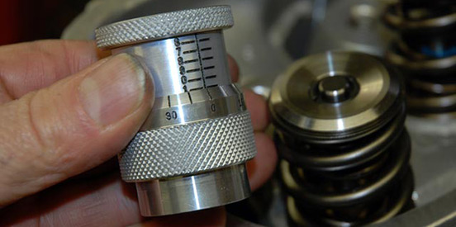
Here’s the valve spring assembly tool we mentioned in the text. It’s a height micrometer designed for use with (obviously) valve springs. Crane Cams manufactured this one. Essentially, it takes the place of the valve spring on the cylinder head as it is mocked up. Turning the micrometer (note the graduations) determines the installed height of the valve springs.

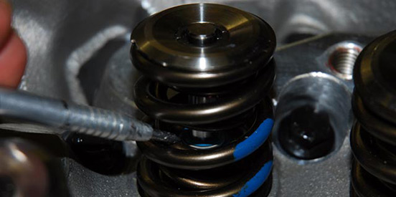
Take a close look at the pointer. See the blue piece with the little spring inside the valve spring? That is the valve stem seal. A seal is installed on each valve for a street-driven engine combination. Obviously, seals are installed as the head is being assembled.

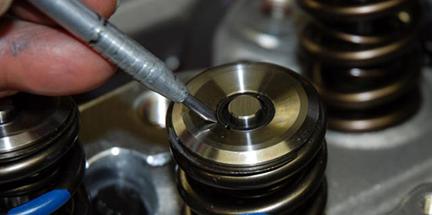
Once the valve springs are compressed, the valve locks (or “keepers”) can be installed. Often they’re fussy to install. It’s easier if you add a little dab of grease to hold them in place as a valve spring compressor is being operated (although keep in mind that it’s advised to have a pro shop handle the head assembly when dealing with large valve spring pressures).

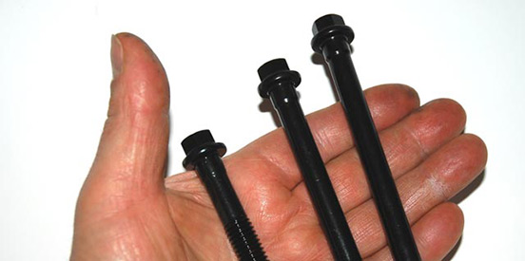
In many engines, you’ll discover there are different head bolt lengths. Be sure to sort and count them before the engine is assembled.

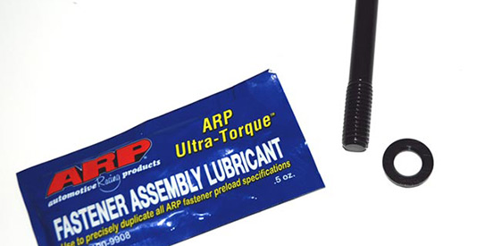
Companies such as ARP include fastener assembly lube with their head bolts. Apply a small amount to the fastener threads along with a small amount to the washer. The lube should be included on the side of the washer that comes in contact with the bolt head. FYI, a small amount of lube goes a long way here.

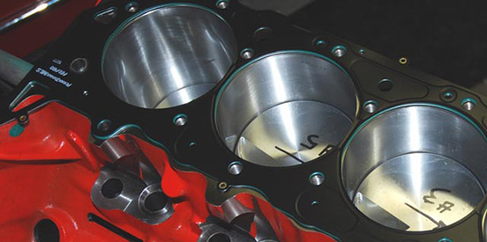
Head gasket installation is rather simple. In most cases, the gaskets can only be installed one way. In other situations, the gasket is installed with the lettering facing up. Before installation, clean the cylinder block deck surface with brake cleaner and a lint-free rag.

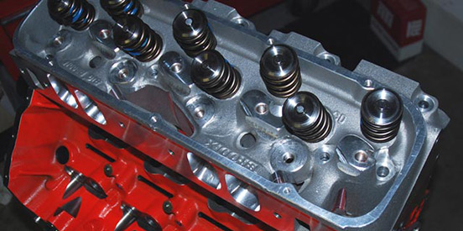
The cylinder head can be dropped on the dowels. Before you drop it in place, be sure to clean the head deck surface. We use a small amount of brake cleaner and a lint-free towel to wipe it clean. Here, the Brodix “Xtra O” heads are installed. Always double-check to make sure the heads are, in fact, dropped over the dowels.

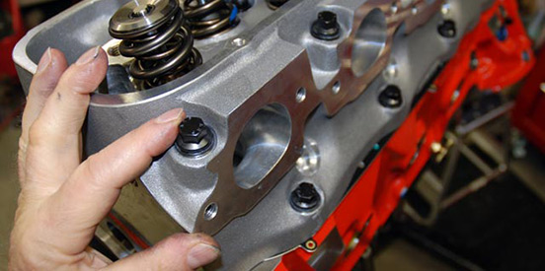
Before torquing the cylinder head bolts, make it a practice to hand tighten each fastener to ensure it doesn’t bottom out. You’ll note here that we’ve hand tightened each fastener and checked the length on all of them. It takes some time to do this (taking into account an engine such as ours has 32 head bolts), but it’s better to be safe than sorry.

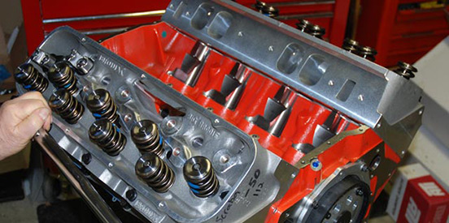
You’re ready to torque the head bolts in place. The text offers more info, but the idea here is to “sneak up” on the torque in three approximately equal steps. In addition, you should follow the factory sequence when torquing heads.

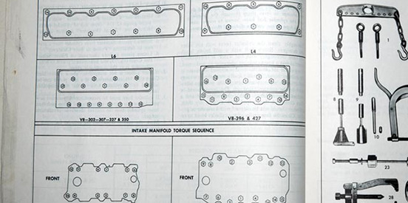
Here’s a photo of a Chevrolet shop (overhaul) manual showing the torque sequence for various engines. Essentially, it’s a practice of starting in the center and working your way out.

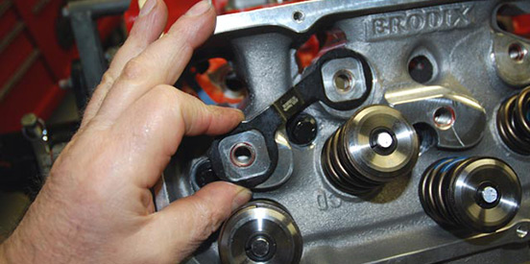
Once both cylinder heads are torqued in place, you can partially install the shaft rocker arm mounts (if the engine is so equipped). Here, we’re installing the Jesel rocker stand link to the rocker boss on the Brodix cylinder head.

Engine assembly: Completing the assembly

By Wayne Scraba, automedia.com

Difficulty: Moderate

Estimated time: 240 minutes
Share
Email
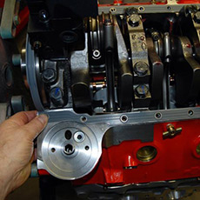
In our last segment, we buttoned up the top end of the engine (cylinder heads). Essentially, we constructed a complete "long block." This time around, we'll complete the engine assembly with rocker installation, intake, carburetor and so on. By the way, the homestretch is very simple. There are a few special tools you'll need, but there's nothing here that's extravagant. And like we've stated in the past, if you can tighten bolts and know how to operate a torque wrench, it's pretty much easy street. Take a look.
Lifter installation
If you can apply lubricant to the body of a lifter, you can install it. Essentially, you should apply motor oil (liberally) to the lifters. Slip the lifters into their respective bores. If the engine is equipped with roller tappets, install the lifter pairs with the associated connecting links. Today, most connecting links are permanently attached to the lifter body, and in most cases the lifters are positioned with the links facing the center of the lifter valley in the cylinder block.
Pushrod installation
In most cases, the pushrods simply drop into a guide plate of some sort in the cylinder head, with the lower end fitting directly into the cup of the lifter. The top end fits into the matching rocker arm. It's a simple install.
On the other hand, if the engine is modified with items such as a small base circle camshaft, non-stock cylinder heads, non-stock rocker arm mounting positions, severely milled deck (or head) surfaces, longer-than-stock valves, the use of valve lash caps and other factors, then you may need to establish the correct pushrod length.
Even in a normal situation (where the geometry hasn't changed due to the factors mentioned above), the tip of the rocker arm tends to sweep across the tip of the valve. If the geometry has changed and the pushrod length is not optimized, the amount of movement the rocker sees across the valve tip is considerable.
To check the geometry and to establish correct pushrod length, you'll need a checking pushrod. There are several available. We have one from Crane Cams. First, turn the engine over until the rocker arm/pushrod combination you're checking is on the base circle of the cam (both valve closed). With the rocker removed, coat the tip of the valve with a black felt marker. Reinstall the rocker arm.
Move the rocker so that a mark becomes visible on the tip of the valve. If the geometry is correct (and the pushrod length is correct) then the mark you see on the valve tip (made possible by rubbing away the felt marker "paint job" you made) should be located approximately one-third of the way across the tip, on the inboard side (toward the intake manifold). If the mark is in the center of the valve tip or if it is closer to the exhaust (header) side of the valve tip, the pushrod is too long. If the mark is closer than one-third the distance to the intake manifold, the pushrod is too short.
To establish the right pushrod length, you'll need the adjustable "checking" pushrods mentioned previously. Install the checking pushrod in place of the conventional model. The adjustment feature allows you to lengthen or shorten the pushrod as necessary. Repeat the "paint the tip" and check the scrub mark with a longer or shorter pushrod length. It's a matter of trial and error (shortening or lengthening the adjustable pushrod) until you arrive at the length where the scrub line on the valve tip is correct. At this point, measure the adjustable pushrods so you can determine the optimum length. You can now order the right pushrods (length) for your application. Once they arrive from the manufacturer, it's a good idea to double-check the length (and the geometry) before slipping them into place.
Rocker arm installation
Conventional stud mount rocker arms simply install over the rocker studs and are most often held in place by way of a lock nut. When installing conventional rockers, you should double-check the fulcrum. Most roller rockers are designed with a machined flat that mates with the rocker adjuster nut. Be sure the machined flat is correctly oriented. Apply a small amount of engine assembly lube to the pushrod tip. The engine will have to be rotated through a complete cycle so that all of the rockers are installed while the cam is on the base circle. All that remains is to install the rocker and to set the valve lash. (Refer to your cam manufacturer specification card for the valve lash figure and to the engine manufacturer specifications for the valve lash procedure.)
When it comes to shaft mount rockers, the installation isn't much more difficult. With pushrod length verified, torque the stand bolts to specifications. Next, apply assembly lube to the pushrod tip and bolt the rocker to the rocker stand. Torque the rocker shaft bolts to specifications. Keep in mind the engine has to be rotated through the cycle so that the rockers are installed with the cam on the base circle. Set the lash, and you're done.
Intake manifold installation
There's no question an intake manifold is an important piece of the high performance puzzle. If installed improperly, they can definitely have a negative effect on performance. The best plan is to test-fit the intake manifold to ensure that it will actually work on your engine (things like cylinder head and block milling have an effect on manifold fit). Here's how it's done.
Place a dry intake gasket on each side of the heads and lower the manifold in place. In some applications, you use a light to peer down the port to check alignment. In other cases, you can feel the fit by using a piece of wire to probe the port alignment by way of the plenum (a stiff piece of mechanic's wire or a coat hanger will work). You should also check the end gaps at the front and rear of the manifold where the intake attaches to the block valley. There must also be a small gap at the front and the rear.
Remove the intake and carefully clean the gasket mating surfaces with brake cleaner (or solvent). Apply a bead of RTV silicone sealer along both of the ends of the lifter valley (the front and rear of the engine). Next, install the intake manifold gaskets on the cylinder heads. A small amount of gasket adhesive can be used to ensure the gaskets do not move as the intake is installed. Carefully lower the intake in place, setting it straight down the valley on the respective gaskets. Do not attempt to slide the manifold from side to side or from front to back. This can create gasket misalignment. By the way, this sounds more difficult than it really is. You simply have to line up the bolt holes in the intake with the threaded holes in the cylinder heads.
Hand thread all of the intake bolts into the cylinder heads. Much like the cylinder heads, there's almost always a specific torque sequence used to tighten intake bolts. Typically it begins from the center and works outward. Consult a factory manual for specs on your specific powerplant. Much like the cylinder head torque sequence, begin the process with one-third (approximately) of the specified torque. Repeat the torque sequence three times (this is often necessary in order to get the manifold gaskets to compress fully).
Oil pump installation
Before installing the oil pump, the driveshaft must be installed. With the engine upside down (crankshaft facing up), it simply drops into place. You can now install the pump. Some pumps such as the big Titan model in our photos use a stud as a fastener. The stud is first installed on the rear main cap, followed by the pump. Then the nut (or bolt, depending upon your application) is torqued to the factory specification.
Oil pan installation
If a windage tray is used in your particular application, there's a good chance it bolts onto special studded main cap bolts (see the accompanying photos for a closer look). Here, it's simply a matter of dropping the windage tray over the studded main cap bolts and tightening the locknuts. Torque to factory specifications.
Next, apply a thin bead of RTV silicone sealer to the oil pan flange on the cylinder block. If equipped with a multiple-piece gasket (common on earlier engines) install the neoprene end seals first, then install the side pan rail gaskets. Apply another thin bead of RTV silicone to the top of the end seals and pan rail gaskets. Alternatively, if the oil pan gasket is a one-piece affair, simply drop it into place. Install the oil pan and tighten the bolts evenly. Double-check the torque specification in your factory manual.
Harmonic damper installation
The harmonic damper (often called a "balancer") is engineered to fit tightly onto the crankshaft. Installing it or removing it can prove troublesome. To ensure you don't have excessive grief, coat the crankshaft snout with anti-seize compound.
The other part of the puzzle is the actual installation. You can't hammer it on. And never use a bolt to install the balancer or you may pull or damage the threads in the crankshaft snout. You have to pull it on. What you'll need is a special tool for the job. We have two of them: One is a vintage GM Kent-Moore tool while the other is from the folks from B & B. In either case, they work in the same way. The body of the tool is a large "stud," and it is screwed into the threads in the crankshaft snout. The damper is slid over the tool body. Next, a special flange with ball bearings is placed against the body of the damper.
With our tools, a five-eighth-inch wrench is used to keep the stud and the crankshaft from turning. A large 1 3/8 nut is used to press the balancer over the crankshaft snout. We don't have a wrench that large, so we use an adjustable crescent wrench for the job (which is perfectly acceptable). By turning the big nut, the damper is slowly and evenly pulled onto the crankshaft. Once it seats against the crankshaft, install the harmonic balancer bolt and washer. Torque the bolt to the crankshaft manufacturer's specifications.
Distributor installation
Before the distributor can be installed, the crankshaft must be rotated until the #1 cylinder begins the compression stroke. This can be determined by watching the valves (rockers) on the #1 cylinder. If both valves are closed, or alternatively if you feel compression escaping from the #1 spark plug hole, slowly rotate the crankshaft until the timing marks on the damper show the correct initial timing (base timing setting).
Next, install a gasket over the end of the distributor gear, and install the distributor shaft into the distributor hole. Select one tower on the distributor cap that will have the #1 spark plug wire connected (usually one that faces forward toward the front of the engine). As the distributor gear meshes with the camshaft gear, you'll find there will be several engagements that work. Pick one where the distributor rotor points directly at the #1 tower of the distributor cap. Simultaneously, you have to ensure that the oil pump shaft is fully engaged. If it isn't, the distributor won't engage fully (and in most cases, the shaft collar won’t drop to the base of the intake manifold). The bottom line: It might take several tries to get the pair of gears and the oil pump shaft to all engage properly. In some cases, a large screwdriver can be used to turn the distributor shaft slightly so that it meshes properly with the distributor.
Install the distributor hold-down clamp, but allow the hold-down bolt to be slightly loose. This will let you advance or retard the spark (ignition) timing as necessary (set after the engine is running). Be sure to follow the manufacturer's recommended procedure for setting the initial spark timing.
Carburetor installation
Carburetor installation is very simple. Install a set of appropriate carburetor studs into the intake manifold (usually a double nut process will be necessary to install the studs). Slip a carburetor base gasket over the studs. Drop the carburetor in place and gently tighten the nuts on the carburetor studs. Usually a crisscross pattern is used to tighten the fasteners. Just don't overdo it. It's easy to crack a carburetor base plate by being too zealous with the fastener torque.
Add the oil pan of your choice (oil pans are typically configured for both the engine and the vehicle chassis). Install your favorite valve covers (ensuring they have sufficient height to clear the valvetrain and an air cleaner of your choice. Aside from a few accessories (vacuum lines, PCV valve, breathers), you're done!
Tools used
- Adjustable pushrod
- Oil pump primer
- Wire crimper
- Crankshaft installation tool
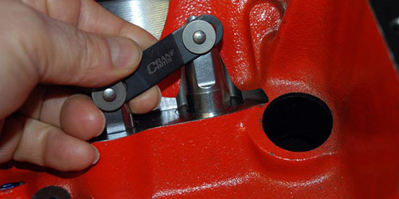
Lifters should be lubed prior to installation. It doesn't matter if they're mechanical rollers (such as these Crane models shown here) or very simple flat tappet models. A good coat of 30W oil is all that's necessary.

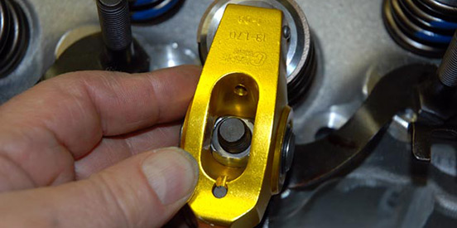
Rocker arm installation isn't difficult, particularly with stud mount rockers such as these extruded aluminum Crane roller versions. The rocker simply slides over the rocker stud; however, the fulcrum must be correctly oriented. See the next photo for more information.

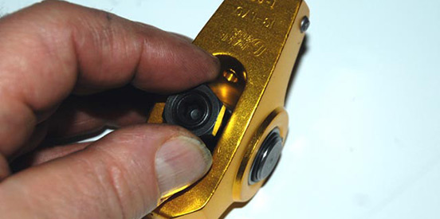
Note the flat on the fulcrum. That's where the rocker adjuster (commonly called a "Polylock") seats on. It must be oriented this way.

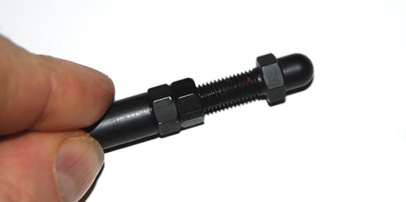
Before any rocker can be completely installed, it's a good idea to check the pushrod length. We use an adjustable pushrod tool to determine the length. Once the appropriate pushrod length is determined, you simply measure the adjustable pushrod and order a set made to length.

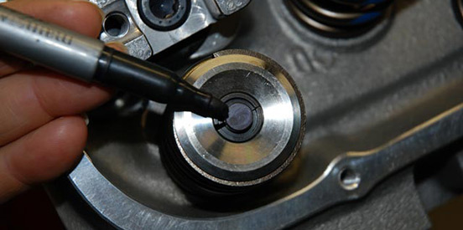
To check rocker geometry (and to determine pushrod length), first coat the valve stem tip with a felt marker as shown here.

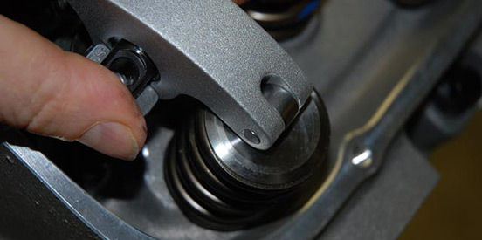
With the checking pushrod in place (camshaft on the base circle), install a rocker. Next, move the rocker from side to side while pushing down. The idea is to make a witness mark on the top of the valve stem.

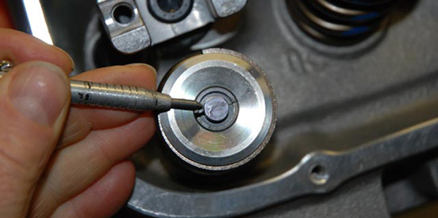
Remove the rocker and examine the mark. As pointed out in the text, you want the witness mark to be approximately one-third of the way up (toward the camshaft).

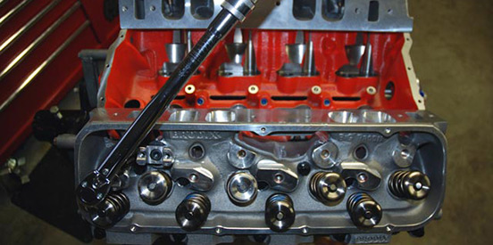
Once you've checked the pushrod length (if necessary, wait until your new pushrods have arrived), you can complete the rocker arm install. In this photo, the rocker stand is torqued to specification.

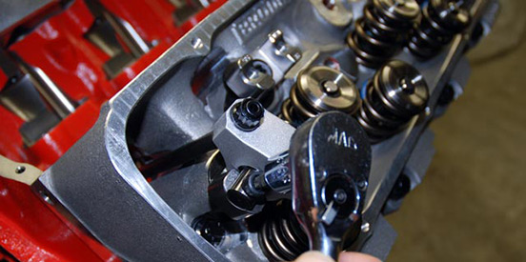
Here, the pushrod is installed and our shaft rocker is bolted in place. It has a pair of torx fasteners on each end. Tighten with a ratchet and then torque to specification.

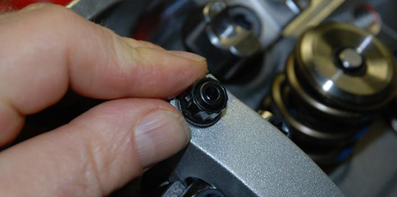
Where conventional rockers have the lash set at the polylock (on the stud/rocker fulcrum), Jesel shaft rockers such as these have the lash set at the pushrod cup. In either case, you still need to use a feeler gauge between the valve tip and roller rocker tip.

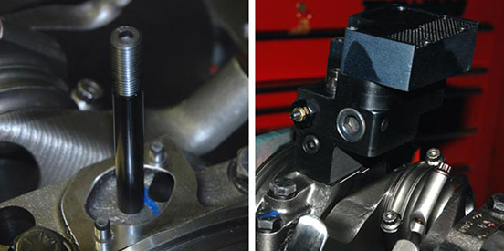
Oil pump installation isn't difficult. Either a stud or a bolt is used to hold it in place. In this photo, the pump stud is installed. In the next photo, the pump is slid into place over the stud (and engaging the dowels on the main cap). Be sure to include the pump driveshaft! In some cases, it can only be installed one way (from the bottom up). Finally, the nut is torqued to specs.

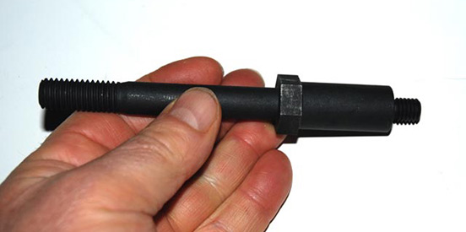
Some engines make use of bolt-on windage trays. Others don't. If it has a bolt-in windage tray, there's a good chance it uses some sort of extended main cap fastener such as these. They take the place of the center main cap bolts. The extensions on the end allow a windage tray to be installed over the caps.

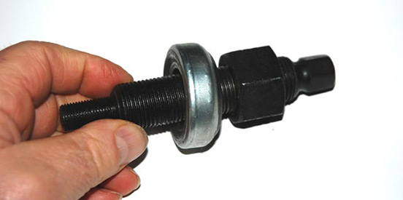
We have several different harmonic damper installation tools in our toolbox. This one is from the folks at B & B Performance. The tool physically pulls the damper onto the crankshaft without damaging the crankshaft (or the harmonic damper).

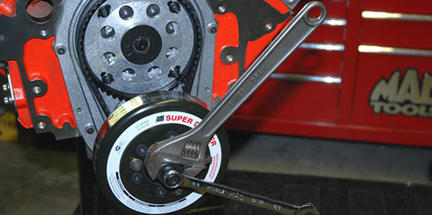
To use the damper tool, the small end is screwed into the crankshaft. The damper is installed over the tool (and engaged in keyway in the crank snout). The special bearing included with the tool is installed between the damper and the large tool nut. A large adjustable wrench is used to tighten the nut while the crank is held steady by the five-eighth-inch box end wrench. Tightening the nut simply draws the damper into place.

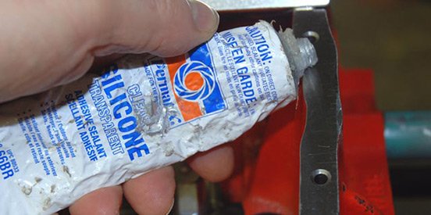
A gasket can be used on the intake manifold end seals, but a bead of silicone is often used instead. Run a bead of RTV over the manifold mounting surfaces on the cylinder block valley (front and rear).

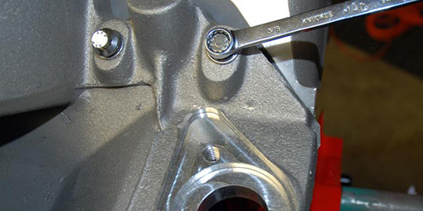
Carefully drop the intake manifold in place and install the fasteners. The text notes the torque sequence, but basically you start in the center and work your way out.

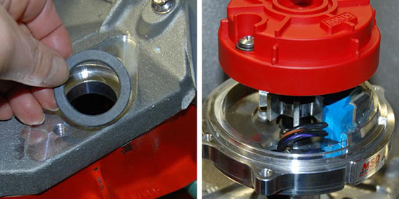
To install the distributor, install the base gasket (or shims) first. Then, drop the distributor into place. It might take several tries to get the orientation right (and simultaneously to engage the oil pump driveshaft).

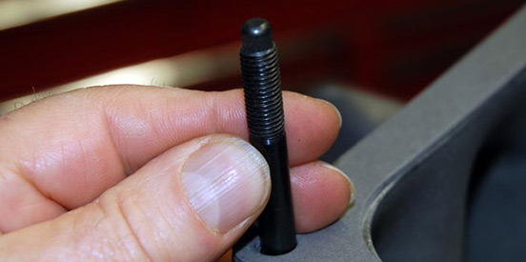
Carb studs are installed in the top of the intake plenum, followed by a carburetor base gasket. Then you can install the carburetor.

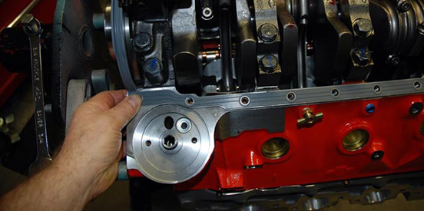
The oil pan installation is rather simple: Run a light bead of RTV silicone over the gasket mounting surfaces of both the oil pan and the block. Sandwich the gasket(s) between them. Install the hardware, torque to specs and you're done.

