2011 Ford Mustang GT 5.0 Coyote Engine

For The First Time Ever, The Mustang Gets Its Own V-8-And We Get The Inside Story On Its Birth
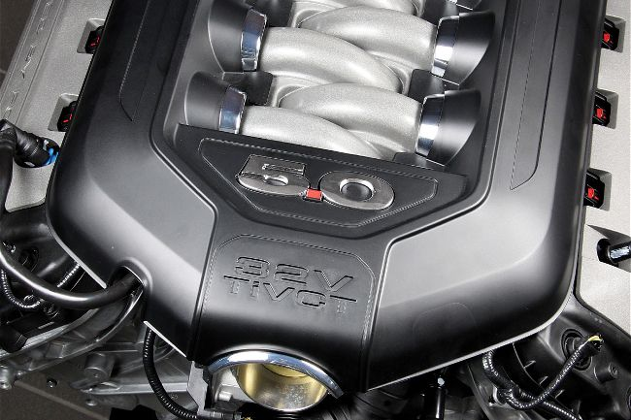
Tom Wilson
February 16, 2010
Photos By: Dale Amy, Courtesy of Ford Motor Company
Of the many milestones in the Mustang's 45-year history, one of the greatest has come to fruition. For the first time the Mustang is debuting its own V-8.
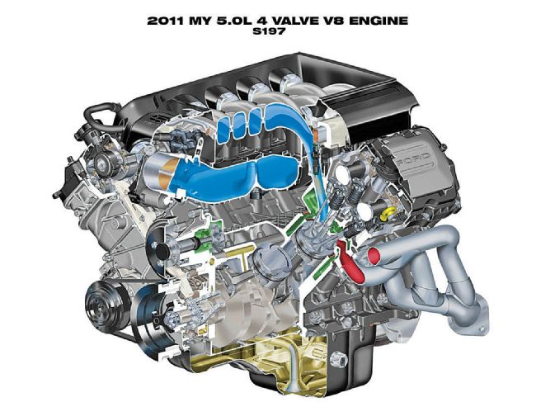
Not a derivation of an existing engine, not borrowed from a sedan, not developed to satisfy a sanctioning body, but conceived, designed, and built as a Mustang performance engine. It is the new 5.0 Four-Valve TiVCT V-8, which simultaneously pays homage to Ford history and traditional enthusiast performance expectations while fully embracing new technologies. Given its intent, performance, and mainstream production, it promises to be one of the most important Mustang V-8s of all time.
Developed under the code name Coyote, the new 5.0 was conceived in 2007 to replace the 4.6 and 5.4 Modular V-8s, which were approaching the end of their development. Ford needed a Mustang GT engine to compete against the new Chevy and Dodge efforts. While the Hurricane and Boss were explored initially-eventually a 6.2-liter SOHC Two-Valve version of that program ended up in the SVT Raptor and soon other F-150s-those large engines proved unsuitable for the Mustang. With time running short, Ford regrouped at the familiar modular engine family with plans for an all-new modular development specifically for the Mustang.
Compare The Jaguar XJ®. Find A Retailer
Few hard points were fixed at the Coyote's conception, but a handful were quickly set. The new engine's point of departure was the existing 4.6 modular architecture. It would not use EcoBoost- Ford's combination of direct fuel injection and turbocharging-but it would be engineered to withstand forced induction and to package EcoBoost fuel injectors in the future. The new engine would be as physically small as possible while physically stronger than the 4.6. Naturally, the team quickly landed on 5.0 liters of displacement. It needed to make 80 hp per liter, or 400 hp. Best of all, as a performance engine the Coyote development team knew the importance of delivering an exciting engine, one that just didn't meet its numbers, but had the precision and responsiveness enthusiasts crave.
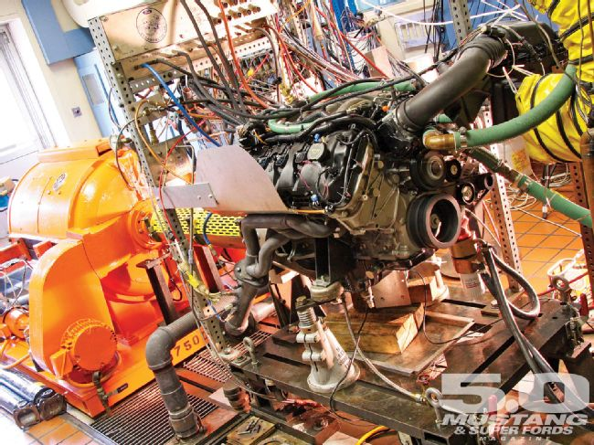
It was not easy. The power goals far exceeded the then-current Three-Valve 4.6 Mustang GT's 65 hp per liter, equaled those of Ford Racing's limited-production big-bore Cammer T50 crate engine, and trounce a hand-built, ported, cammed and electronically tuned 5.0 H.O. pushrod engine with long-tube headers. There were no bye runs from Ford management on durability, cost, noise or other guidelines. Furthermore, the job had to be done in less than two years, a previously impossible time frame.
Known more formally as the 5.0 4V TiVCT V-8, the new engine is an all-aluminum, 5.0-liter, double-overhead-cam, four-valve-per-cylinder powerhouse. It redlines at 7,000 rpm, boasts an 11.0:1 compression ratio, a low-friction compact roller-finger follower valvetrain, varies timing on all four camshafts, weighs a svelte 430 pounds as-shipped (approaching 1 pound per horsepower and not gaining a pound over the 4.6 Three-Valve), and sails through every brutal Ford durability and emission test. Benefitting from the latest in computational fluid dynamics, computer modeling, computer-aided engineering and rapid prototyping, the Coyote answers Mustang enthusiast's dreams with 1.4 horsepower per cubic inch right off the showroom floor!
Consider A Jaguar XF®. Find A Retailer Now
Rated at 412 hp at 6,500 rpm and 390 lb-ft of torque at 4,250 rpm in the 2011 Mustang, the Coyote is built at the Essex Engine Assembly Plant in Ontario, Canada, a medium-volume facility. The Coyote seems destined to appear in other rear-drive applications to justify its development costs and Essex plant status, but when and where remain unknown. For now, the Mustang has the Coyote to itself.
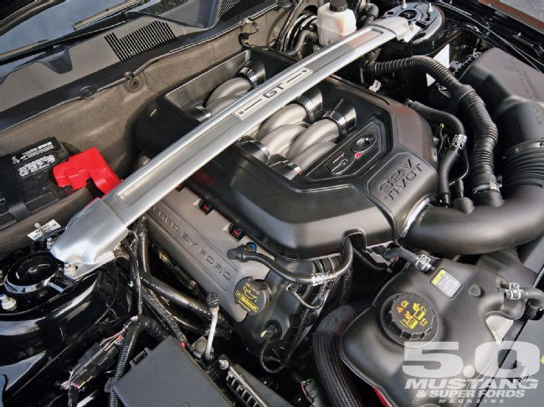
Furthermore, completely overlooked in the pre-release speculation are the all-new six-speed manual and updated six-speed automatic gearboxes developed for the Coyote/Mustang combination. They promise equal steps forward in smoothness and fuel economy as the new engine.
In these pages we're presenting the most in-depth look at the new 5.0-liter you'll find anywhere. Researched directly with the Coyote development team, this article is as close as you'll come to an official handbook on the new engine; we hope you enjoy learning about this tremendous Mustang improvement as much as we did.
Speed Breeding
Our delight with the Coyote starts with its existence. That Ford would develop a new performance V-8 in the midst of a perilous economy, nagged by debt, and busy delivering the advanced EcoBoost technology, was a surprise to us. Congratulations go to Ford management for its focus on product and ability to make the difficult financial decisions to keep the company independent. Without that foundation, this Coyote may have never been born.
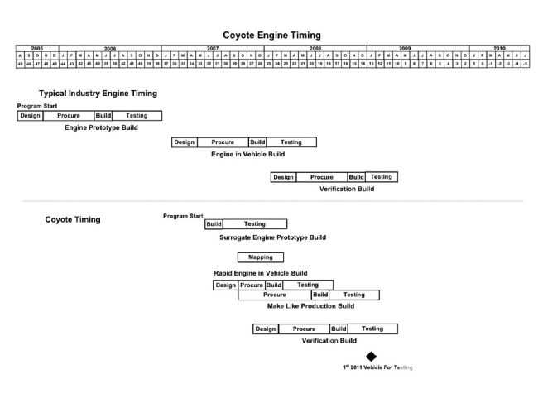
So why did Ford commit to the Coyote? The short answer is because we enthusiasts demand a winning V-8 and Ford could logically build one. Most fundamentally, the Coyote could be built inexpensively. Gary Liimatta, base engine systems supervisor for Coyote, summed it up. "This program was done inexpensively compared to other comparable programs of a similar content. I've always liked to call it sort of a dividend program; we had facilities in place, we could make an all-new design, but basically run it down the same lines and same machine processes without making a major investment. And so when people say, 'How could Ford do this right now in this economy with the fuel CAFE and everything else?' It's because we had all these things in place. We could do that inexpensively and have it be good business, so we weren't being irresponsible, even though it was a lot of fun."
Due to Ford's tremendous investment in V-8 manufacturing capacity, the new engine would take that form. To an enthusiast it may seem self-evident any new Mustang GT engine would be a V-8, but not necessarily so in this age of turbo V-6s. However, as Ford's plans clearly forecast more V-6s and fewer V-8s, making good use of Ford's existing excellent V-8 production capacity made financial sense.

Photo Gallery
View Photo Gallery




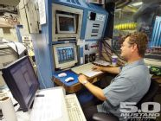
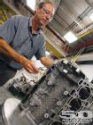
As Mike Harrison, Ford's program manager, V-8 engine systems, and likely the highest ranking manager with daily oversight of the Coyote put it, "The overall goal early on was a brand-new platform-we call it a modular family but we needed a brand-new platform as we had tapped out the current architecture. If we were going to get more power we were going to have to increase the bottom end, and we were going to have to do things to enable [engine] speed."
"The early thing was to set out a brand-new platform for further expansion. Bringing in new technology, bringing in new upgrades, but we really needed a new, stronger, better base. And that was our initial goal," Mike added.
Part of a new base engine is its longevity. With engine production life-spans often measured in decades it was important the Coyote had long-term breeding. Mike explained it: "We knew that someday there would be a DI version of this engine. We knew someday there would be a supercharged version of the engine. We knew that someday someone would want to do something on it," he explained. "So we wanted to make sure when we did the initial design work that it would be robust enough to not have to re-engineer the whole thing down the road and any subsequent programs would be very investment efficient and time efficient and so we did package DI injectors, we did really improve the bulkhead strength to take supercharging, we upgraded the cylinder head bolts and the main bearing bolts, all of that stuff ... We just wanted to make sure it was a good base going forward, that the architecture would last us the next 10 or 15 years."
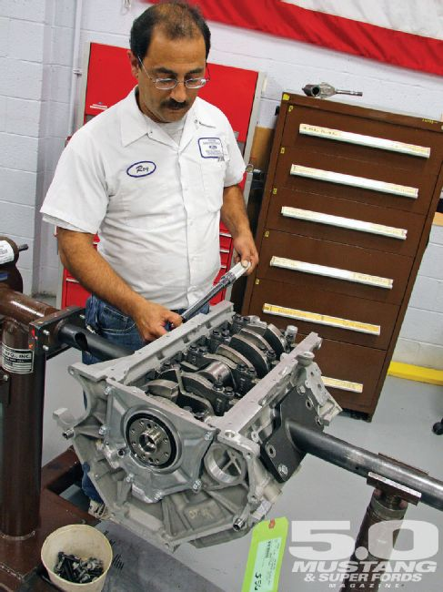
And while you, the Mustang buyer, may not directly have had a seat at Ford's conference table, you still played a major role in deciding on a naturally aspirated V-8. Enthusiasts themselves, the Coyote team understands that overall the Mustang GT market is technologically conservative, or maybe we enthusiasts better understand there is no replacement for displacement. And so the team wanted to introduce the new engine in traditional, less-expensive, naturally aspirated dress.
But as we just heard, this doesn't mean the Coyote will always keep its traditional charms. The engine was engineered from the beginning for supercharging or EcoBoost, so why not EcoBoost the engine now?
"We were able to meet our objectives without it, and quite frankly, it's quite expensive," Mike educated. "On this platform, its $50 to do DI on the V-8 with two pumps and eight injectors ... And the other thing is, we only had two years to deliver it, from initially talking about it to spitting 'em out at the factory. It could have been potentially one of the technologies that tripped us up in terms of timing."
So, while 90 percent of Ford engines will boast boost by 2013, having the Mustang GT engine make power the conventional way costs less and better fits its market. Furthermore, as we'll see later, the Coyote team found ways of gaining much of the EcoBoost fuel economy and efficiency gains with zero extra cost. We think a crisp, naturally aspirated revver like the Coyote was definitely the right call for the Mustang, and think it will remain a fresh alternative in an increasingly turbo world.
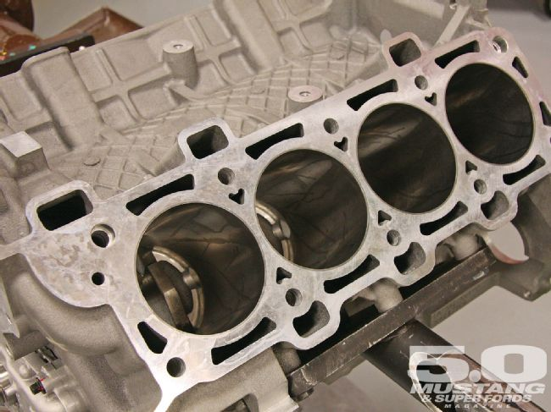
Speed was also a hallmark of Coyote development. By the time Coyote had been approved there were only two years in which to design and build it-a full year less than normal. And a looming deadline can focus your thinking.
Gary Liimatta noted, "For this engine the decisions were made very quickly ... We had a very strong technical team, a small team with strong leadership. I just wanted to emphasize that all of the decisions in this program were made quickly because we had a philosophy of, 'We have to hit 400 horse' ... that aligned all of our activity. Everything that supported 400 horse went in, and ... if it didn't support the goal it didn't make the cut. And so we were very quick and nimble."
Even so, the hands-on work can only be hurried so much. The rest came out of the engineers' hides. Months of overtime and weekends went into make this engine happen in a hurry. So if you ever meet a Coyote engineer, be sure to say thanks.
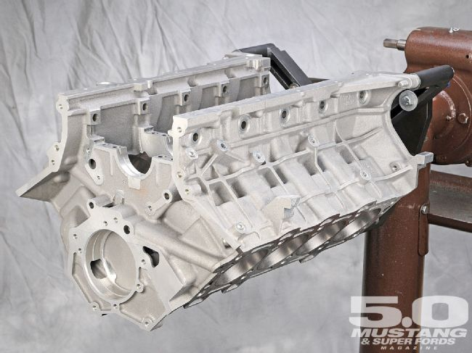
Regardless of budget or time constraints, to reach their goals the Coyote team knew they would need every wrench in the toolbox. Gary described the teams strategy: "The power targets we had for the engine weren't going to be achieved by not trying to cover just about everything we could cover to make horsepower. So we looked at every single element. We canvassed our colleagues on what they had done, did benchmarking of our competitors, looked at SAE papers, partnered with some of the guys that are running NASCAR teams. 'How do you make horsepower?' 'What are some of the areas you look for over and above the usual cams and valves and all that sort of thing?"
Because of the rapid time line-two years is smoking the tires on the design, and validation and tooling of a new engine-the Coyote team pioneered a consolidated design and testing procedure. Traditionally engine development is a linear, three-year process. The new engine is designed, computer modeled, built as a prototype and dyno tested. Then revised engines are built, put in vehicles and tested, and then the engine is refined yet again, calibrated and finally makes production.
For Coyote there wasn't enough time to neatly lay out all the steps end-to-end. Luckily, computer modeling and rapid prototyping capabilities have grown so powerful that software can stand-in better for iron and aluminum than even two years ago. Therefore the initial design and computer modeling were telescoped on top of each other. Simultaneously, surrogate engines were built to test specific aspects of the new 5.0. Surrogate engines are running engines built from almost anything handy that sort of represent the final engine, but designed to test just one narrow aspect of the final engine. Real Frankenstein's monsters, surrogate engines did not represent the new engine in detail and had no future other than as development hacks.
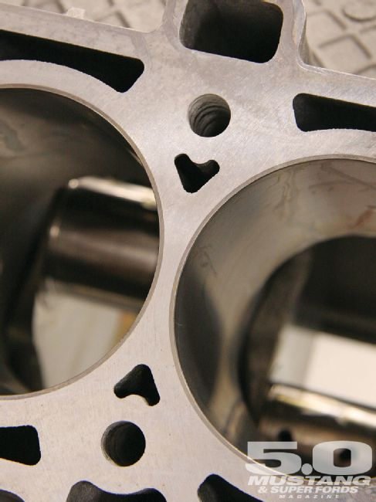
EPD Supervisor Jeff Kolodziejczyk was the man with his hands on the surrogate engines. A snowmobile racer and two-stroke tuning specialist after hours, Jeff put his wrenching experience to use cobbling together and dynoing Four-Valve V-8s, mainly from GT500 parts.
"The surrogate level was my favorite level of the program," he explained. "I say that because we're basically all enthusiasts, we [the Coyote team] all have race backgrounds of one form or another and this was like, 'go ahead and do what you'd like to do at home. Look at aftermarket parts, use what parts you have, put it together as quickly as possible, demonstrate you can meet the functional objectives.'
Jeff had "some old spray-bore blocks laying around" at Ford and combined them with production GT500 heads. From the FRPP catalog, he selected the aggressive 4V High Lift Camshaft Kit and initially set the compression ratio at a low 9.66:1 "and walked it up from there." A deep-sump oil pan was built and it was off to the dyno.

Photo Gallery
View Photo Gallery
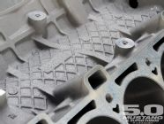
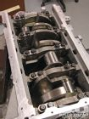
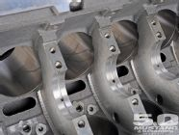
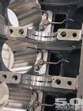
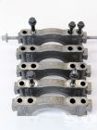
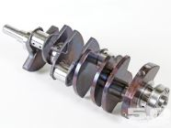
Key challenges during the surrogate phase were the intake and exhaust manifolding layout and runner length; camshaft selection; and lubrication. From an enthusiast's perspective, this is where the Coyote got its howl. Fundamental architecture changes were possible, or as Jeff put it, "During this phase, particularly testing this engine on the dyno, we had good opportunity to influence the design."
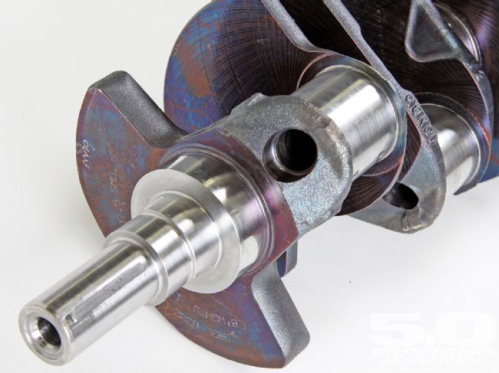
In fact, Jeff and Adam were simultaneously running their phases of the Coyote program-one in hardware and the other in software-yet constantly comparing results and cross-verifying and improving their work as they went. Not much later Adam and Jeff would work with those laying out the Coyote's architecture, while continuing to develop and validate the Coyote's fundamental power-making ability.
In short, Coyote development more exploded in several directions instead of a connected straight-line series of dots. It was a tumultuous, tiring effort, but it worked. In just 16 months the first Coyotes hit the dynos in January 2009. "The first engine out of the box in the development cell ran for 800 hours, and that's Performance Run, and so it was a very good success," says Gary.
"And our first engine went to map, and for us, we were just very proud of that-it was good enough for map right out the door. We thought it was impossible when we first started off." Going to map means the engine was good enough to have its core combustion personality set in stone. Once mapped, the fundamental engine would be frozen and the long validation and calibration work would begin.
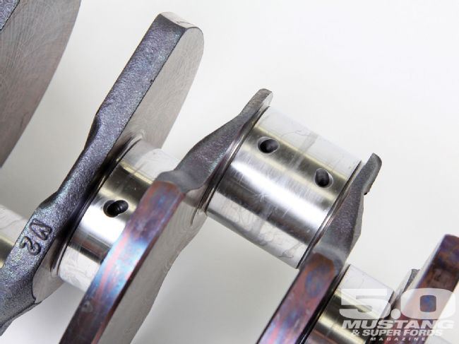
Besides meeting the performance goals the Coyote had to pass all of Ford's standard durability tests. These dyno sessions are incredibly brutal, always far exceeding what any rational customer would do to his engine, and occasionally surpassing what is physically possible in a car.
We observed some of this internal combustion water-boarding, and for anyone with a foot-pound of mechanical sympathy it isn't pretty. Engines run fatigue cycles equivalent to 62 Daytona 500 races. Others replicate customer drive cycles for 1,000 running hours to include 1,000 cold starts, plus hitting its peak torque and power for sustained periods. That test alone runs 100 hours a week for two and a half months.
We witnessed another torture session where the engine was run at WOT for several minutes, the headers glowing just a hint of red, then the engine shut off and after several seconds of sitting, -20 degree ice water was forced through the cooling system. Frost formed on the test rig as the engine was about frozen to death, then the ice water stopped, the engine started and after a handful of seconds idling was taken back to max rpm, max load for another heat cycle up to 225 degrees. Each complete cycle takes about 10 minutes, and the engine must survive days of these non-stop thermal shocks.
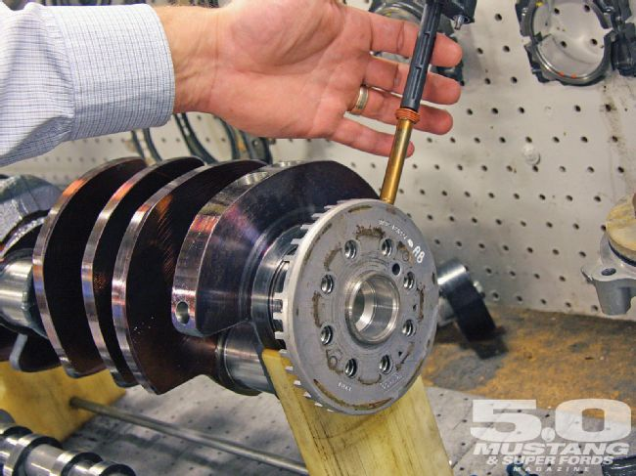
Most incredibly, "It can't be on its last legs at the end of the test," says Mike. "It can't be that it hasn't seized yet, we need to see crosshatching on the cylinders, no full-face ring wear, leak down needs to be below, oh, eight percent; it has to be very, very functional and could go do it again, quite frankly."
Be assured, this is one team, and engine, that has gone the extra mile to produce a no-excuses Mustang V-8.

Photo Gallery
View Photo Gallery
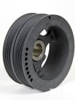
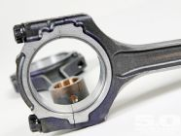
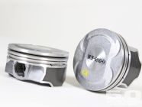
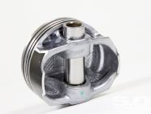
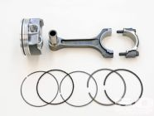
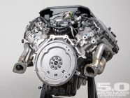
The Short-Block
Because a major mandate of the Coyote program was utilizing Ford's existing V-8 mass-production capabilities, and because 5.0 liters was considered the appropriate displacement, the jumping-off point for the Coyote was the closest existing engine, the Three-Valve 4.6 V-8.
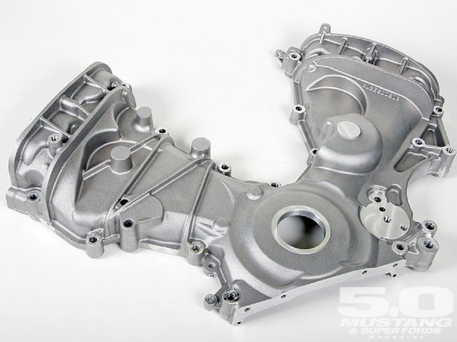
There was no requirement to save anything of the 4.6 in the Coyote other than it must be suitable for production on the same machinery. As primary goals were the Coyote be stronger, more compact and powerful than the 4.6, it was a given that almost nothing from the 4.6 would carry over to the Four-Valve 5.0 TiVCT. Essentially nothing did, except the 4.6 bore spacing and its inherent limit on bore diameter.
Bore spacing is critical in the modular engine family-all modulars use 100mm (3.937-inch) bore spacing-because bore spacing and right bank leading are the major non-adjustable features of Ford's block machining line at the engine plant. In fact, bore spacing is likely the defining characteristic of the modular engines. They got the name "modular" because they were conceived in the '80s as a family of engines the assembly plant would sense as nearly identical and thereby allow rapid flexibility in their production. Thus, a modular could be a V or inline four-, six- or eight-cylinder engine, and any one of those engines could be built on Ford's engine lines with just a few hours of change-over time. In some cases similar engines could be built at the same time on the same line in random order, such as is done with 4.6 and 5.4.
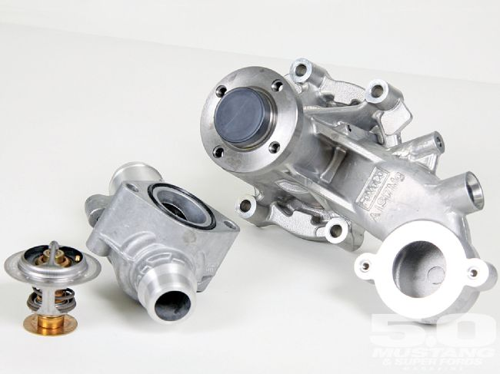
Given all that, the new 5.0 was going to have a 100mm bore spacing and claim its place as the newest member of the modular family even though in nearly all other respects it is an all-new engine.
Of course, the Coyote team was as intent on giving its performance engine the maximum possible bore diameter. A large bore allows better breathing because it unshrouds the valves, plus it supports higher rpm operation because more of the displacement is in the bore and not the stroke so piston speed can be conserved.
Therefore, the Coyote team turned to the pressed-in iron cylinder liners in the Coyote's aluminum block. The critical decision was to get the liner as thin as possible for the largest possible bore, but not so thin it would be weak. In the end, that measurement was 92.2 mm, or 3.263 inches. This is 2.0mm larger than the 4.6 bore, a dimension taken mainly out of the cylinder liner and not the block.
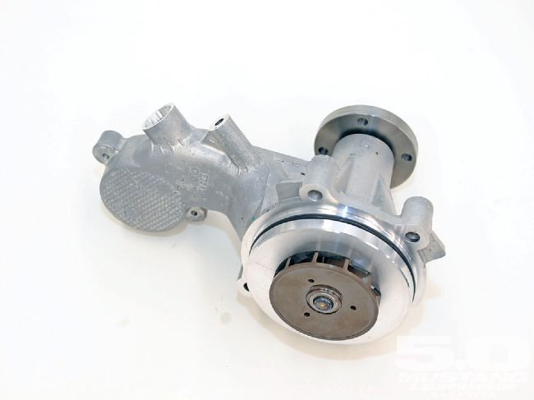
Stroke was driven by the compromises inherent in reaching the desired 5.0 displacement such as keeping the engine physically compact (low and narrow), moderating piston speed, leaving room for ring packaging and so on. The Coyote team elected to retain the 4.6's deck height, and a 92.8mm (3.653-inch) stroke was selected to reach 5.0 liters.
To put the 5.0's short-block architecture in perspective, here it is compared to the familiar 4. 6 and 5.4 modulars:
 | 4.6 |  | 5.0 |  | 5.4
Bore Spacing | 100.0 mm | (3.937 inch) | 100.0 mm | (3.937 inch) | 100.0 mm | (3.937 inch)
Bore | 90.2 mm | (3.544 inch) | 92.2 mm | (3.623 inch) | 90.2 mm | (3.544 inch)
Stroke | 90.0 mm | (3.537 inch) | 92.8 mm | (3.653 inch) | 105.8 mm | (4.165 inch)
Deck Height | 227.0 mm | (8.937 inch) | 227.0 mm | (8.937 inch) | 256.0 mm | (10.079 inch)
Con Rod Length c-c | 150.7 mm | (5.933 inch) | 150.7 mm | (5.933 inch) | 169.1 mm | (6.658 inch)
Rod-to-Stroke Ratio: | 1.67 |  | 1.62 |  | 1.60
Note how there is an even 400cc increase in displacement with each engine, but how the 5.4 requires a taller and wider engine (deck height) to accomplish its increase over the 5.0. This is the tradeoff in being married to the 100mm bore spacing.
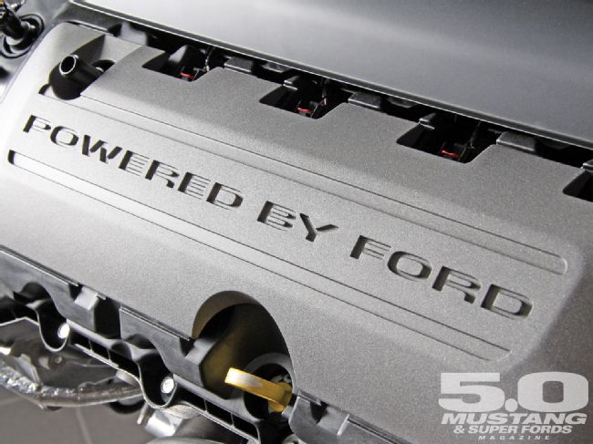
Keeping the same bore spacing also partially drives dimensions in the crankshaft and main bearings. Lowering friction is another major concern with the Coyote's 7,000-rpm redline, so the impetus was not to increase bearing diameters or widths. Existing 4.6 bearing sizes proved bulletproof and the Coyote crankshaft shares journal sizes with the 4.6 crank. In fact, the aluminum bearing shells are direct carryovers from the 4.6. No fancy tri-metal or copper bearings were required, so that was one less thing to re-invent.

Photo Gallery
View Photo Gallery
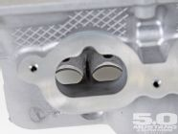
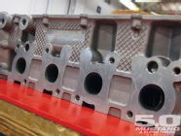
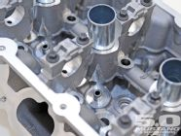
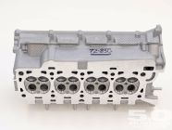
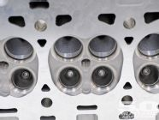
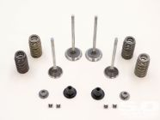
Another seemingly simple choice was to make the block aluminum, as the Blue Oval mandate is to save weight. However, the Coyote will inevitably be supercharged. The team didn't want to have to re-engineer the block later, so it was designed with forced-induction loads in mind.
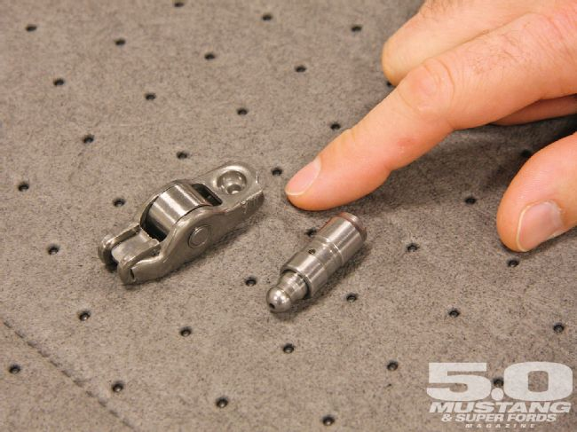
This extra material is best seen in the main-bearing bulkheads, which are now a couple millimeters thicker. Fastener sizes are larger too. All are generous, and should prove absolutely bulletproof in naturally aspirated trim. They also pack the reserve strength to withstand us hot rodders bolting on blowers. This bodes well for modular engine building as we've just gained a strong, lightweight aluminum block with production engine economies of scale. Too bad the connecting rod isn't as over-built, but that's getting ahead of the story.
Something Ford has identified as important in its new 6.2 truck engine and the Coyote 5.0 is crankcase bay-to-bay breathing. This is managing air pumped by the pistons sliding up and down in their bores. This constantly changes the shape of the crankcase volume, creating powerful pulses, especially in the area where opposing cylinders share a "bay" between main bearing bulkheads.
Research shows either sealing the bays to minimize breathing, thus forming "air springs," or opening the bays to allow liberal communication have advantages. The Coyote team chose liberal bay-to-bay breathing, with limber holes strategically placed in the main bearing bulkheads and credits this as an important power builder. It no doubt has a positive effect on ring seal.
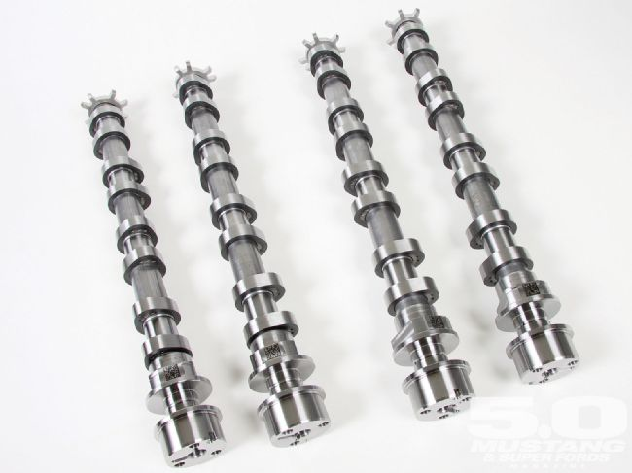
The Coyote team says the forged. powdered-metal connecting rod is the least robust link in the 5.0 chain. Engineers noted it is absolutely strong enough for its naturally aspirated application in the Mustang, but just absolutely strong enough. It's worth noting that while the Coyote rod shares its big- and small-end diameters plus its center-to-center length with the 4.6 rod, the Coyote rod has been redesigned to more evenly distribute bearing loads and is definitely an improved piece.
Most ominously, supercharging will require a stronger forged rod, so we expect to see those, and, no doubt, a short-block in the FRPP catalog before long. This adds a whole new layer of commitment to bolting a blower on a Coyote. We'll have to let the brave among us prove the standard Coyote rods' boost tolerance. For those planning on a rod-exchanging teardown right away, Ford says the Cobra's Manley forged rod will just fit, but you must be careful. No word on how to package a forged piston and rod combination.
Because a fully populated Coyote crankcase is packaged tightly as coach airline seating-the already abbreviated piston skirts come close to the crankshaft counterweights-there is no room left for stroke increases.
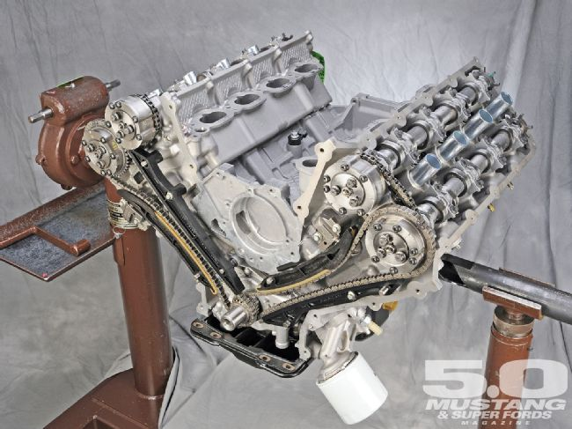
You may also think "weak" when viewing the Coyote's racy-looking but hypereutectic pistons. But there's a twist: oil-cooling jets. A fine mist of oil is squirted continuously from jets in the block's main webs. This oil sprays directly on the underside of the piston, at the vulnerable piston boss and bottom of the crown. The engineers sold the expense of oil jets to management by telling them it speeds engine warm-up (which is true), but the real reason was for piston cooling, hence longevity. This means the lighter, quieter, tighter-fitting, less-expensive hypereutectic piston can be run in this demanding high-rpm, high-load application.
Benefits of the squirters are extensive. Testing shows the crankshaft runs 25 degrees cooler with them, and they help with octane sensitivity. Combined with the heads superior water-jacketing they are one reason the high-compression Coyote can feed on 87-octane gasoline. Interestingly, adding piston-cooling oil jets was one thing engineers on the original Four-Valve modular-the 280hp Lincoln Mark VIII's 4.6-told us they would do if asked to increase performance. That was 17 years ago, so it's been a long wait for this fundamental improvement.
While perhaps not as sexy as the zoomy new cylinder heads, the Coyote short-block is a comprehensive re-think and re-engineering of the modular V-8 and is clearly poised as the all-new performance Ford engine foundation for years to come.
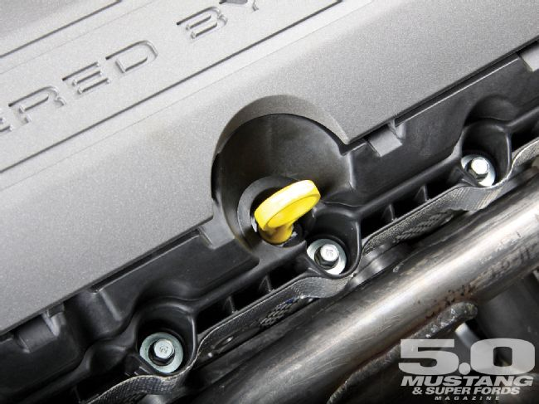
Cylinder Head & Valvetrain
"The Coyote head at a given lift actually outflows a Yates D3 head." Now that Adam Christian, internal combustion engineering analyst, has your attention, "It's a Four-Valve, right, we're cheating [The radical Yates NASCAR race head is a two-valve.-Ed.], but up to our peak lift, 13mm, we're actually out-flowing the Yates head. And that pretty much means we're outflowing Brand X, Y, and Z."
That's a great recommendation for your next Mustang GT's breathing capability. To put it in a Ford production car context, Mike Harrison noted, "These are the best heads we could find that are as-cast production cylinder heads. Adam and Todd made sure that at every valve lift that we were superior in the performance numbers, not just at the top end. It's not a compromised port, it's wonderful."
We'd love to show a flow chart of the new head, but Ford was reluctant to post exact numbers. It causes them headaches from snivelers who don't precisely replicate the published results. But don't doubt the Coyote heads howl all over the V-8 competition. Our guesstimate is these intakes flow a bit over 300 cfm.
More importantly from the Coyote team, "And that's only half the story, because the team didn't just focus on the intake ports ... it was designed as a system; to work with the intake manifold ... It was designed from the valve to the plenum, and not as separate pieces as is often the case because of the way things turn out."
This systems engineering, where powerful computers, innovative software, flexible cross-team communication and parallel development allow keeping many variables updated in real time was repeatedly cited as central to the Coyote's engineering success.
To make such an impressive head, the team knew it would need all the tricks. Four camshafts were a given, both for the four-valve-per-cylinder architecture, but also to enable the hugely important TiVCT function. The best previous modular production casting, the GT500 head was looked at first, and given the short wick on the entire project the initial thought was to use that head. But the GT500 casting had two strikes against it: it was too large and couldn't make the performance numbers! So even though there wasn't time to design a new cylinder head the head specialists went through six months of 12-hour days and working weekends to design and deliver a new casting.
To speed the design the Coyote head had two starting points: architecturally the GT500 head and conceptually the recently designed 3.5/3.7 V-6 combustion chamber-both twin-cam, Four-Valve designs. The Coyote head's architect, Todd Brewer, cylinder-head-design technical expert explained the approach: "We took things we knew how to do and started there."
Don't think Todd copied anything directly from either of these heads. These starting points just gave the general layout and relationships; not a single part was carried over from either head into the Coyote.
Beginning, as always, from inside the head and working outward, from the 3.5-liter concept Todd changed the distance between the valves, the valve angles, the back-cut angles on the valves, and the valve seats. This was all done virtually, with CFD modeling showing what worked and what didn't. The intake valves were stood up so the intake ports would be farther from the engine's centerline. This got the valves away from the pistons, allowing more valve lift and TiVCT range of authority. It also facilitated gentler curves in the intake manifold, increasing breathing.
Port design was driven by Adam Christian's analyticals and Jeff Kolodziejczk's surrogate engine work. Working back-and-forth, Adam would do the quick and dirty one-dimensional computer modeling at his desktop, followed by Todd's three-dimensional work and then a combination of the two-the so-called 1D3D CFD-at Ford's forebodingly named Numerically Intensive Computing Lab. This is where the serious number-crunching is ground out, with the 1D3D software combining both pressure and flow functions into one mind-numbing exercise.
It's difficult to overstate the power of these levels and volume of computing. It is more accurate and vastly quicker than building test parts for something such as a flow bench, even with rapid prototyping. Without it the Coyote would not have made it on time. Even at the design level Todd enjoyed being able to change one variable such as valve angle and have the software automatically update everything else, all the way out to valley volume or exhaust manifold placement.
It's worth mentioning that while we hot rodders think in terms of port volume, factory engineers such as Adam and Todd can change nearly anything during the design phase, and are thus interested in total runner length and volume from the intake manifold to the valve. Cylinder head port and runner shape are also important, but secondary concerns to them.
Reducing cylinder-head size and weight was a major priority. While retaining the GT500s general layout of two cams working four valves per cylinder through roller-finger followers and hydraulic lash adjusters, every aspect of the GT500 head and valvetrain was re-evaluated to serve on the 7,000-rpm 5.0 liter. Downsizing the valvetrain for weight, size, and high-rpm reasons was a prime directive. The camshafts were brought closer together by 20 mm, and the hydraulic lash adjusters and roller-finger rockers miniaturized. This allowed narrowing the head left to right and shortening it vertically.
Stabilizing the valvetrain for 7,000-rpm operation was obviously required. The Four-Valves' smaller cam journal diameters were tossed in favor of the larger Three-Valve dimensions to give a stiffer camshaft. Furthermore, the camshaft bearing supports were repositioned to more optimal locations. Todd says the valvetrain is stable to the engine's redline plus several hundred more rpm, obviously all that's required and hinting at the "almost" valve lofting trick Adam alluded to. The valve-guide material is also upgraded for high-speed operation, and the intake guide was given a larger aluminum boss for streamlining.
A major goal for the Coyote head was superior coolant flow volume and even coolant distribution, especially around the exhaust valves. This was achieved via extensive computational flow dynamics and careful architecture, setting new internal Ford cooling records in the process.
The breakthrough was a new coolant path called cross-flow cooling. All previous modulars are series cooled, where the water rises from the block into the rear of the head, flows forward through the head and out into an external crossover tube in the valley and finally the thermostat.
The Coyote's cross-flow cooling mainly rises up from the block on the exhaust side of the head, passes evenly around the exhaust valves, then the spark plug and intake side of the head into a manifold. The manifold is really just a long, extra large galley cast into the intake side of the head. From the manifold the coolant exits at the front of the head to a crossover passage cast into the block, so there is no external tube taking up room in the engine's valley, obstructing the intake manifold (or supercharger, should you add one).
A small amount of coolant is still pumped into the head at the rear, but just enough to organize the coolant flow toward the front of the head and the crossover. Of course, the coolant flow was optimized using extensive computer analysis; the team demanded exceptional cooling to support power and suppress detonation in the high-compression, low-octane Coyote.
Another flow change was to the oil. Until now modular's had oil feeding from the front of the left head and back of the right head, but the Coyote feeds both heads from the front. "That's one of the things where we're preparing ourselves for future technologies, oil pressure actuated things in the valvetrain. There are a lot of different ones, so we wanted to make sure we're setting ourselves up to run some of those devices," said Gary Liimatta.
Perhaps the final major head-design challenge was packaging everything into the downsized Coyote head. This was only slightly complicated by leaving room for an EcoBoost fuel injector. Its path low on the intake side was protected during Coyote development in case Ford decides to fit the somewhat bulky direct injection injector to the 5.0-liter in the future.
Ignition And Electronics
Coyotes in the 2011 Mustang use the Copperhead version of Ford's electronic engine control system. Jeff Seaman, the lead calibrator on the Coyote/Mustang project, ran us through the system's amazing highlights.
Copperhead is considerably more complex than previous EECs. It has to be with the TiVCT, but we didn't think 15 different tables would have cam timing input, but they do. Copperhead also integrates the new six-speed transmissions and engine into one speedier controller, so there's another layer of complexity.
Other changes are the addition of One Touch Start-the ignition key only needs a moment in the "start" position and the computer does the rest-as well as aggressive decel fuel shutoff and torque-based decel. The latter two shut off the fuel more often and sooner than previous EECs while coasting, on long downhills, and even during mid-shifts with the new six-speed manual transmission.
The 2011 Mustang also features a new digital mass air meter and universal exhaust gas oxygen sensors, which report a numerical air/fuel ratio-to something like the fourth decimal point-to the EEC. Previous systems weren't much more than rich/lean indicators.
Jeff reports that calibrating the 2011 Mustang took from April 2008 to November 2009. When he started, the car wouldn't start; when he finished, it was perfectly driveable, a job that took him to Arizona in the summer, Canada in the winter, and the heights of Colorado. The challenges of tuning the Coyote centered on its huge airflow. At low rpm, the engine is touchy because the combustion chamber has no tumble or swirl, so lighting the lean mixtures in that environment take careful throttle, fuel, and spark control. The precise sensors also pick up things such as the cams torquing out of shape, requiring compensation at high rpm.
The Coyote's tubular headers were a real challenge for cold starts, so Jeff had to use all his knowledge to get them to pass emissions. And then there was everything over 6,000 rpm, a range where Ford calibrators simply haven't gone before. Maintaining precise control up to the Coyote's 7,000-rpm redline was trying. Team members said if it had been any calibrator other than Jeff-a rabid enthusiast himself-they might have been told to limit the new Mustang's rpm and call it a day. We're lucky so many dedicated enthusiasts were on the Coyote team.
With that good fortune in mind, we must thank the Coyote team for reinventing the 5.0-liter engine back to Ford in a new form better than we could have imagined. So prepare to enjoy the second coming of the 5.0 revolution-the wait is nearly over.
5.0 Tech Specs
5.0 4V TiVCT V-8
First Model Year 2011
Engine Family Modular
Code Name Coyote
Displacement 4957cc (302 ci)
Bore x Stroke 92.2 x 92.8mm (3.263 x 3.647 inch)
Horsepower
- 412 hp @ 6,500 rpm, 91 octane
- 402 hp @ 6,500 rpm, 87 octane
Torque
- 390 lb-ft @ 4,250 rpm, 91 octane
- 377 lb-ft @ 4,250 rpm, 87 octane
Shipping Weight 430 pounds, includes water pump
Block Low-pressure cast 319 aluminum, pressed-in thin-wall iron liners
Bore Spacing 100mm (3.937-inch)
Deck Height 227mm (8.937-inch)
Deck Thickness 13mm (0.510-inch)
Cylinder Head Retention 12mm bolts, 4 per cylinder, 10 bolts total per bank
Oil 5W/20 weight, mineral
Oil Pan Stamped steel, 8 quarts
Windage Tray Integral w/oil pan gasket
Oil Pump Gerotor
Pistons Hypereutectic, short-skirt, flat-top w/four equal valve reliefs; moly friction-reducing coating; oil-jet cooled
Piston weight 500 grams
Piston Pin Full-floating, 22mm diameter
Piston Pin Retention Wire lock
Piston Rings 1.2 x 1.2 x 2.5 mm, moly top ring
Connecting Rod Powered metal forging, I-beam, no balance pad
Connecting Rod Length 150.7mm (5.933-inch)
Rod/Stroke Ratio 1.62
Crankshaft Forged steel, fully counterweighted, induction hardened
Main Journal 67.5mm (2.652-inch) diameter
Rod Journal 53.0mm (2.082-inch) diameter
Flywheel Retention Eight-bolt
Cylinder Heads Aluminum, four-valve per cylinder
Head Bolts 12mm, four per cylinder
Valve Covers Composite
Compression ratio 11.0:1
Valves 37 x 31mm (1.454 x 1.218-inch), four per cylinder
Camshafts DOHC, four camshafts, independently adjustable timing
Camshaft Timing Twin independent variable
Duration 260 degrees intake, 263 degrees exhaust
Lift 12mm (0.472-inch) intake, 11mm (0.432-inch) exhaust
Lift Limit 13mm (0.510-inch) physical limit in head
Valve Followers Roller-finger follower
Lash Adjusters Hydraulic
Coolant Organic (red)
Exhaust Manifold Short-tube, S44100 stainless-steel Tri-Y tubular headers; 10mm mounting studs w/prevailing torque nuts
Intake Manifold Constant cross section, long-runner single-plane (single-scroll); molded composite w/upper section colored; front throttle body mount
Throttle Body Single-blade, 80mm, e-throttle
Engine Management Software Copperhead
Mass Air Meter 86mm, digital
Oxygen Sensors Universal Exhaust Gas
Knock Sensors Two, in block valley
Ignition Timing Crank trigger, rear of crankshaft
Ignition Coil-on plug
Spark Plug NGK Iridium
Firing Order 1 5 4 8 6 3 7 2
Cylinder Numbering
- Right bank: 1, 2, 3, 4
- Left bank: 5, 6, 7, 8
Fuel System Port fuel injection, returnless
Fuel Injectors 32.8-lb/hr
Fuel Pressure 55 psi
Fuel Requirement 87 octane minimum, 91 octane best/rated power
Coyote Slim
Anyone who's lived around coyotes knows just how thin they can be. Apparently some of that has rubbed off on the Coyote engine, which at last count was just 430 pounds. This is the shipping weight from the Essex assembly plant and includes the water pump but not the alternator, AC compressor, or starter.
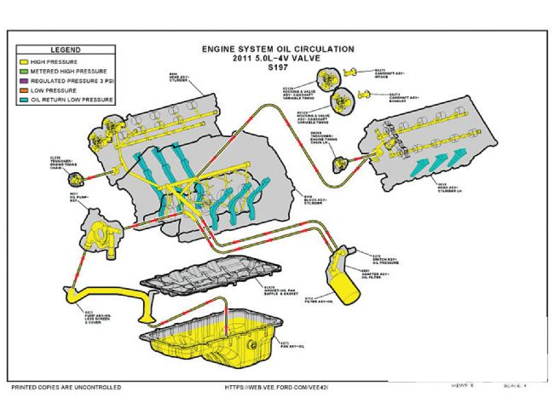
This also the same weight as the Three-Valve 4.6, which is commendable considering the Coyote's larger displacement, two extra camshafts, extra valves, four cam timing phasers, extra crankshaft counterweights, beefed block, and other niceties. The engineers say they saved weight with the plastic intake, hollow camshafts, composite valve covers, five-core head castings, and plenty of attention to detail all over the engine.
Coyote Oiling
Considerable work went into prepping the Coyote's oiling system for its 7,000-rpm redline and high-g Mustang home. It begins with thin 5W-20 mineral oil for reduced oil-pump-drive requirements, less internal drag, and quicker cold-start lubrication. Oil capacity was increased to 8 quarts, both to ensure adequate supply at high engine speeds and to increase oil change intervals to 10,000 miles.
The oil pan shape and baffling was aided by computer modeling to check sloshing behavior while braking and cornering. Testing also showed oil drainback out of the valve covers while cornering (and drifting!) proved inadequate with the initial design, requiring slight but vital revisions to the drainback channel shape in the side of the block.
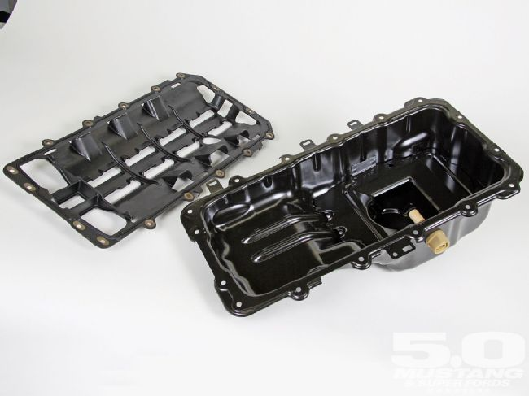
At 1g cornering, the oil was accumulating in the valve cover and flinging into the PCV system via the camshaft-timing wheels. These "pip wheels" make great oil paddles at 3,500 rpm, so Habib Affes Ph.D., CAE technical expert, modeled the situation, disclosing that down in the block's oil drain passage there was a curve or bump. At 1g cornering, this bump-physically angled at 45 degrees-was sensed as flat by the oil, so it would not drain past it. Straightening the curve lowered the oil puddle depth around the pip wheel from 11mm to 3mm, curing the PCV problem.
Interestingly, one item needing less oiling are the VCT phasers on the camshafts. Thanks to the cam torque actuation strategy, the phasers do not require high-pressure oil from the pump, but are instead fed bleed oil from the front cam bearing. Had CTA not been used, the oil pump would have needed enlargement to keep a relatively large volume of pressurized oil ready to go next to the phasers in the cylinder heads. And that would have cost horsepower.
Crankcase ventilation and oil drainback are major oiling improvements in the Coyote. Crankcase breathing has never been particularly good in high-rpm modulars, and early testing showed the Coyote's high volumes of drainback oil at high rpm were air-locking the crankcase from the top of the engine. In other words, the gush of oil trying to drain down at 7,000 rpm was blocking the pressurized crankcase air trying to find its way up, effectively choking the PCV system and inhibiting drainback.
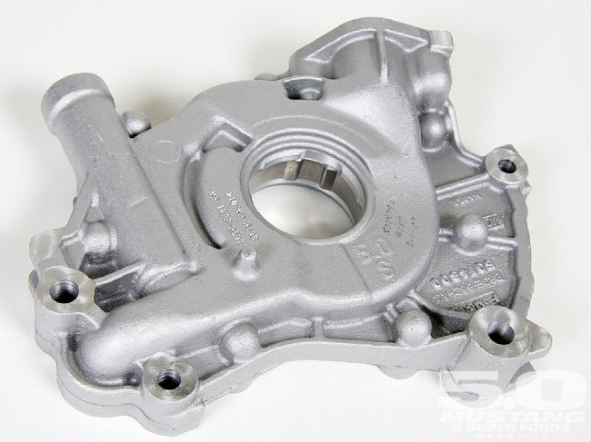
The cure was to separate the drainback paths from the crankcase breathing chimneys. Thus, Coyotes have three large oil drainbacks on the exhaust or lower side of the cylinder head. They mate to corresponding passages on the outer side of the block that downspout the oil into the pan-similar to the dry-sumped Ford GT block.
For PCV gasses, passages are placed at the top of the crankcase, about where the camshaft would be in an OHV block. These passages connect to corresponding flues on the intake side of the cylinder heads. Thus, the oil drains and breather vents are completely separated and probably approach double the combined area of previous modulars.
Consideration was given to an external oil cooler, but ultimately it was decided not to penalize all Coyote buyers for the occasional antics of a miniscule fraction of owners. Oil temperature rises precipitously when the Coyote is revved more than 4,500 rpm for extended periods, and then an external oil-to-air cooler is vital. But those conditions can only be reached on a road-racing track, so the expensive cooler was ditched and engine management strategies were used to protect the engine during hot idles. However, the mounting area for the cooler was "protected" during the 2011 Mustang's development. That makes it easier for the open-trackers among us to fit a cooler (highly recommended by Coyote engine designers), and tells you something about Ford's intentions for special editions of the Coyote-powered Mustangs.
And don't worry about the occasional open-track without an oil cooler. The engineers say the oil cools quickly as soon as you take your foot out of it, and the engine management will limit the torque output if the oil gets too hot.
Direct Performance
Some may wonder why the Coyote is not debuting with EcoBoost, Ford's combination of direct fuel injection and turbos. It's a fair question, but after driving EcoBoost in everything Ford puts it in, we're not missing it on the Coyote.
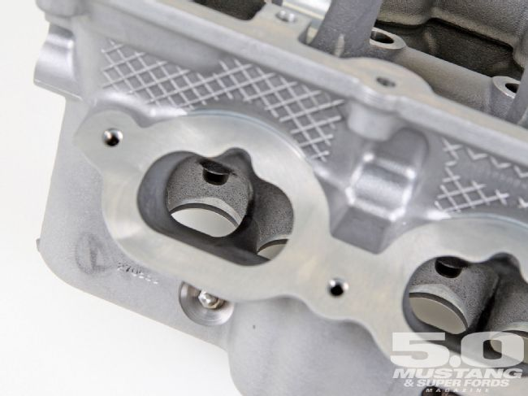
EcoBoost is efficient, torquey, somewhat revvable, and expensive. For a performance car, its personality is a hint cool, without an exhaust snarl or light-speed snappiness. In fact, after 25 years of driving performance cars, we're convinced there is nothing better than a crisp 400-500hp, naturally aspirated small-block when it comes to driving fun. The Coyote comes awfully close to perfection on paper, so we're really looking forward to driving it.
For the Coyote team, Mike Harrison expresses the inevitable concern. "I'm personally worried that when it launches people will think, 'Oh, doesn't it have DI on it? You know, it's not relevant.' I'm a bit worried about that, but I hope the metrics will speak for themselves, because we're delivering DI-like performance. We're trying to leave the impression it is fully competitive without it."
A big reason Mike isn't too concerned is the Coyote has garnered much of EcoBoost's advantages without the cost.
As a Coyote team engineer put it, "On a naturally-aspirated engine, the biggest benefit of DI is charge cooling-and it's a volumetric efficiency benefit and not a tolerance benefit. We squirt the injectors while the [intake] valve is open, and it's open a long time, which we haven't done before. It seems simple and gets you half the benefit of DI-for no costs at all."
The only apparent downside is cylinder-wall washing at low engine speeds, so the injector is limited to closed-valve periods at low rpm. Also, the camshafts change valve timing, so that's something else to synchronize with the injector in the engine management calibration.
Twin independent Variable Cam Timing
Trick as it is, TiVCT is not new. It's been used in other Ford engines, mainly in Europe, since 2004. Its job is to vary the timing of the intake and exhaust valve events, and to do so independently of each other. To accomplish this, separate intake and exhaust camshafts are required, so the technology wasn't available to the Three-Valve 4.6 V-8. Furthermore, the Coyote uses cam torque actuation with its TiVCT, which we'll cover in a minute.
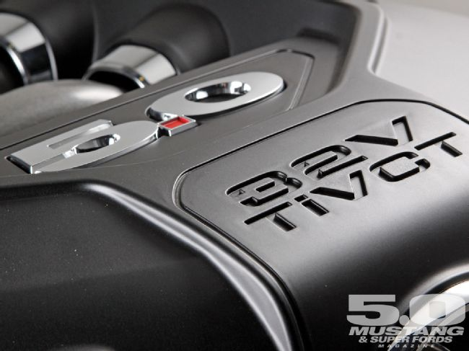
Advantages to TiVCT are immense, and the Coyote would not come close to its impressively wide powerband, high peak power, and fuel economy without it. With TiVCT, the Coyote torque and horsepower peaks are separated by 2,250 rpm, whereas the Three-Valve 4.6 peaks are 1,750 rpm apart using variable cam timing on a single cam. The 4.6 Two-Valve peaks are but 1,200 rpm apart with fixed cam timing, and the venerable pushrod 5.0 H.O. peaks are separated by a mere 1,000 rpm.
Camshaft movement in traditional TiVCT systems is accomplished by porting pressurized oil into the cam phasers attached to the drive end of each camshaft. These have two each advance and retard chambers to physically move the cams. Pressurized oil is routed into the chambers by a shuttle valve and solenoid actuator under computer control.
The Coyote's TiVCT benefits from cam torque actuation. Instead of high-pressure oil energizing the cam phasers, CTA uses the valvespring energy torquing through the camshafts. At certain periods of cam rotation, valvespring pressure tries to advance the cams, and retard them at other points. This snappy back and forth energy is traditionally dissipated uselessly into the timing chains, but with CTA it's used to power the cam phasers. Engine oil is still used to fill the cam phaser chambers and thus hold the new cam position, but not physically advance or retard the cam-that work is done strictly by cam torque from the valvesprings. As such, there is no hardware in CTA. It is only a strategy.
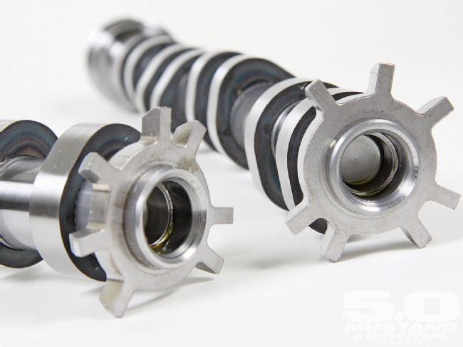
In fact, in exchange for some crafty thinking and hard-won computer software, there are less hardware and cylinder-head-design headaches with CTA. The control mechanism for shuttling oil in and out of the phasers is a simple solenoid because the three-way shuttle valve is not required. High-pressure oil is also not needed, so the engine's oil pump can be downsized and horsepower saved. Nor are dedicated oil passages to the phasers required. Instead, the Coyote's TiVCT with CTA system siphons off bleed oil from the nearest cam journal.
Control of the system requires a camshaft position sensor on each camshaft, plus the crankshaft position sensor. While cam timing is locked into a base mode during some engine modes, namely start and WOT, the rest of the time the cam timing can be all over the map. The engine management computer runs numerous algorithms to determine where to position each cam independently of the others.
Cam timing can be varied up to 50 crankshaft degrees, and the change made in just 0.2 second. The engineers have a field day with TiVCT, noting they can dial in more valve overlap than the raciest conventional cam or run minimal go-to-church valve timing. Aside from the obvious power benefits, TiVCT definitely increases fuel economy during light throttle and cruise modes. Other uses of TiVCT are to increase valve overlap at certain points to increase incoming charge dilution with exhaust gasses. This is passive EGR, which eliminates the need for an EGR system on the Coyote.
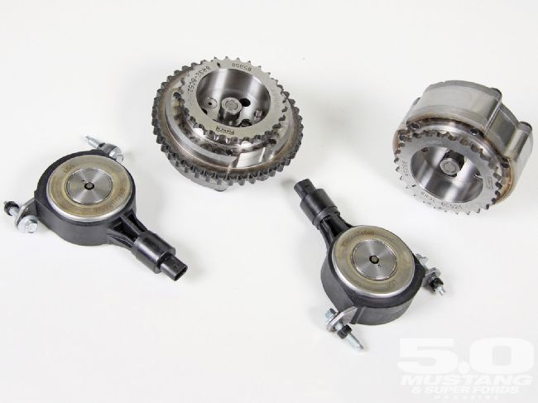
If the highly unlikely event the timing chains or VCT units fail, the Coyote is a free-wheeling engine, so the pistons and valves won't crash.
Intake Manifold
Casual enthusiasts will glance at the Coyote intake manifold and think, "Yep, another composite intake." And they might also notice the engine cover is a "picture frame" design, so the intake runners can be seen.
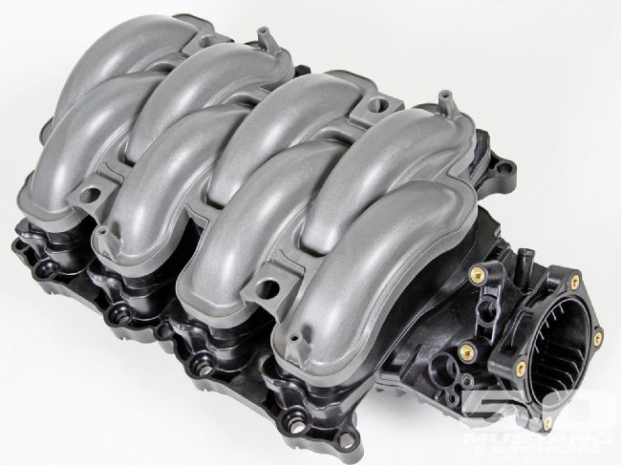
As you might think, there's a bit more to it than that. The Coyote spy shots running loose over the Internet last year showed an aluminum intake manifold, but that was simply an expedient. Early on it was fast and cheap to tool up a handful of aluminum Coyote intakes, but there will never be a production aluminum intake, as all the advantages are with composite. The plastic intakes weigh less, are less expensive in large volumes, and offer dead smooth interior passages compared to aluminum's pebbly runs and casting flash hurdles. Composite does not conduct heat well at all-think of it as an isolator-so a composite intake runs cooler than an aluminum one. Plastic can also be molded in colors, as is the top portion of the Coyote intake.
Mechanically, the Coyote intake is a single-plane. The engineers call it a single-scroll because it is curled up like a snail shell (you didn't think we'd call it a ram's horn, did you?) to fit deep inside the Coyote's valley. The team worked a bit to get the intake plenum far down in the valley to reduce engine height, while simultaneously packaging runners slightly longer and with more gentle turns than those on a Three-Valve 4.6. A major packaging help was routing the coolant crossflow through the block rather than in a separate casting across the valley as with previous modular's.
Tuning on the 430mm-long (16.9-inch) intake tract (from runner entry to the intake valve) is for a 6,500-rpm power peak, the Morse equations putting the second resonance at that point.

Photo Gallery
View Photo Gallery
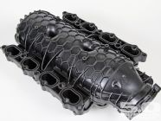
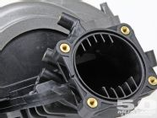
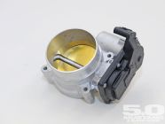
As for that wonderfully centralized front throttle body location, "For years those of us working on Mustangs wanted that center entry throttle. [It was] a major victory," said Mike Harrison. The center entry requires less direction changes for the airflow, resulting in more even airflow distribution. It also gives "half order" resonant frequencies for a more sporting induction sound.
Like the rest of the induction tract, designing the intake manifold relied heavily on Ford's 1D3D CFD software.
Exhaust
An area where the Coyote breaks from the modular pack is its pulse-separated, tubular headers. While hardly the first tubular Ford headers, these intelligently tuned manifolds represent a deep commitment to making power. Doggedly designed, protected from both axe-wielding finance men and dent-prone assembly plants, then nurtured by patient calibration engineers, these headers visibly represent the willing-to-bleed-for-it dedication the Coyote team had toward making power.
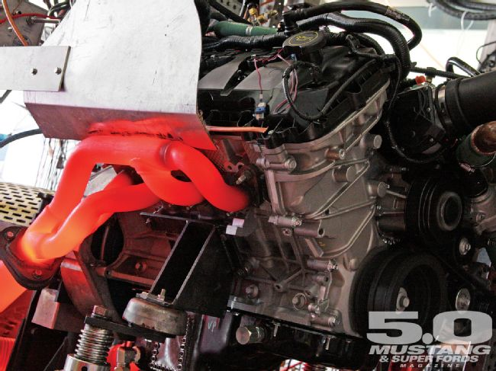
Technically, Coyote headers are a short Tri-Y design complicated by the Coyote firing order differing from other Blue Oval V-8s and the need to package the catalytic converters close to the engine. We'll let Adam Christian, the team member who designed these headers, as well as the prototype builder who welded up the prototypes in his home garage, tell the Coyote exhaust manifold story as he told it to us.
Adam started by showing us some test results of the current Mustang GT header. "Here's a comparison of a standard cast manifold like on the Three-Valve 4.6 today, which is a nice design. It was hard to beat those manifolds, actually."
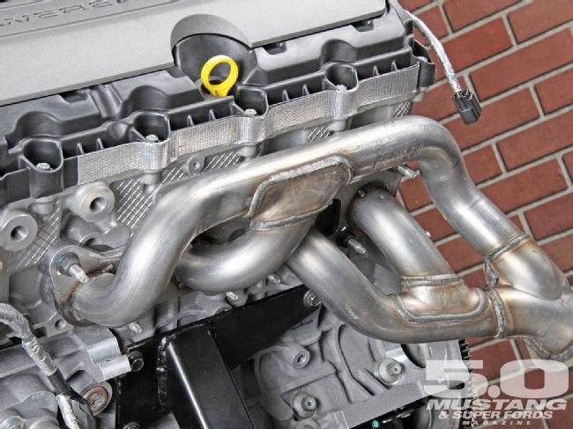
"Headers only give you torque, right? That's in general. And while we wanted torque, we needed to sell the manifolds on power. We had already beat our torque target, so advertised power [was the goal]," Adam explained. "When I left racing [Ford Racing], I told the guy, 'I'm going back to production and I'm taking two things with me: headers and valve lofting.' And at least we got one of them into [the Coyote]. We almost loft-it's really close! We basically go to zero force over the nose, but it doesn't actually come unglued."
"So basically the benefits of the tubular headers in a nutshell is about 15 lb-ft and 6 hp," Adam added. "The thing that you'll notice is, you know what a set of Tri-Y headers are supposed to look like-a simple side and a complex side. On all previous Ford engines, the complex side is always on the driver side. This engine is swapped because the firing order is changed. The complex side should be on the passenger side, which is nice for the steering-shaft packaging and everything. What you'll see on these headers though is that we look like we don't know what we're doing, and they are actually simple connectivity on both sides-front pairs, rear pairs, both banks."
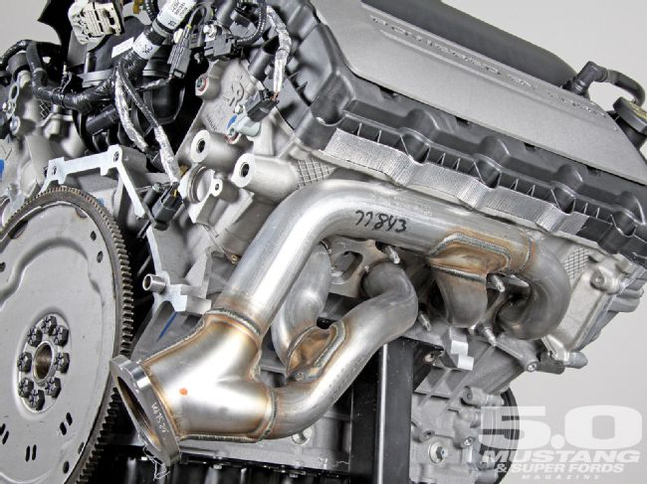
"The reason is that you have to have the catalysts very close to the engine-they have to light off-and when you have that kind of length and you try to separate the 90-degree cylinders, which is what you pick for connectivity, you don't have enough length. What ends up happening is you take the blow-down pulse that occurs in the second cylinder, and you push its pulse into the overlap period of that first cylinder, and you actually destroy the volumetric efficiency," Adam continued. "You've helped the pumping because you've moved that pulse out of the pumping portion of that cylinder, but you've hurt its Vol-F [volumetric efficiency] and the net result is zero; you don't get anything for it. And if you look at [Brand T], they're made that way. [Brand C] tends to do just straight-up manifolds. They're nice manifolds, but just straight up."
"This literally was a morning-shower epiphany thing ... you don't know the amount of work [it was] to push that exhaust flange down as far as it is. The catalysts are short. They're actually stacked on top of each other. The bricks have no separation between them at all, they're just crammed together. They touch; there's no cat monitor in-between. Usually there is a HEGO in-between and we don't have it," Adam said. "So we had pushed the package as far as we could and there just wasn't enough length to get it to work, and then I thought, 'What if we just don't try to pair the 90-degree cylinders? What if we just try to bring them together as much as possible?' And that's what you see, particularly the right bank; right-bank cylinders 1 and 2 come right together, and those two fire right on top of each other. You see the secondary pipe is actually bigger than the rest-that's to take the larger blow-down of those two."
"So we've separated the 180-degree cylinders because we have enough length that we have fixed the Vol-F on all those cylinders so they scream. And the 90-degree pairs are also happy in terms of volumetric efficiency-but they have a pumping hit. So that's the best trade-off; basically, if you have to be that short, this is the type you want to have," he said.
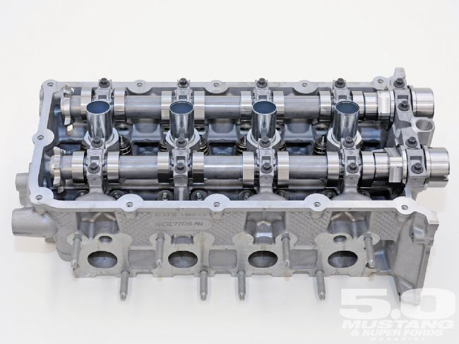
"I have to hurry up and apply for a patent on these, 'cause no one else builds them this way," Adam confessed. "Our peak Vol-F, which is at peak torque, is 110 [percent]. It depends on the dyno cell, right, but we've hit as high as 110, 108, so it's pretty impressive. And at peak power we're pretty close to 100. I don't know, typically 98, 99 [percent]."
Certainly the end result is impressive. "Torque is almost 400 lb-ft out of 5.0 liters; no one else comes close. And it's these type of things that help-the intake runner lengths, the port volumes-because we could have gone with a super-short intake and sold out all the torque to go for peak power. It's those small details, the TiVCT, those are the things that let us get that kind of torque," Adam elaborated.
Or, in the words of Gary Liimatta, "This is a really, good engine, but it is the culmination of a many, many, many small details all pointing in the right direction. The successes we've had are by very hard work."
Some of the hard work in places far from the exhaust paid off in delivering these headers as production pieces. Asked how a stainless steel tubular header compares to a cast-iron exhaust manifold in cost, Mike Harrison spoke right up. "To run a fabricated tubular header on a production engine is a decision that's not taken lightly, and we revisited it on a number of occasions."
Politically, headers are highly visible targets to the cost-cutters. "They are more than double the cost of a cast manifold," explained Mike. "At 6 hp it's hard to justify, but we wanted to build the best 5.0-liter engine out there. And sitting with the [management] team and educating them on the details, defending them ... but we set up cost targets early in the program and we hit the cost targets, so there really was no leg for the more senior management team to stand on. In fact, if I had been overrunning my costs, I would have had to give something up and [the headers] would have been it. [But] we were able to contain this within the overall cost target of the engine, so we were able to deliver our metrics, and, you know, that helped."
Durability is another tubular-header concern. "The problem is the manifolds grow with heat and this pipe tries to pull the short one right out of the collector," explained Adam. "Those rear, short primaries need to twist, so it grows to the rear." These durability concerns led to some of the otherwise non-optimal intersections around the Coyote headers collectors.
Another issue is getting a tube header to work at the vehicle assembly plant, where the tools are huge and time is precious. The header, "has to be durable, work, and can be assembled [with workable] decking zones and tool paths," said Adam. Coyote engines are fitted to Mustangs from the bottom at the plant and are the widest part of the engine, so tucking them close to the engine was important.
Name Game
Gary Liimatta explained how a Mustang engine was named after a canine.
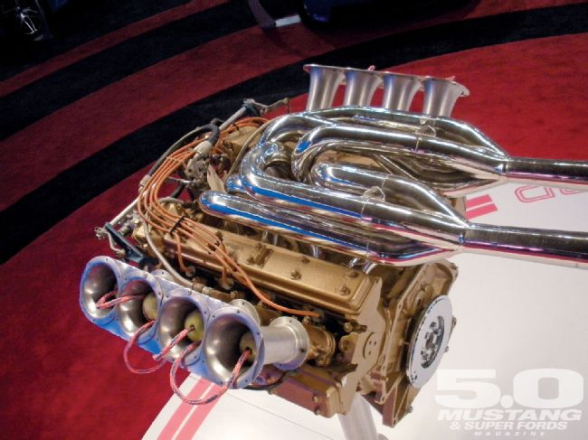
"On the engine programs, we all have code names because we don't want to tip off our direction in case anything leaks from a supplier or something. On this program, we decided to hold a contest among our small group to see if we could come up with a name. So we just sent out an email and took all these submissions from everybody.
"A lot of people got their kids involved and we had all sorts of colorful proposals, but ultimately we decided to go with one that came from John Norcott, who was one of our V-8 engine planners.
"He proposed 'Coyote' and we really liked the idea because it originated with A. J. Foyt's race team. He had a Four-Valve V-8-I believe it was back in 1969-and it was, to the best of our knowledge, the first Ford Four-Valve V-8 ever made.
"There were a lot of good synergies because we were really after the performance," Gary said. "We liked the idea of it being linked to an Indy engine, and when we actually saw that engine in the early days, when we came into our old Triple E building, many of us drooled over that engine. So it was just a natural fit."
"Of course, we had a big debate about Road Runner, Coyote, and some of the negative connotations of 'Coyote' that I won't bother with ... but we decided there was enough there that we would go with it, and it really stuck, too," he added.
Transmissions
Coyote engines are debuting in front of the 6R80 automatic-new to Mustang-and the all-new MT82 manual transmission in the 2011 Mustang. Both are six-speeds.
The 6R80 is new to Mustangs but has been running in Expeditions and Navigators. Upgraded for 2011, it is a filled-for-life box with enhanced power capability. This is a pure clutch-to-clutch automatic with no bands, plus a one-way clutch (not a sprag) has been added to further smooth the shifts. The Coyote applications get their own torque converter and feature a PRNDL321 shift pattern, plus grade assist. The GA holds lower gears on big decels and between corners.
The 6R80, which is built in Ford's Livonia, Michigan plant, has its own oil-to-air cooler and weighs 20 pounds more than the out-going Mustang automatic at 215 pounds. The V-6 Mustang will also use this automatic, but with fewer clutches, a smaller torque converter, and a different front face.
The new MT82 manual is designed by Fords JFT joint venture with Getrag in Germany and built in a four-way joint venture plant in China. It features synchromesh on all gears, including Reverse, even in the six-cylinder version. The engineers tell us it is a slick-shifting unit thanks to ball bearings and pivoting shift forks on the shift rails, and there are positive shift stops inside the gearbox.
The box features a middle bulkhead for much better shaft support and a two-piece housing for reduced driveline bending. All gears are honed or ground, then hard-finished for quiet running. The synthetic lube is fill-for-life. Center distance is 82 mm, an insignificant millimeter closer than the out-going Tremec. Weight is 49 kg (108 pounds), and the torque capacity 375 lb-ft.
There's a bit of bad news: The MT82 Coyote applications feature skip shift. That's where the shifter will only go from First to Fourth if you shift within a certain speed range. Ask any Corvette driver: This is a curse-at-the-moon imposition in the name of fuel economy.
Lipstick On A Coyote
When it came time to integrate the Coyote into the '11 Mustang, the Coyote team worked closely with Ford's design studio.
Everyone involved understood Mustang enthusiasts are just as apt to gather around their cars with the hood up as down. So the Coyote team "took ownership of the engine cover and the ignition cover."
"We wanted to make sure you could see the original runners as well. We did some painting of the intake and discussed painting of the cam covers before we decided to go to composite, getting the natural color of black with composite."
Obviously our entire magazine staff is grinning like Cheshire cats about the "5.0" logo atop the engine cover. Having been there for the original Fox 5.0 phenomena, we're only too happy to relive our youth again in the new car.
Like designing the engine, the underhood styling is mainly done with computers. Every point in the engine compartment, from the inner fenders to the stuff hanging off the firewall and fenders, is digitized in Ford's database. The Coyote team could then add its engine to the database and visualize the entire package before it was rendered in final form.

